79. Marketing approaches (ethnocentric etc.)
1. Fill in the Gaps
A British management with an _______________________ approach to global marketing would be convinced that we Brits are the experts about luxury cars or jewellery – and therefore our insights should work everywhere in the world. Good luck with that. A polycentric approach is the opposite, with an excess of localism, tailoring every aspect of every product to ______________ tastes. So what’s the point of being an international company? Finally there’s the geocentric approach, which tries to gain insights from every country, but use them to target products at a common _________________ of ‘global consumers’ with similar tastes, e.g. drinkers worldwide of malt whisky.
Missing words from: segment, local, ethnocentric
2. Match the business examples to the three theoretical models, e.g. 2.1 B. Such an exercise will always be a simplification, by all means say it’s half this and half that.
Factor | Business examples | Business examples
 | A. Apple makes its business decisions in America – and consumers worldwide follow Apple’s lead | E. Domino’s Pizza UK launched in Germany but came unstuck as home delivery was not as popular as here
2.1 Ethnocentric | B. McDonalds uses common branding globally – but tweaks the menu to suit local tastes and pockets | F. Leigh, Day & Co is a UK law firm with branches in the USA and elsewhere. All operate separatel
2.2 Polycentric | C. Toyota focuses on promoting its hybrid cars in Europe, because they allow it to sell at a price premium | G. Unilever markets some brands everywhere, such as Magnum and Ben & Jerrys, but also offers some products that suit only local tastes
2.3 Geocentric | D. In India Coca-Cola makes small, 200ml cans that are sold for less than 10p – but the product is the same | H. The Economist magazine is produced in London but sells more copies outside the UK than within
3. Data Response
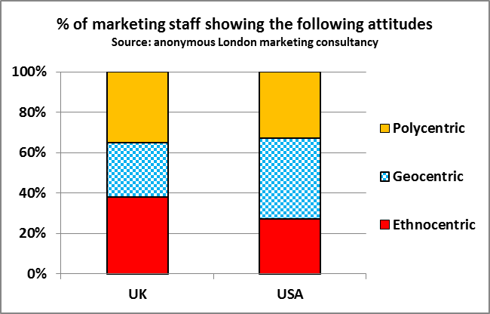

3.1 Based on the data, explain one possible reason why U.S. marketing executives might be more successful globally than British ones.
______________________________________________________________________________________
______________________________________________________________________________________
______________________________________________________________________________________
3.2 Explain why an ethnocentric approach to global marketing might be unsuccessful in the case of Jaguar cars.
______________________________________________________________________________________
______________________________________________________________________________________

79. ANSWERS - Marketing approaches (ethnocentric etc.)

1. ethnocentric … local … segment

2.
Factor | Business examples | Business examples
 | A. Apple makes its business decisions in America – and consumers worldwide follow Apple’s lead | E. Domino’s Pizza UK launched in Germany but came unstuck as home delivery was not as popular as here
2.1 Ethnocentric A, E, H | B. McDonalds uses common branding globally – but tweaks the menu to suit local tastes and pockets | F. Leigh, Day & Co is a UK law firm with branches in the USA and elsewhere. All operate separately.
2.2 Polycentric F | C. Toyota focuses on promoting its hybrid cars in Europe, because they allow it to sell at a price premium | G. Unilever markets some brands everywhere, such as Magnum and Ben & Jerrys, but also offers some products that suit only local tastes
2.3 Geocentric B, C, D, G | D. In India Coca-Cola makes small, 200ml cans that are sold for less than 10p – but the product is the same | H. The Economist magazine is produced in London and the same magazine is sold worldwide

3.1 Based on the data, explain one possible reason why U.S. marketing executives might be more successful globally than British ones.
- The data reveals the British as significantly more ethnocentric than American managers; therefore the Brits are more likely to think that ‘we know best’ and therefore launch products elsewhere without adjusting effectively to local tastes, habits and attitudes. This would suggest that American managers are more successful at ‘glocalising’ than the British

3.2 Explain why an ethnocentric approach to global marketing might be unsuccessful in the case of Jaguar cars.
- It might be unsuccessful if Jaguar Land Rover (JLR) fails to consider what overseas buyers want from a luxury car. The luxury car market is global, with cars such as a Porsche being made in the same way for every market – but the key to this is to make sure to understand the requirements of buyers in major markets worldwide; that means being geocentric, not ethnocentric

