82. Mergers and Acquisitions (Global)
1. Fill in the gaps:

Acquisitions are purchases: one company buys another in order to gain full management control. The other word for this is a ___________________. When Cadbury decided that chewing gum was the market to be in, it bought America’s No 2 gum producer: Adams. Soon afterwards, in 2008, it launched Adams’ main brand ‘Trident’ chewing gum in Britain. By pushing Adams gum through the Cadbury _______________________ channels in countries such as Britain, Ireland and India, sales of Adams gum rose sharply in 2008 (but later fell back; in 2015 Wrigley was back to its traditional UK market share of 93%).
Growing ‘internally’, by new ______________________development, can be a slow and expensive way to enter a new country or market. Mergers and Acquisitions are a way to achieve quickly a ________________ that might otherwise take decades. Positive examples include BMW’s success with the Mini and Wal-mart’s purchase of Asda. Disasters include Mercedes’ purchase of Chrysler (which lost the ______________________ company more than $80 bn). Missing words from: French…distribution…German…goal…recession…takeover…product
2. Takeovers and business strategy.
UniProcter is a British multinational producer of cosmetics. The business is analysing its international position by looking at market growth and its own market share. Look at the bar chart then answer questions 2.1 and 2.2.

Figure 1: UniProcter market share and annual market growth by country
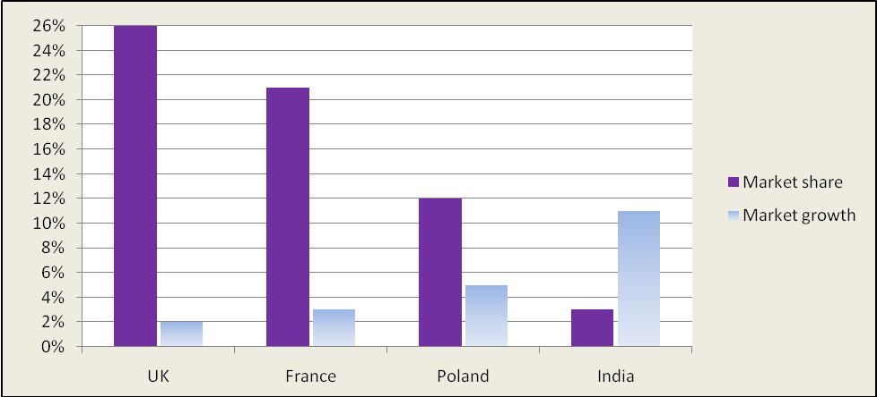
2.1 Outline two reasons why Uniprocter might prefer to take over a rival in India than in the UK.
______________________________________________________________________________________
______________________________________________________________________________________
______________________________________________________________________________________
2.2 A cosmetics producer in Poland is in financial difficulties. It has proposed a merger with Uniprocter. Outline one reason why the Uniprocter directors might accept the proposal and one reason why they might reject it.
______________________________________________________________________________________
______________________________________________________________________________________
______________________________________________________________________________________
3. True or False?
3.1 Acquiring a rival producer is likely to be riskier than buying a company in a different market.
3.2 Buying companies around the world ensures that the firm becomes too big to fail.
3.3 There are valuable economies of scale when a company can sell the same product in many different countries.

82. ANSWERS: Mergers and Acquisitions (Global)

1. takeover … distribution … product … goal … German

2.1
- The Indian market for cosmetics is growing at around 11% per year compared with UK market growth of 2%, i.e. there is vastly more potential.
- This is compounded by the company’s very low market share in India. If the company can grow from 3% to 6%, it’s a doubling of sales. This seems more possible than UK share doubling from 26% to 52%.

2.2
- Accept because Poland offers a lot of potential compared with the other countries in the EU, UK and France.
- Reject because the Polish company seems to be over-valuing itself if it thinks it should ‘merge’ with Uniprocter; perhaps Uniprocter should make a cut-priced takeover bid.

3.1 False
3.2 False
3.3 True

