83. Migration and global labour force
1. Insert appropriate words:
Somehow, migration has come to be seen as a problem. In fact __________________________ built America and recent research shows it to be beneficial to the UK economy. A strength of the US economy is that if there are job losses in Detroit, people can sell up and move to Los Angeles or New York to find work. Free ____________________ of labour in the European Union attempts to achieve the same. Therefore if a Jaguar Land Rover is expanding too fast to train up enough new car software engineers, it can hire from Germany or Italy – and not have its _________________________ plans halted. Free movement of labour helps _____________________ growth. Those with particular skills or experiences can be employed almost anywhere globally, such as footballers, doctors, bridge engineers, English teachers, games software designers and engineers. To be able to work globally gives an individual a huge amount of choice/freedom.
Words from: movement, economic, expansion, immigration
2. State the term or phrase explained by each of the following:

2.1 The efficiency gains an economy might receive from employing motivated, skilled staff from overseas.
2.2 Thinking globally, acting locally.
2.3 Going abroad to seek a new life elsewhere.
2.4 The steps a product might go through as it moves globally from manufacturer to consumer.

3. Data response

University Challenge  The global market for university education is a competitive one. UK universities spend large sums of money marketing to students worldwide – with good reason, as overseas students contribute roughly £2.5bn to the UK economy.  Since 2010 the government’s attempt to reduce immigration led to tougher Visa regulations. This has affected the number of tourists coming from China and India – and has a big effect on student numbers from India | 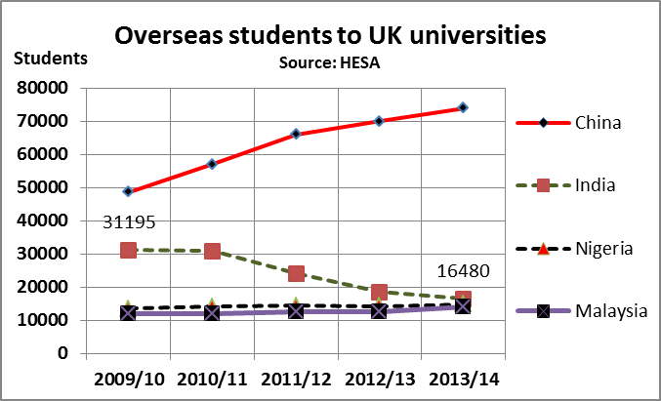

3.1 Of the countries on the graph, identify one that you would advise a university to target. Explain your reasoning.
_____________________________________________________________________________________
______________________________________________________________________________________

3.2a) Calculate the percentage decline in students coming from India between 09/10 and 13/14
______________________________________________________________________________________
3.2b) Explain two ways in which this decline might be damaging to the UK in the long term.
______________________________________________________________________________________
______________________________________________________________________________________
______________________________________________________________________________________

3.3 Outline one possible reason why Chinese students may be coming to the UK in increasing numbers.
______________________________________________________________________________________

83. MARK SCHEME : Migration and global labour force

1. Insert the correct words:
1. In order – immigration … movement … expansion … economic

2. State the term or phrase explained by each of the following:

2.1 Productivity gains
2.2 Glocalisation
2.3 Emigration
2.4 Global supply chain or distribution channel.

3. Data response

3.1 China as it’s growing and it represents the largest group (and largest potential population).
But perhaps India has potential for recovery

3.2a) minus 47.2%

3.2b)
- Fewer highly skilled/educated Indians to work in our Finance and IT sectors
- Fewer Indian businesspeople in the future brought up as Anglophiles (after all, that’s why Tata bought Jaguar Land Rover – one of the most successful-ever inward investments to the UK)

3.3 The increase to the UK may be no greater than the increase to other countries such as the US and Australia
… but if it is a greater increase, that may reflect a cultural affinity (probably down to Downton Abbey, Sherlock and One Direction)

