85. Multinationals – The Benefits
1. Delete as necessary
Multinationals, at their best, contribute to improved living standards, employment opportunities and better technological knowledge in countries where they operate. Over time the presence of multinationals can lead to greater productivity/personnel amongst domestic firms, enhancing economic growth. Chasing these benefits, many countries offer tax concessions, substitutes/subsidies and favourable business terms to attract/avoid multinationals.
2. Data Response
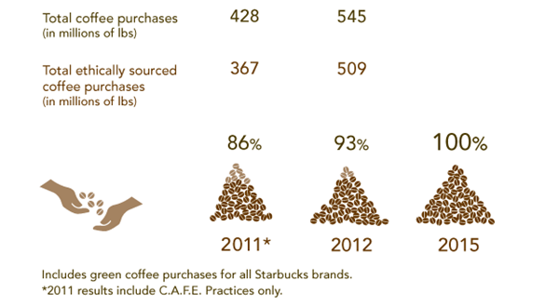 | Starbucks, the multi-$billion coffee multinational, says that in 2015 all of its coffee beans will come from C.A.F.E. (Coffee and Farmer Equity) sources. This is in addition to Starbucks being one of the world’s biggest purchasers of Fairtrade coffee.  Starbucks claims to “champion business practices that help produce social, environmental and economic benefits for the communities in which [it] operates”. 85% of Starbucks coffee is grown on family farms of less than 12 hectares.
What’s The Impact? - Positive ☺, Negative ☹ or Not Sure 😐? Briefly explain why:

2.1 Starbucks provides 4.9 million hours of training for store partners (employees) ☺ ☹ 😐
______________________________________________________________________________________

2.2 Closure of local, independent coffee bars due to competition from Starbucks ☺ ☹ 😐
______________________________________________________________________________________

2.3 Starbucks staff volunteered 383,000 hours in local communities ☺ ☹ 😐
______________________________________________________________________________________

2.4 100 % of coffee purchases conform to C.A.F.E (Coffee and Farmer Equity) principles ☺ ☹ 😐
______________________________________________________________________________________

2.5 Outline three benefits to local economies of a multinational like Starbucks “championing business practices that help produce social, environmental and economic benefits” such as those mentioned in the text.
______________________________________________________________________________________
______________________________________________________________________________________
______________________________________________________________________________________
3. Manufacturing multinationals
When Toyota opened its first factory in Thailand in 1979 the country was still in the early stages of economic development. Further factories followed and now there are three Toyota assembly plants in Thailand producing 650,000 cars a year and employing 20,000 staff. The jobs are relatively well paid, and staff are operating in hugely safer at work than in many other Thai factories.
3.1 Why might multinationals such as Toyota treat staff in developing countries better than local employers?
_______________________________________________________________________
_______________________________________________________________________
3.2 Why may governments in developing countries welcome a factory set up by a company such as Toyota?
______________________________________________________________________________________
______________________________________________________________________________________

85. MARK SCHEME : Multinationals – The Benefits

1. productivity … subsidies … attract

2. What’s The Impact? - Positive ☺, Negative ☹ or Not Sure 😐?

The statements here have been designed to provoke some useful in-class debate. Students might correctly argue that more information would be useful (thus marking lots of 😐); if so, they should be encouraged to say what extra data they would like to have

2.1 Starbucks provided 4.9 million hours of training for store partners (employees) ☺
Significant benefit to staff (and longer term therefore to the skills base of the countries)

2.2 Closure of local, independent coffee bars due to competition from Starbucks ☹
Negative impact on consumer choice, prices and (potentially) local employment.

2.3 Starbucks staff volunteered 383,000 hours in local communities ☺
Positive for both staff and the communities.

2.4 100 % of coffee purchases conform to C.A.F.E (Coffee and Farmer Equity) principles ☺
Probably positive (though the true value of this initiative is not clear)

2.5 The higher prices paid to coffee farmers will benefit local communities as farmers use their profits to buy more local products; similarly the loans may be used to buy land and/or locally produced machinery; expanded farms or higher yields may lead to employment opportunities; infrastructure improvements may benefit all businesses in the area; the C.A.F.E principles should help to protect the environment, helping secure sustainable economic growth for the area.

3.1 Why might multinationals such as Toyota treat staff in developing countries better than local employers?

- Multinationals are more likely to have learnt that good working conditions and strong human relations aren’t really costs – they’re a benefit to a business
- Multinationals soon learn that if they treat staff or customers badly in one part of the world, the rest of the world gets to hear about it. So they have a greater incentive to act responsibly than local employers

3.2 Why may governments in developing countries welcome a factory set up by a company such as Toyota?
- Economic growth comes from higher levels of investment (which will inevitably happen if Toyota builds a factory) plus greater productivity from your population – the lessons to be learnt from Toyota management will help there as well

