87. Protectionism
1. Delete as necessary:
Protectionism refers to economic polices, such as tariffs, quotas and government actions (often known as non-tariff agreements/barriers) used to restrict imports. For example, if cheap imports threaten domestic producers then policies may be used to ‘protect’ the domestic industry from this threat. Equally a country may penalise/subsidise local industries giving them competitive advantage over foreign rivals. The ASA/WTO has responsibility for promoting and policing free trade (according to agreements aimed to reduce protectionism) between countries.
2. State the phrase or term explained by each of the following:
2.1 Product standards and technical regulations, which, if not met, result in import bans.
2.2 A restriction on the quantity of a good that can be imported into a country in a given period of time.
2.3 Countries agreeing to trade freely with each other, but with import protection from outside of the group.
3. Data response
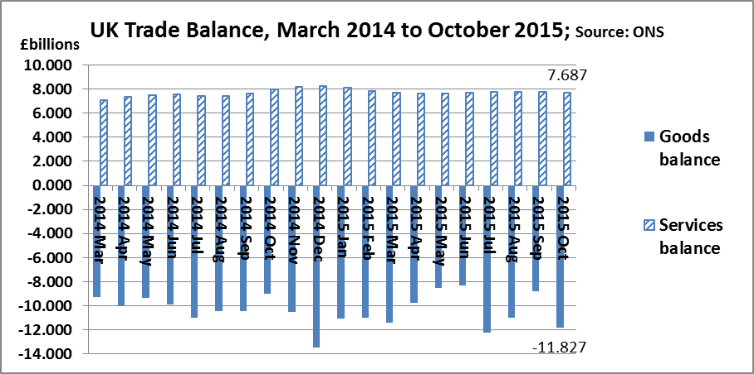

True or False? Use the bar chart to identify whether each of these statements is true or false:
a) The UK’s trade balance was in deficit by just over £2 billion in November 2014 (TRUE/FALSE)
b) The bar chart provides clear evidence that the UK’s trade balance is improving (TRUE/FALSE)
c) The bar chart shows that the UK’s trade balance is usually positive (TRUE/FALSE)
d) The data shown provides a solid reason for Britain to introduce protectionist measures (TRUE/FALSE)

4. Explain:
4.1. Explain why, faced with company failures and job losses in the UK steel industry in 2015, industry representatives demanded that ‘anti-dumping’ tariffs should be placed on Chinese steel exports to the UK.
______________________________________________________________________________________
______________________________________________________________________________________
4.2 Explain one reason why it might be harder for the UK to win trade battles on its own than when within the EU.
______________________________________________________________________________________
______________________________________________________________________________________
4.3. Explain why poor countries might be the biggest losers if import protection is used more widely in future.
______________________________________________________________________________________
______________________________________________________________________________________

87. ANSWERS: Protectionism

1. barriers … subsidise … WTO (World Trade Organisation)

2.1 Non-tariff barriers
2.2 Quota
2.2 Trading bloc

3.1
a) True
b) False
c) False
d) False. Our trading position might be poor, but protectionism might cause retaliation that makes it worse.

4.1. Explain why, faced with company failures and job losses in the UK steel industry in 2015, industry representatives demanded that ‘anti-dumping’ tariffs should be placed on Chinese steel exports to the UK.
- ‘Dumping’ means selling items below their cost of production, perhaps simply to get rid of excess stocks, but also perhaps with a predatory intent. So if dumping is suspected, it’s very reasonable to demand that the government should help protect local industries

4.2 One reason why it might be harder for the UK to win trade battles on its own than when within the EU.
- Trade battles can be won when economic might is on your side. No-one lightly starts a trade dispute with America or China – or the EU; if China takes an aggressive stance on trade, the E.U. is big enough to take it on (the EU is China’s No 1 export destination); Britain would probably find it much harder

4.3. Explain why poor countries might be the biggest losers if import protection is used more widely in future.
- A Donald Trump government in the US might spark of a series of more protectionist measures across the world; because America’s economy is so diverse and not very dependent on exports, it will be fine; but poor countries are usually heavily dependent on the export of just a few products; protectionism elsewhere might hit them very hard.

