

Business

3;BSB and 4;BSB

A-Level

**Course Handbook**

**NAME:**

**Introduction to the department**

Welcome to Business. We hope that you enjoy your time in the department and find the process of studying the course a challenging and rewarding one.

The purpose if this guide is to provide you with a range of information and advice to help you organise your programme of study, learn independently, and equip you with important information about the department and how it can support you.

In addition to A Level Business, The Business department offers BTEC courses that are the equivalent to either 1 or 2 A Levels. We also offer a GCSE equivalent BTEC course as part of the college’s Access programme. There are 8 teachers in the department, and we are a friendly approachable team, based in the Business Office room 202 on the ground floor of the ILC. Our teaching classrooms are in the same area: rooms 200 – 205.

**Teaching Staff:**Ellen Bateman  
Seonaid Botfield   
Jasjeet Gill   
Ilse Howling

Brenda Kerr  
Verity Kimber  
Sofia Neves  
Jane Scott

**Head of Department:**Anne Lomas

**Director of Faculty (Humanities and Social Sciences):**Deborah Haggar

Along with the names above, the following departments and places will be useful whilst studying on the course:

**The ILC** – your go-to place to complete work and independent study outside of lessons. The Silent Study area provides an area to work individually, whilst the library contains an excellent selection of wider reading. Make sure that you have familiarised yourself with the ILC when you start the course

**The Exams Office** – for any questions you have about your exam entries, exam timetable or remarks and script requests.

**Learning Support** – for any extra support or advice you need to help you study in general. If you are struggling to organise and manage your workload; need help refining your essay-writing technique; help with revision; or if you think you might be entitled to any exam concessions, learning support are the people to talk to.

**Careers** – when you start to think about your options after college, whether university or employment based, careers can give you advice on where to apply and help in producing a personal statement.

**ExpecTations**

**What is expected of students?**

1. **Attendance and punctuality** – learning cannot begin if you are not in lessons or if you arrive late to them and miss important content. Students should maintain full attendance and punctuality. Any unavoidable and legitimate absences should be accounted for properly, meaning that students get a parent or a guardian to contact college and then email their teacher(s) to catch up on missed work
2. **To maintain a mature and respectful learning environment** – this means behaving in and out of lessons in a way expected of a Sixth-Form student: listening carefully to the views of others and offering constructive contributions in class
3. **To stay up-to-date** – you will be set weekly structured preparation or homework tasks and it is essential that these are completed on time and in the required level of detail. We use structured homework to consolidate particular content or to set up lessons to come. If work is incomplete your understanding will be incomplete and you will under-perform. If you arrive at a lesson having not completed preparation work then your teacher may also ask you to leave and complete this elsewhere.
4. **To stay organised** – managing the demands of a minimum of three subjects is challenging, especially when you are being taught more than one unit in each. You need, therefore, to stay organised. This means preparing a folder for each of your units, bringing the correct materials to each lesson and recording homework in the same place every time
5. **To meet the 50/50** – students are expected to conduct 4.5 to 6 hours of independent study a week. This will include structured preparation or homework tasks set by your teachers along with proactive tasks you complete yourself to consolidate and extend your understanding. See the advice later in this booklet for more help on doing this.
6. **To make the most of feedback and support** – you will get a lot of feedback during your time on the course. This will come as written feedback on assessed work, verbal feedback on general class or homework, and targets set at formal 1-1s. Feedback needs to be recorded carefully by you and acted upon. When you get back assessed work, for example you will be asked to record your own targets based on this, and may, in addition, be asked to attend a lunchtime workshop to help process feedback.
7. **To be resilient** – any subject will at times be very challenging. At times you will not do as well as you want or will struggle to understand a new topic or idea. You need to be prepared to spend more time on areas such as these and to seek out extra help when needed. These experiences of finding areas where you are not doing so well and improving them are what lead to success.

**What can you expect of your teachers?**

1. **To deliver structured and engaging lessons** – your teachers will deliver lessons designed to challenge your understanding whilst also helping you to gradually build up your knowledge and skills. These lessons will follow the scheme of work, a version of which you can see in this handbook.
2. **Regular assessment and feedback** – in addition to your benchmark assessments (four in the first year and three in the second) your teachers will regularly set you exam-style questions to give you opportunities to practice and improve. Feedback will be given on standardised sheets which include the relevant mark scheme and clear developmental targets
3. **Structured weekly work** – you should expect to be given a significant amount of work to do by your teachers each week. You will be given guidance on how long this should take and completed work will be checked and/or taken in
4. **Additional support** – your teachers will be happy to provide extra help outside of lessons either informally, by responding to emails, or more formally through departmental workshops. Workshops are the best opportunity to received additional help and work best when students come to lunchtime sessions with a specific area of confusion or set of questions to get answered

**Approach to remote teaching and learning**

Following the closure of schools and colleges in March 2020, teachers and students have adapted to a new environment of remote teaching and learning. How ‘remote’ this is depends on the wider context of COVID-19, but the department has clear plans, and expectations of its students, in each of the scenarios below.

1. ***Normal Opening: The College is open as normal; all students attend and follow a full, face-to-face timetable***

In this situation the department would run lessons, as normal and all of the expectations of students and teachers on the page before would apply

1. ***Blended Learning: students will receive a mixture of physical and remote lessons, attending college physically one week and remotely the other***

The department will continue to offer high quality lessons in this scenario although the exact nature of teaching and learning may vary depending on what content is being covered. Students should expect a mixture of:

* **Streamed lessons** – when appropriate, lessons including half of the class will be streamed live through Microsoft Teams to the other half of the class learning from home
* **Recorded content** – tutorials, demonstrations, presentations etc. will be pre-recorded for students to watch and complete a set of follow-up tasks
* **Structured independent work –** students may be longer project-style work, or work that is made up of several structured tasks and asked to work on this independently for a period of time, during which their teacher will be available for support
* **Preparation work** **–** class time may be used to set students independent work in the form of research or pre-learning to prepare them for a specific live lessons, which will then be used to assess students’ level of understanding of the work they have completed.
* **Homework** – students will also be expected to complete homework tasks

1. ***Remote Learning: students will receive remote lessons and assessment will be conducted remotely***

In the event that college is not open for physical lesson, teaching and learning will move online through the combined use of Microsoft Teams and Godalming Online. The specific nature of each week’s learning will vary depending on what is being covered, but students should expect a mixture of:

* **Live lessons through Microsoft Teams** – this is a fantastic platform that allows classes to video-call, watch presentations, take part in Q&A, group work, 1-1s all in real-time. Teams lessons will be the main part of remote teaching and learning but may take a slightly different form or length than physical lessons to help students engage fully. For example, a 1.5 hour physical lesson might translate to a 30-45 minute Teams lessons, made up of a brief teacher-led presentation and class Q&A, followed by 45 minutes of structured independent work, during which time the teacher conducts 1-1s with students
* **Online submissions** – students will upload work regularly to help their teacher monitor their progress and offer support when needed. This will be done through the ‘Assignments’ feature on Teams or through Godalming Online
* **Remote Workshops** – in addition to remote lessons, department workshops will continue remotely to provide students with extra points in the week to get 1-1 help on content, homework or remote learning in general

**Expectations of students in scenario 2&3 –** if students find themselves learning remotely or in a mixture of physical and remote lessons, then the department has clear expectations of how they should work in this environment. The department has considerable experience in delivering content remotely and key to this is students remaining engaged, establishing a clear working routine and communicating effectively with staff. More specifically it is expected that students will:



* Attend all remote lessons unless told otherwise by their teacher
* Actively take part in remote lessons e.g. contribute questions and answers, take part in group work, turn webcams on (with the background blurred) when asked to by their teacher
* Submit all work via Godalming Online or Microsoft Teams by the deadline set
* Communicate regularly with their teachers, either as part of scheduled 1-1s or more informally to discuss work or any problems they might be having. This will be through Email or Teams.

To identify where your remote strengths and weaknesses might be, complete the specific department audit below. This is made up of the essential skills you would need to learn in a remote or blended environment.

|  |  |
| --- | --- |
| **Remote Learning Skills Audit that you need to master to succeed on this course** | ***Tick*** |
| Log on to Office 365 using your college details (in college and at home) |  |
| Open Microsoft Teams and find a class team |  |
| Join a lesson on Teams and post a comment |  |
| Download the Teams app on your phone |  |
| Upload or attach documents in Teams |  |
| Save documents on OneDrive |  |
| Access your OneDrive files at home |  |
| Share documents, PowerPoints etc without attaching them to emails |  |
| Access Godalming Online course pages and download files |  |
| Upload work onto Godalming Online |  |
| Log on to any magazines or websites needed on the course |  |
| Access Estream to watch films/documentaries/pre-recorded content |  |



*[](https://www.google.co.uk/url?sa=i&url=https%3A%2F%2Flogotyp.us%2Flogo%2Fmicrosoft-teams%2F&psig=AOvVaw2Wl1l6bVS-gskR2jhCsLQD&ust=1594130388988000&source=images&cd=vfe&ved=0CAIQjRxqFwoTCNDg_8_kuOoCFQAAAAAdAAAAABAD)*There are lots of places you can go to get help with the skills listed above.

To begin with, speak to your teachers to get help with the basics of using Microsoft Teams or Godalming Online. This can be done at the start of the year through departmental surgeries and through workshops. A good idea would be to bring the completed audit above to a workshop and go through this with your teacher to fill in any gaps.

The IT Department are also available to offer more technical support or if you run into a problem your teacher cannot resolve. If in college, IT can be found on the top floor of the 300s. Also have a look at the IT Helpdesk on Godalming Online, which has help on using features such as Office 365. Finally IT are also contactable via [ITsupport@godaming.ac.uk](mailto:ITsupport@godaming.ac.uk)

If you are concerned about how to organise your time and working habits during a period of remote learning, then speak to your tutor for ideas and techniques to work independently. The Learning Support Department are also available to discuss specific concerns or individual learning needs further.

**Course Overview**

|  |  |  |  |
| --- | --- | --- | --- |
| **YEAR ONE** | **COMP 1** | **BUSINESS OPPORTUNITIES**  **Compulsory short answer questions in Section A of the exam** | **A Level = 33.3%** |
| **BUSINESS FUNCTIONS**  **Compulsory Data Response questions in Section B of the exam** |
|  |  |  |  |
| **YEAR TWO** | **COMP 2** | **BUSINESS ANALYSIS AND STRATEGY**  **Compulsory Data Response questions** | **A Level = 33.3%** |
| **COMP 3** | **BUSINESS IN A CHANGING WORLD**   * **Case Study and 5 compulsory questions** * **1 synoptic essay from a choice of 3** | **A Level = 33.3%** |

**The Exams**

At the end of your second year you will take three exams in:

**Exam 1: (2.25 hours / 80 marks / 33.3%)**

* **Section A:** Compulsory short answer questions
* **Section B:** Compulsory data response questions

**Exam 2: (2.25 hours / 80 marks / 33.3%)**

* Compulsory data response questions

**Exam 3: (2.25 hours / 80 marks / 33.3%)**

* **Section A:** Case study and 5 questions
* **Section B:** 1 essay from a choice of 3

**Student scheme of work**

Below is a summary of how you will be taught the different units of the course and how this fits into the approximately 66 weeks of teaching time over the two years of your A-Level. You will also see the key assessment points given below. It is important that you know when these are so that you can organise your revision and preparation. An important idea to understand when looking at this student scheme of work, is that the course flows consistently over two years. The topics you study at the start of your first year are as ‘difficult’ as those you will look at the end of your second year. You need to treat all work in the same way and apply yourself fully throughout. Also consider that the May half term in the first year is, in reality, the mid-point of the course not the summer holiday. This time will go quickly so make sure you understand the structure of the course fully and get any help when it is needed. Please note: “Benchmarks” indicated show when the marks are to be uploaded to the portal, so the actual assessment will happen approximately two weeks before that shown below.

Should you have only one teacher, the schedule will remain roughly the same as below, only you will be taught by one member of staff.

|  |  |  |  |
| --- | --- | --- | --- |
|  | **A-LEVEL YEAR 1** | | |
| **Week** | **Teacher 1 (3 hours per week)** | **Teacher 2 (1.5 hours per week)** | **Assessment** |
| **Start of term/L6 Enrolment** | | | |
| **L6 Enrolment** | | | |
| 1 | Enterprise | Business Location |  |
| 2 | Business Plans & Business Structure | Business Revenues & Costs |  |
| 3 | Business Structure | Business Revenues & Costs |  |
| 4 | Business Structure & Markets | Business Revenues & Costs |  |
| 5 | Markets | Business Revenues & Costs |  |
| 6 | Markets | Business Revenues & Costs |  |
| *Half Term - 25th – 29th October (1 week)* | | | |
| 7 | Markets & Market Research | The Role of The Finance Dept & Business Finance for SMEs (COMP1) |  |
| 8 | Market Research | Finance: Business Finance for Companies (COMP2) | **Benchmark 1** |
| 9 | The Functions of the HR Dept | Finance: Cash Flow Forecasting |  |
| 10 | People: Changes in Working Practices & W/F Planning | Finance: Cash Flow Forecasting |  |
| 11 | People: Recruitment & Training | Finance: Cash Flow Forecasting |  |
| 12 | People: Appraisal & W/F Performance | Finance: Budgeting | **Benchmark 2** |
| 13 | People: Organisational Design | Finance: Income Statement |  |
| *Christmas Holiday – 17th December – 4th January* | | | |
| 14 | People: Organisational Design | Finance: Income Statements |  |
| 15 | People: Motivation | Finance: Ratio Analysis |  |
| 16 | People: Motivation | Marketing: 1st 'Intro' section | **Student Review 1 Available** |
| 17 | People: Management & Leadership | Marketing: Product |  |
| 18 | People: M'ment & Leadership & Employer/ee Relations | Marketing: Product |  |
| 19 | People: Employer/ee Relations | Marketing: Product |  |
| *Half Term - 14th February – 18th February* | | | |
| 20 | Operations: 1st 'intro' section & Added Value & Production | Marketing: Product |  |
| 21 | Operations: Productivity | Marketing: Price |  |
| 22 | Operations: Technology & R&D | Marketing: Price | **Benchmark 3** |
| 23 | Operations: Lean Production | Marketing: Promotion |  |
| 24 | Operations: Quality | Marketing: Place |  |
| 25 | Operations: Purchasing | Marketing: Decisions about Mktg Mix |  |
| *Easter Holiday – 1st April – 19th April* | | | |
| 26 | Operations: Economies of Scale | Marketing: New Technology |  |
| 27 | Catch up / Revision | Catch up / Revision |  |
| 28 | Revision | Revision |  |
| 29 | Revision | Revision |  |
| 30 | Revision | Revision |  |
| 31 | Revision | Revision |  |
| *Half Term30th May – 3rd June* | | | |
| 32 | Preparing for U6: Ethical and Environmental Pressures upon Business | Preparing for U6: Influences of Legal Factors upon Businesses | **Benchmark 4** |
| 33 | Preparing for U6: Ethical and Environmental Pressures upon Business | Preparing for U6: Influences of Legal Factors upon Businesses |  |
| 34 | Preparing for U6: Ethical and Environmental Pressures upon Business | Preparing for U6: Influences of Legal Factors upon Businesses | **Student Review 2 and Predicted Grade Available** |
| 35 | Preparing for U6: Ethical and Environmental Pressures upon Business | Preparing for U6: Influences of Legal Factors upon Businesses |  |
| 36 | Preparing for U6: Ethical and Environmental Pressures upon Business | Preparing for U6: Influences of Legal Factors upon Businesses | **Last day of L6 teaching Wed 6th July** |
| 37 | INSET | |  |

Colour Key for Year 1 Scheme of Work:

Black = COMP1 Business Opportunities

Blue = COMP1 Business Functions

Pink = COMP3 Business in a Changing World

|  |  |  |  |
| --- | --- | --- | --- |
|  | **A-LEVEL YEAR 2** | | |
| **Week** | **Teacher 1 (3 hours)** | **Teacher 2 (3 hours)** | **Assessment** |
| **Start of term/L6 Enrolment** | | | |
| **L6 Enrolment** | | | |
| 38 | Intro to course & Market Analysis (PED & YED) | Decision-Making Models |  |
| 39 | Analysing Financial Performance (Budgeting) | Decision-Making Models |  |
| 40 | Analysing Financial Performance | Decision-Making Models | **Benchmark 5** |
| 41 | Analysing Financial Performance | Decision-Making Models |  |
| 42 | Analysing Financial Performance | Aims and Objectives & Strategy and Implementation |  |
| 43 | Analysing Financial Performance | Strategy and Implementation |  |
| *Half Term - 25th – 29th October (1 week)* | | | |
| 44 | Analysing Financial Performance | Strategy and Implementation |  |
| 45 | Analysing Financial Performance | Strategy and Implementation |  |
| 46 | Analysing Non-Financial Performance | Strategy and Implementation |  |
| 47 | Data Analysis | Strategy and Implementation | **Benchmark 6** |
| 48 | Sales Forecasting | Strategy and Implementation |  |
| 49 | Sales Forecasting | Investment Appraisal |  |
| 50 | Sales Forecasting | Investment Appraisal | **Student Review 3 Available** |
| *Christmas Holiday – 17th December – 4th January* | | | |
| 51 | Special Orders and Change | Investment Appraisal |  |
| 52 | Change | Risk Management |  |
| 53 | PEST Factors - Economic | RE-CAP Ethical & Environmental |  |
| 54 | PEST Factors - Economic | RE-CAP Legal |  |
| 55 | PEST Factors - Economic | International Trade |  |
| 56 | PEST Factors - Economic | Globalisation |  |
| *Half Term - 14th February – 18th February* | | | |
| 57 | **MOCK EXAMS** | |  |
| 58 | PEST Factors - Political | Globalisation |  |
| 59 | PEST Factors - Political | The E.U. |  |
| 60 | PEST Factors - Social | The E.U. | **Benchmark 7 and**  **Student Review 4 Available** |
| 61 | PEST Factors - Technological | The E.U. |  |
| 62 | COMP 1,2 & 3 Revision and exam practice | COMP 1,2 & 3 Revision and exam practice | **Past Paper final practise** |
| *Easter Holiday – 1st April – 19th April* | | | |
| 63 | COMP 1,2 & 3 Revision and exam practice | COMP 1,2 & 3 Revision and exam practice |  |
| 64 | COMP 1,2 & 3 Revision and exam practice | COMP 1,2 & 3 Revision and exam practice |  |
| 65 | COMP 1,2 & 3 Revision and exam practice | COMP 1,2 & 3 Revision and exam practice |  |
| 66 | **Last Day of U6 Teaching - Friday 14th May** | | |

Colour Key for Year 2 Scheme of Work:

Black = COMP2 Business Analysis and Strategy; Blue = COMP3 Business in a Changing World; Green = Revision / consolidation time

**Assessment**

When starting the course, it is important to know how the course is assessed. All assessed work is marked around what are known as **‘assessment objectives’** (AOs) which have been set by the exam board. You need to understand what each of these is and how many marks it carries for each type of question. If you can do this then you will know what skills to demonstrate and to what extent for each question on the exam.

|  |  |  |  |  |  |
| --- | --- | --- | --- | --- | --- |
|  | | **COMP 1** | **COMP 2** | **COMP 3** | **OVERALL WEIGHTING** |
| **AO1** | Demonstrate knowledge of terms, concepts, theories, methods and models to show an understanding of how individuals and organisations are affected by and respond to business issues. | **12-14%** | **4-6%** | **6-8%** | **24-26%** |
| **AO2** | Apply knowledge and understanding to various business contexts to show how individuals and organisations are affected by and respond to issues. | **7-9%** | **11-13%** | **4-6%** | **24-26%** |
| **AO3** | Analyse issues within business, showing an understanding of the impact on individuals and organisations of external and internal influences. | **6-8%** | **5-7%** | **11-13%** | **24-26%** |
| **AO4** | Evaluate quantitative and qualitative information to make informed judgements and propose evidence-based solutions to business issues. | **6-8%** | **6-8%** | **10-12%** | **24-26%** |

***What do these mean?***

***AO1 – ‘Content’ or ‘Knowledge’.*** The use of using your own knowledge and understanding of Business. This is what you have learned from lessons and independent study when covering the specification. There should be a ‘reasonably wide’ coverage of content points when writing answers, although this depends upon the style of questioning and the command word used in the question.

***AO2 – ‘Application’ or ‘Context’.*** Every individual or business has a different context, so what might be welcomed by some might not be by others; what is appropriate to some is inappropriate to others etc. This skill requires learners to recognise this in their answering. It is also awarded when dealing with numerate information, when the right data must be selected and used appropriately from stimulus material.

***AO3 – ‘Analysis’.*** The explanation of cause and effect. The more complex your chain of argument and the greater the level of clarity, the higher the marks. It takes high level understanding to explain why something has happened and what is likely to happen as a consequence. The use of models and theory to explain cause and effect is also required to score well, as is the processing and use of numbers and quantitative method.

***AO4 – ‘Evaluation’.*** Reasoned, justified decision making and the drawing of conclusions. To do this, opposing arguments should be weighted and there should be a balance of arguments to be fair and objective. Points of evaluation must stem from the lines of analysis given.

**A-Level Mark schemes**

A typical 6 mark question

|  |  |  |  |
| --- | --- | --- | --- |
|  | **Using examples of goods sold in a supermarket, explain the difference**  **between inferior and normal goods. (6)** | | |
| **Band** | AO1 | AO2 | AO3 |
| 2 marks | 2 marks | 2 marks |
| **2** | **2 marks**  Good knowledge of the relationship between income and demand.    Clear understanding demonstrated. | **2 marks**  Good application of relevant supermarket examples covering both normal and inferior goods. | **2 marks**  A good analysis of the difference between normal and inferior goods in relation to income elasticity.    The analysis shows a clear understanding of the impact of income on demand. |
| **1** | **1 mark**  Limited knowledge of the relationship between income and demand. | **1 mark**  Limited application of relevant example of either a normal or inferior good sold in a supermarket. | **1 mark**  A limited analysis of the difference between normal and inferior goods.    The analysis shows a superficial understanding of the impact of income on demand. |
| **0** | **0 marks**  No knowledge demonstrated. | **0 marks**  No application of relevant examples. | **0 marks**  No analysis offered. |

A typical 8-10 mark question, with evaluation

|  |  |  |  |  |
| --- | --- | --- | --- | --- |
|  | **Consider, using the concept of price elasticity of demand, why ‘raising price might**  **be a poor decision’. (8)** | | | |
| **Band** | AO1 | AO2 | AO3 | AO4 |
| 2 marks | 2 marks | 2 marks | 2 marks |
| **2** | **2 marks**  Good understanding of the concept of PED.    Definition is clear and precise. | **2 marks**  Good application of raising the price in the context of the text.    Clear reference to the data and relevant content. | **2 marks**  Good, clear analysis of how the PED for a good impacts upon sales when price is raised. | **2 marks**  Well-balanced evaluation of how a change in price may have either a positive or negative impact upon total revenue. |
| **1** | **1 mark**  Limited understanding of the concept of PED.    Definition is partially correct. Superficial understanding. | **1 mark**  Limited application is attempted to the context of raising the price of coffee in the cafe. | **1 mark**  Limited analysis of how the PED for a good impacts upon sales when price is raised.    Superficial arguments  with little development. | **1 mark**  Limited evaluation of how the change a change in price may impact upon a business.    Superficial judgements made. |
| **0** | **0 marks**  No understanding or knowledge of the concept of PED. | **0 marks**  There is no application to the decision to raise the price of coffee in the café. | **0 marks**  There is no analysis of the impact of raising the price of a good. | **0 marks**  No evaluation of a strategy to raise the price of a good. |

**Example Exam Paper**

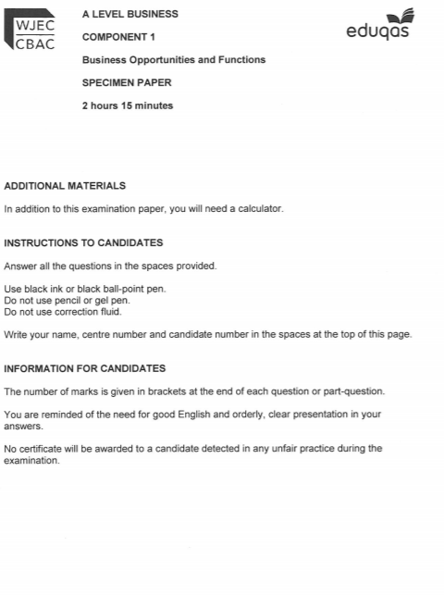

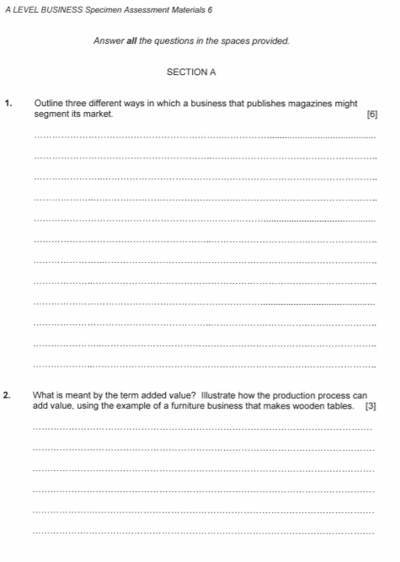

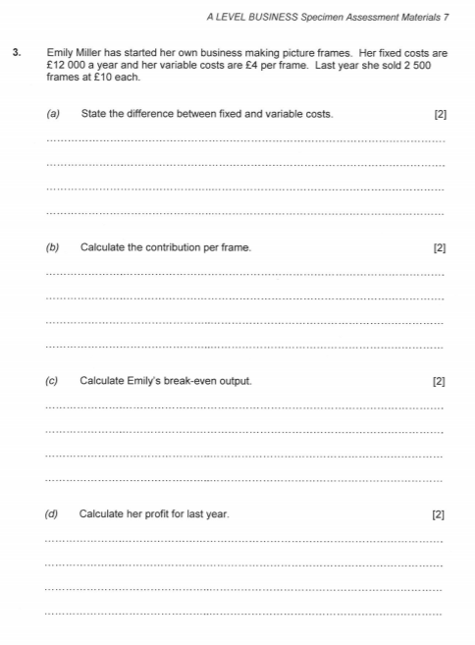

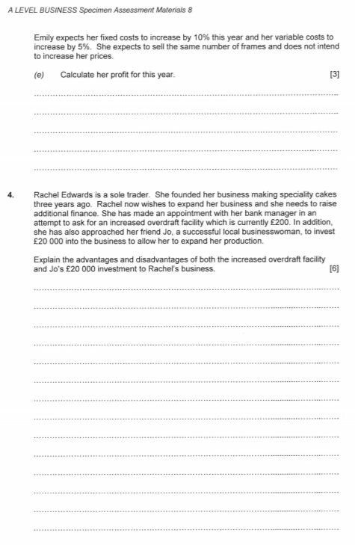

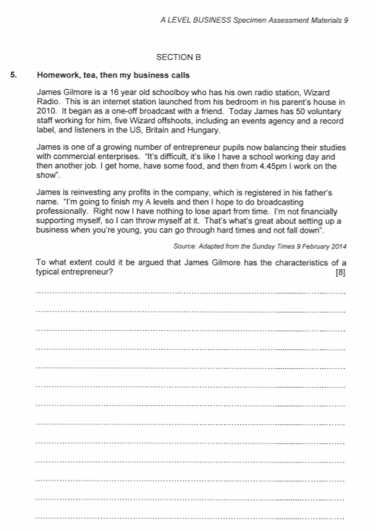

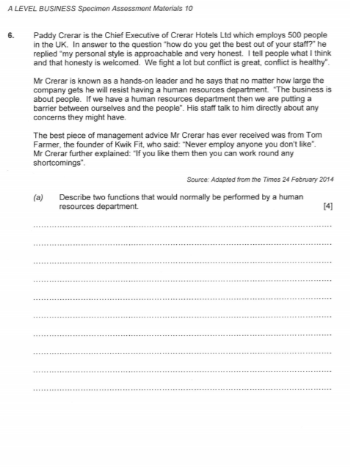



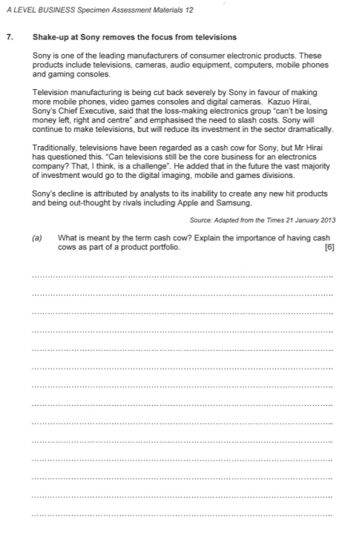



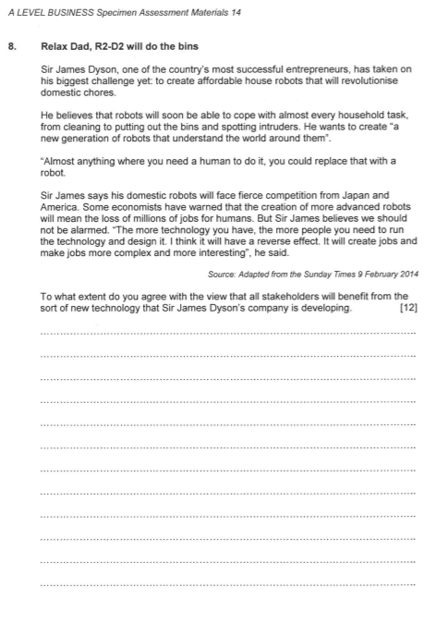



# **Business Department Assessment Policy**

## The Importance of Feedback

Learning will not happen instantly and takes time; attending lessons is not enough, you also need to be working outside of class, to learn new information and consolidate learning. In the process, you will make mistakes but hopefully feedback will enable you to learn from these mistakes. Better to make a mistake during the year and correct it, than make your first mistake in the actual exam! Feedback is essential for your learning and will consist of written (teacher marking), peer (where you feedback on someone else’s work in the class) and self (where you assess yourself).

## Weekly Independent Tasks (Homework)

Homework does not necessarily need to be completed at home! You can use free periods during the day to complete these tasks outside of lessons. To keep a good work/life balance, you might like to treat College as an 0845 to 1615 day and use your free periods in the library completing tasks. This will minimise the work you need to complete at home and might make you more productive!!

Each week, you should be spending approximately 5 hours on independent tasks. Your teacher will set homework tasks and advise you of additional reading that you should undertake. If the homework set does not take the full 5 hours to complete, you should conduct further reading and research to consolidate learning. Homework tasks will consist of two main types:

*‘PREP WORK’:* Not all homework will be marked. It will be given a quick inspection in class and then will involve peer and self-assessment as part of a class exercise. This work will ‘prepare’ you for the lesson and could involve reading specific chapters in a text book or carrying out specific research.

*CONSOLIDATION EXERCISES:* These may take the form of revision worksheets, small case studies, or past paper questions/common works to be used for formal/self/peer assessment or discussions in lessons.

**Annual Review Grade (ARG)**

At the end of year 1, your teacher will decide what your ARG will be, based upon your benchmarks and other factors such as your ‘Approach to Learning’ (see below). You will have a 1-2-1 in the Summer, when your Lead Teacher will tell you what your ARG is. The ARG is your teacher’s honest decision on your grade performance in the first year of your course and therefore will be the chief determinant for your predicted grade, which is what is entered on your UCAS application forms. Universities will offer places on their courses based upon these grade predictions alongside other elements of the UCAS form including references and personal statements. Benchmark 3 and 4 would normally carry more weight than 1 and 2 but since they have been carried out remotely under the current Covid-19 scenario, although still valid, they will be taken into consideration alongside other factors like your ‘Approach to Learning’ before and after lockdown to signal your academic potential.

The ARG plays a key part in determining the context in which you progress to the second year. Students who receive an A*-D grade are encouraged to continue with their studies into the 2nd year. However for students who receive a U or E Grade as their ARG, it suggests that for whatever reason they have struggled with the transition from Level 2 Courses (GCSE) to Level 3 Courses (A-level). This will be evidenced by poor performances throughout their benchmarks and an inconsistent or poor approach to learning in their student reviews and via formal Action Plans. Students who receive a U Grade we would not recommend to continue with the course and they would need to speak to a Senior Tutor about alternative pathways.

The College adopts a consistent and optimistic approach to predicting grades to ensure that they are both aspirational and achievable. A predicted grade is what we believe a student is likely to achieve by the conclusion of their course in positive circumstances.

The ARG is important in forming the basis for the predicted grade, but the predicted grade will also be aspirational for the students’ ambitions although it must remain realistic and cannot be based on the idea that only now will the student start to work harder in the second year.

**Approach to Learning (before 20th March 2020)**

How you were engaging in your learning, evidenced by attendance, punctuality, ability to meet weekly deadlines with quality work, how you sought out extra support via workshops and your overall communication with your teachers.

**Approach to Learning (after 20th March 2020)**

How you are engaging in your learning remotely, evidenced by the ability to meet weekly deadlines with quality work, attendance at any remote lessons (unless previously communicated to state your unavailability) and communication with your teachers via Email and/or Microsoft Teams.

## Benchmark Assessment Tasks

Throughout the course, you will be set benchmark assessments. These will consist of the type of questions that you would see in the exam and will cover the topics covered to date. How you perform in these assessments will be formally logged and will directly contribute towards your ARG, although in the current Covid-19 scenario they will be viewed alongside a much wider set of variables, such as your Approach to Learning. Benchmarks provide a valuable opportunity for feedback regarding your knowledge and understanding as well as an opportunity to develop your exam technique. Feedback can take the following forms:

* *WRITTEN TEACHER FEEDBACK:* Some benchmark assessments and home works will receive written feedback in the form of comments that relate directly to the assessment criteria of the exam board. Alongside this, comments and questions will be posed about how to improve.
* *VERBAL TEACHER FEEDBACK:* This may take place during lesson time however formal 1-2-1’s will also occur in November and March at which point progress with assessments can be discussed.
* *WRITTEN PEER FEEDBACK*: One some occasions, your teacher will ask you to formally mark and feedback on a classmate’s common work in lesson. This is valuable experience for you to not only learn from others but gain a better understanding of the assessment objectives and mark schemes.
* *REFLECTION AND TARGET SETTING:* After each assessment, students will be expected to reflect on the written/verbal feedback from their teacher and set themselves targets for improvement in the period in question.

Benchmarks and home works tasks are an ideal way to assess your knowledge and understanding and get valuable feedback.

## Other Considerations

* *LATE POLICY:* In line with the ‘College Assessment Policy’, the department are under no obligation to provide feedback to a student who does not meet the internal deadlines for weekly independent tasks, benchmark assessments or coursework drafts. Please be warned that a failure to meet the final coursework deadline is the equivalent to missing the exam and it will be recommended that the student should be removed from the course. Students who fail to prepare adequately for the lesson as requested maybe excluded for part of the lesson and asked to work independently at the back of the classroom. A continued failure to meet ‘PREP’ work requirements will result in a reference to the pastoral team and a phone call home to parents.
* *RETURNED WORK:* Work will be assessed and returned within 10 working days of it being submitted unless it is the final coursework submission. The exam board stipulates that no feedback or formal grade can be released to students by the teacher. The exam board reserve the right to inform you of the final grade in August with your results. Please do not ask the teacher for your final mark as they will be unable to provide it.
* *PLAGIARISIM:* Plagiarism is submitting another person’s written work as one’s own original work or using someone else’s idea without referencing the source or using pictorial work without permission or referencing the source. If there is a suspicion of plagiarism, the Head of Department and Senior Tutor will be informed and a meeting will take place. If a student is found guilty, they will be subject to disciplinary action by the College and the awarding body will be informed. Students should be aware that the College is subscribed to software designed to detect plagiarism.

I have read, understood and agree to this assessment policy.

Student Signature: Date:

………………………………………………………………………………………………………………….

**Benchmark Checkpoints, Student Reviews (Reports) and Mock Exams 2021-23**

Below is an overview of all the key assessment checkpoints

|  |  |  |
| --- | --- | --- |
| **CHECKPOINT** | **DATE** | **DETAILS** |
| **Benchmark 1 Checkpoint** | Oct 2021 | **25 mins. 2 x 8 mark past exam questions on topics studied so far.** |
| **Parents Evening (For All)** | Nov 2021 | **Meetings with your parents to discuss how you have settled in and transferred from GCSE to A-level learning based upon:**   1. **Approach to learning** (how you are engaging in your learning, evidenced by attendance, punctuality, ability to meet weekly deadlines with quality work, how you have sought out extra support via workshops and your overall communication with your teachers) 2. **Performance Grade** in Benchmark 1 and from your homework tasks |
| **XMAS BREAK** |  |  |
| **Benchmark 2 Checkpoint** | Dec 2022 | **60 mins Mock Exam on Business Opportunities** |
| **Student Review 1** | Jan 2022 | **A review of your progress in the first term (12-13 weeks of teaching) after a 1-2-1 with your Lead Tutor:**   1. **Performance grade (A to U)** (based on benchmark 1 and 2 but also your homework tasks) 2. **Approach to Learning** (how you are engaging in your learning, evidenced by attendance, punctuality, ability to meet weekly deadlines with quality work, how you have sought out extra support via workshops and your overall communication with your teachers). |
| **Benchmark 3 Checkpoint** | Mar 2022 | **40 mins Essay questions (both parts of a two-part question).**  You will pick one title from a choice of two titles |
| **Parents Evening (Targeted)** | Mar 2022 | **Meetings with your parents primarily where teachers may have a concern about your progress since Student Review 1 in January.** |
| **EASTER BREAK** |  |  |
| **Benchmark 4 Checkpoint** | June 2022 | **45 mins MID COURSE ASSESSMENT**  2 multi-stage, data response, past paper questions. Questions could be on anything from COMP1. |
| **Student Review 2** | June 2022 | **A review of your progress for the academic year (30-35 weeks of teaching) after a 1-2-1 with your Lead Tutor**   1. Approach to Learning 2. Performance Grade (Annual Review Grade or ‘ARG’ – performance for whole year (see notes above in main doc.) 3. Predicted Grade |
| **SUMMER BREAK** |  |  |
| **Benchmark 5 Checkpoint** | Sept 2022 | **25 mins on Decision Making Models**  1 multi-stage past paper question. |
| **Parents Evening (All)** | Oct 2022 | **Meetings with your parents to discuss how you have settled in to the second phase of learning:**   1. **Approach to learning** (how you have engaged since Student Review 2 including completion of summer homework and the first five weeks of teaching – deadlines met, engagement in class and communication with teacher) 2. **Performance**with reference to your draft coursework mark and to talk about the final deadline for after half-term. 3. **How to support you:**Discuss how parents can further support you and what is coming up in this year |
| **Benchmark 6 Checkpoint** | Nov 2022 | **30 mins exam style question on Ratio Analysis**  This will require you to undertake a full ratio analysis of a business from accounts provided. |
| **Student Review 3** | Dec 2022 | **A review of your progress for the academic year since last Student Review (July) after a 1-2-1 with your Lead Tutor**   1. Approach to Learning 2. Performance Grade (based upon benchmark 6 and homework tasks) compared to Predicted Grade |
| **XMAS BREAK** |  |  |
| **Benchmark 7 Checkpoint** | Feb 2023 | **2 hour and 15 mins Mock Exam**  This will be a COMP2 style exam |
| **Student Review 4** | Mar 2023 | **A review of your progress for the academic year (30-35 weeks of teaching) after a 1-2-1 with your Lead Tutor (see above)**   1. Approach to Learning 2. Performance Grade (based upon benchmark 7 Mock Exam only) compared to Predicted Grade |
| **Parents Evening (Targeted)** | Mar 2023 | **Meetings with your parents primarily where teachers may have a concern about your progress since Student Review 4.** |
| **EASTER BREAK** – Last day of U6 teaching Fri 14th May | | |

 **Business Department**

**50:50 Help and Advice**

Key to your success whilst studying in the Department is the level of effort and work you put into your subjects outside of lessons. The college’s expectation is that you match every hour of class time with an hour of independent study – **50:50**. This will include completing **structured homework** tasks set by your teachers but will also require you to **work independently**; finding ways to consolidate and extend your understanding. To help you to do this, the list below gives some ideas or activities to consider each week.

**Consolidate your weekly work *(Suggested time = 1.5 hours per week)***

Go over your lesson materials and handouts from that week making sure that all activities have been finished in detail. If you have been reading articles or sources, go over these highlighting key points and adding annotations to the margins. When you have looked at a new concept or period, produce a simple mind-map to summarise the key information ready for future revision.

**Read an Extension article/chapter *(Suggested time = 1-2 hours per week)***

Read a Business Review article that supports what you have been doing in class. Use the Dynamic Learning link available on your GOL page. Print out the article, create a set of sub-headings and then take detailed notes. Alternatively, use the tutor2u.net website to help your understanding of topics covered in class and produce notes accordingly.

**Watch a documentary and keep up with current affairs *(Suggested time = 1 hour per week)***

Business is a ‘live’ topic, that requires you to have an excellent understanding of current affairs. Watch the news regularly, read newspapers and keep up to date by looking at the BBC newsfeeds on the GOL page.

Estream has a wide selection of Business documentaries which support your courses or extend your understanding. Alternatively, use the TV Choice link on GOL to gain access to excellent documentaries on Business topics. You may often find yourself watching part of a documentary in class and can then also finish this off at home.

There are numerous TV programmes about how businesses are run. Examples include ‘Inside a Business’ and ‘Inside the Supermarket’. These are an excellent information source and will allow you to see how organisations put the theory you will learn into practise. Make sure that you are ‘actively’ watching e.g. create a basic spider-diagram with the issue you are investigating in the middle and then record brief notes around it.

**Revision *(Suggested time = 1 hour per week)***

It is never too early to start the process of revision, particularly if you are on a linear A-Level course. Go back to topics and lesson materials you completed earlier in the year and start to produce revision notes e.g. flashcards, mind-maps, typed notes, glossaries, key-dates timelines etc. Starting your revision early will make it much easier when you come to revise for your end of year or final exams fully.

**Past-Question practice *(Suggested time = 1.5 hours per week)***

Use the selection of past questions from the department’s Godalming Online pages (or straight from the exam board: EDUQAS (part of WJEC) to practice structuring and writing exam-style answers. Once you have chosen a question revise its contents by going over your notes, prepare a detailed plan, and then write it under timed conditions. You can then bring this to one of the weekly support sessions to get feedback.











