Name: ________________________________

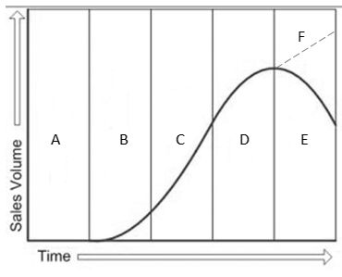**1.3.5 Marketing strategy**

1. Identify the stage of the product life cycle referred to in each of the comments.

|  |  |  |
| --- | --- | --- |
| Comment | Diagram reference | Name |
| Sales are likely to be low as the product is new to the market |  |  |
| An established product which is bringing in revenue |  |  |
| Heavy investment but no sales |  |  |
| The business changes an aspect of the product to try and sustain the level of sales |  |  |
| Likely to be characterised as a dog in the Boston Matrix |  |  |
| Revenue is increasing as the product gains popularity |  |  |

1. Match each term or statement to the correct box in the Boston Matrix.

|  |  |  |  |
| --- | --- | --- | --- |
| Market growth |  | Market share | |
|  | High | Low |
| High |  |  |
| Low |  |  |

1. Cash cow
2. This product may soon become obsolete
3. Revenue from this product may be used to support a problem child
4. Problem child
5. May become a rising star of the future
6. Probably an established product that has reached maturity
7. Rising star
8. An extension strategy may be used to maintain a product’s position
9. Dog
10. A business may invest heavily in promoting this product to help it grow