Name: ________________________________

**1.3.2 Branding and promotion**

Hidden in the grid below are:

* Three benefits of strong branding
* Three ways to build a brand
* Three changes in branding to reflect social trends

1. Find each term
2. Write each term in the table
3. Write a clue for each term

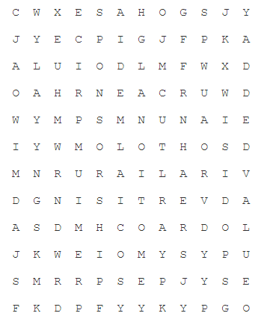

|  |  |  |
| --- | --- | --- |
| Benefits | Ways | Changes |
|  |  |  |
| Clue: | Clue: | Clue: |
|  |  |  |
| Clue: | Clue: | Clue: |
|  |  |  |
| Clue: | Clue: | Clue: |

