Name: ________________________________

**2.2.3 Break-even**

1. Answer the following questions based on the break-even chart for a new bike shop.

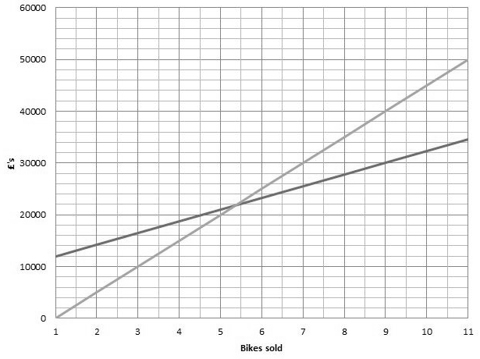

0 10 20 30 40 50 60 70 80 90 100 110

|  |  |
| --- | --- |
| What are the fixed costs? |  |
| What are the variable costs per bike? |  |
| What is the break-even level of bikes sold? |  |
| What is the price per bike? |  |
| What is the contribution per bike? |  |
| What is the profit or loss if 25 bikes are sold? |  |
| What is the profit or loss if 90 bikes are sold? |  |
| What is the margin of safety if 100 bikes are sold? |  |