Name: ________________________________

**31. Economic influences 1 - Inflation Mark: /12**

1. In April 2015 the rate of inflation in the UK, as measured by CPI, was -0.1%. In May 2015 it rose to 0.1% in May. What was the change in the rate of inflation? /2 marks

__________________________________________________________________________________________________________________________________________________________

1. In April 2015 inflation figures showed that food costs were 3% down on April 2014 and transport costs 2.8% lower than 12 months previously. If in April 2014 an average basket of food shopping cost £30, what could we expect it to have cost in April 2015? /2 marks

____________________________________________________________________________________________________________________________________________________________________________________________________________­­­­­­­­­­­­­­­­­­­­­­­­­­­­­­­­­___________________________

1. In June 2014, the ONS estimated that the average salary in the UK was £27,271, and was an increase of 0.6% on June 2013. Calculate the average salary in the UK in 2013.

/2 marks

____________________________________________________________________________________________________________________________________________________________________________________________________________­­­­­­­­­­­­­­­­­­­­­­­­­­­­­­­­­___________________________

1. The chart below (source: ONS) shows contributions to inflation figures by sector.

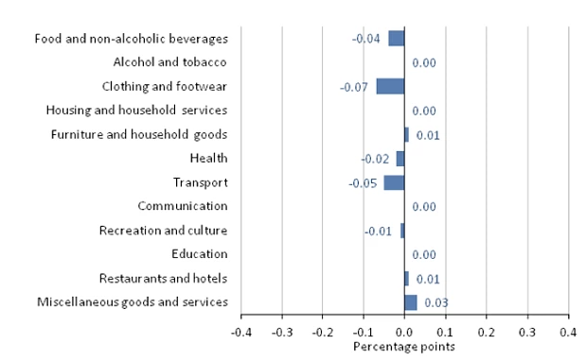

1. Which three sectors had the main downward effect on inflation? /3 marks

______________________________________________________________________________________________________________________________________________________________________________________________________________________________

1. What is the average contribution of these three sectors? /3 marks

______________________________________________________________________________________________________________________________________________________________________________________________________________________________

Explain one benefit to a business of low rates of inflation.