Name: ________________________________

**33. Economic influences 1 – Taxation and subsidies Mark: /18**

1. The diagram below shows the demand and supply curves and the equilibrium both before and after an indirect tax is applied to a good.

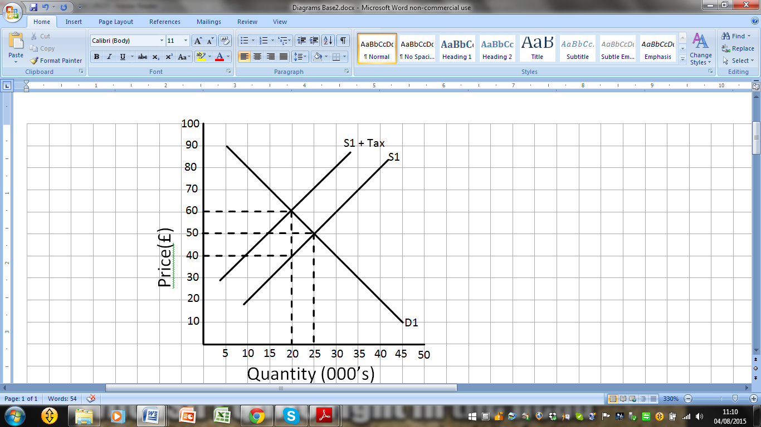

1. Calculate total revenue at the original equilibrium of D1S1. /3 marks

______________________________________________________________________________________________________________________________________________________________________________________________________________________________

1. Calculate the new total revenue after the tax has been applied. /3 marks

______________________________________________________________________________________________________________________________________________________________________________________________________________________________

1. Calculate the percentage change in total revenue after the tax has been applied. /3 marks

______________________________________________________________________________________________________________________________________________________________________________________________________________________________

2. Draw a supply and demand curve to show what would happen if the government added a subsidy to a good. /9 marks

State one type of good a government might tax and one it might subsidise.