**29. Stock Control Mark: /12**

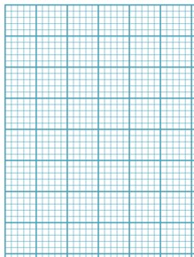

Weeks

7000

6000

5000

4000

3000

2000

1000

0

Stock

Re-order level

0 1 2 3 4 5 6

1. What is the buffer stock level? /2 marks

**1000 units**

1. What is the lead time? /2 marks

**1 week**

1. What is the maximum stock holding? /2 marks

**7000 units**

1. What is the re-order quantity? /2 marks

**6000 units**

1. What is the average level of stock? /2 marks

**4000 units**

1. If stock ordered in week 1 was not delivered until week 4 after how long would the business have run out of stock? /2 marks

**1 2/5 weeks** or 1 week and 2 days (assuming operate 5 days a week)