**31. Economic influences 1 - Inflation Mark: /12**

1. In April 2015 the rate of inflation in the UK, as measured by CPI, was -0.1%. In May 2015 it rose to 0.1% in May. What was the change in the rate of inflation? /2 marks

-0.1 to + 0.1 = **+0.2**

1. In April 2015 inflation figures showed that food costs were 3% down on April 2014 and transport costs 2.8% lower than 12 months previously. If in April 2014 an average basket of food shopping cost £30, what could we expect it to have cost in April 2015? /2 marks

£30 x 0.97 = **£29.10**

1. In June 2014, the ONS estimated that the average salary in the UK was £27,271, and was an increase of 0.6% on June 2013. Calculate the average salary in the UK in 2013.

£27,271 x 100 = **£27,108**

100.6

1. The chart below (source: ONS) shows contributions to inflation figures by sector.

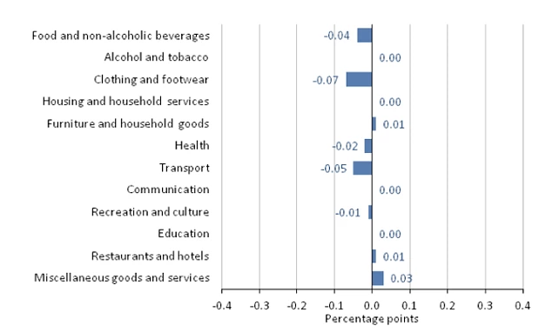

1. Which three sectors had the main downward effect on inflation? /3 marks

**Clothing and footwear**

**Transport**

**Food and non-alcoholic beverages**

1. What is the average contribution of these three sectors? /3 marks

-0.7 + -0.5 + -0.4/3 =

**-0.53**