**33. Economic influences 1 – Taxation and subsidies Mark: /18**

1. The diagram below shows the demand and supply curves and the equilibrium both before and after an indirect tax is applied to a good.

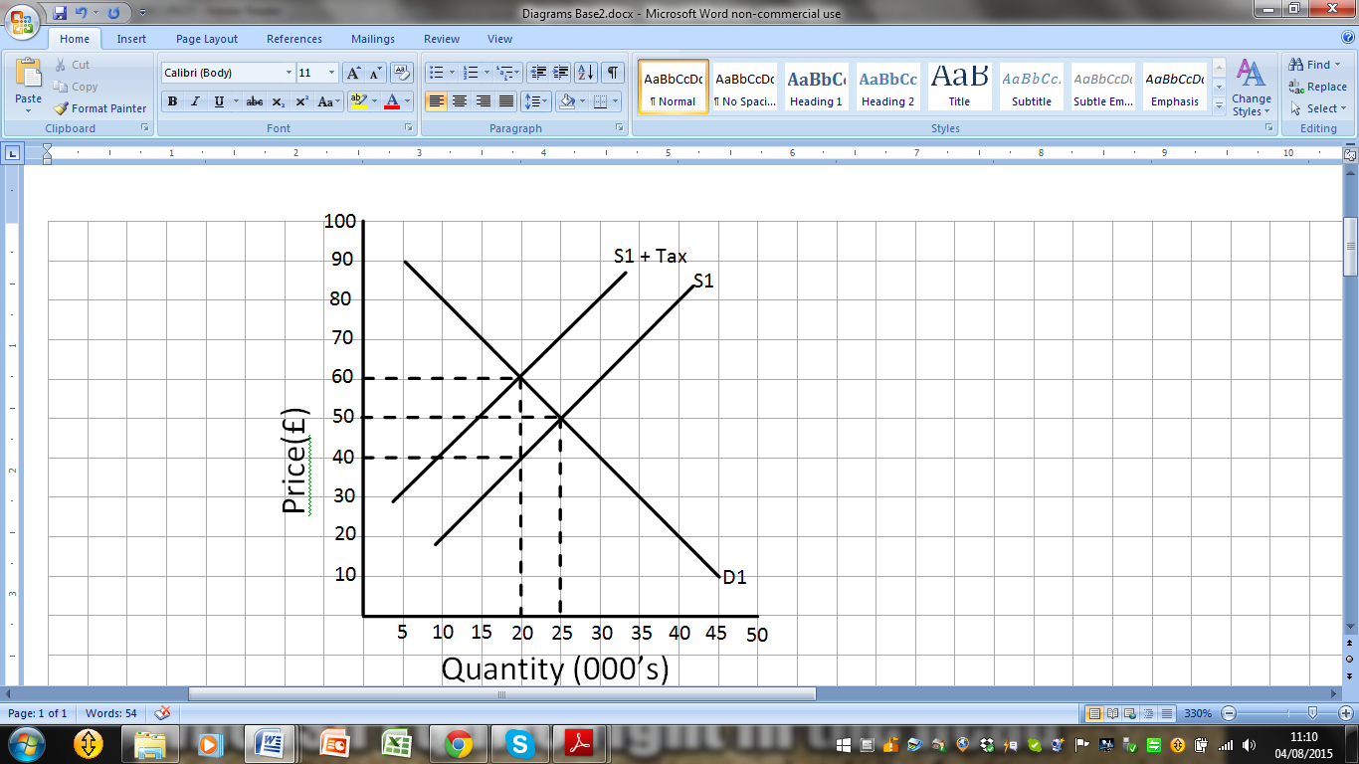

1. Calculate total revenue at the original equilibrium of D1S1. /3 marks

£50 x 25 000 = **£1,250,000**

1. Calculate the new total revenue after the tax has been applied. /3 marks

£60 x 20 000 = **£1,200,000**

1. Calculate the percentage change in total revenue after the tax has been applied. /3 marks

Percentage Change = (£1 200 000 - £1 250 000) x 100 = **4% decrease in revenue**

£1 250 000

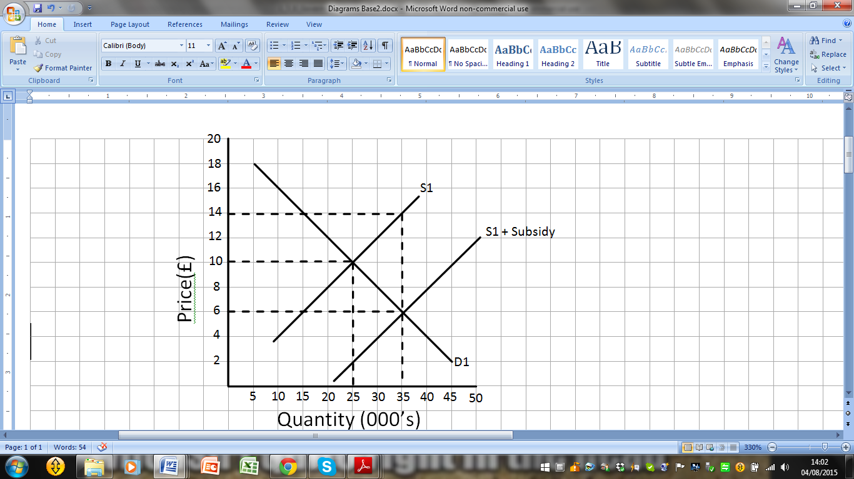2. Draw a supply and demand curve to show what would happen if the government added a subsidy to a good.

/9 marks