**[IN THE NEWS](http://www.tutor2u.net/)**

**It's All Going Pear-Shaped for GoPro**



[**Jim Riley**](http://www.tutor2u.net/business/blog/its-all-going-pear-shaped-for-gopro#bio)

16th January 2016

If you are a GoPro shareholder, don't look down. The share price graph below looks terrible as GoPro struggles to grow in an increasingly competitive market.

Mrs tutor2u got a GoPro for Christmas, but it seems even our custom wasn't enough to rescue a poor sales performance in the last quarter of 2015.

The [BBC reports here on the latest sharp drop in GoPro's share price](http://www.bbc.co.uk/news/business-35308870) as the markets take stock of revenue forecasts that are well below analyst expectations.

GoPro is facing increasing competition from new entrants into the action camera segment. Notable Xiaomi - which has already proved a strong competitor to Apple and Samsung in the smartphone market - who launched their first action camera in early 2015.

The result of increased competition is that GoPro has been forced to reduce selling prices. it is no longer able to adopt a premium pricing strategy which was so successful when GoPro appealed to the early adopters.

Not only is GoPro's revenue growth slowing. It is also cutting a substantial number of employees in order to reduce operating costs.

Looking at the share price graph below for 2015, it is clear that shareholders who were investors by the middle of last year have suffered significant losses as GoPro's market capitalisation has collapsed. It looks like a 60% fall in business value since then.

The question is what kind of strategy might be enough to turn the tide. Once stock markets lose faith in growth stocks like GoPro, they rarely recover.

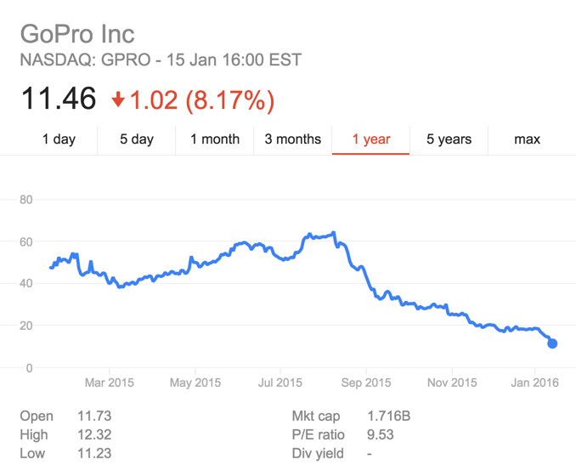

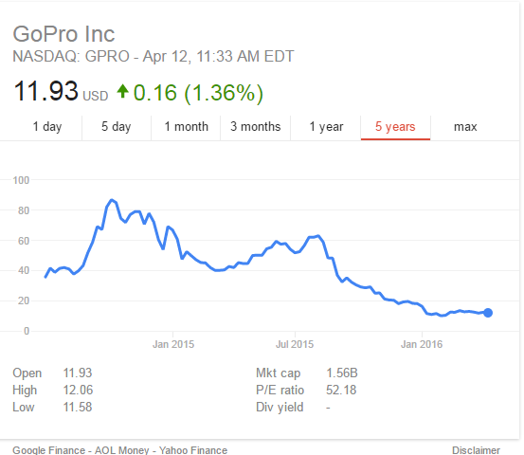

This useful infographic from the excellent Statista website illustrates ow GoPro's revenues have climbed in recent years.

However, when the percentage growth is calculated (the dark line whose data is scaled on the right-hand axis), the sharp fall in revenue growth becomes clear.

