**Tesco customers are going bananas over price hike**

By Simon Read Personal finance reporter[Share this with Facebook](https://www.bbc.co.uk/news/business-45419805)

* [Share this with Messenger](https://www.bbc.co.uk/news/business-45419805)
* [Share this with Twitter](https://www.bbc.co.uk/news/business-45419805)
* [Share this with Email](mailto:?subject=Shared%20from%20BBC%20News&body=https%3A%2F%2Fwww.bbc.co.uk%2Fnews%2Fbusiness-45419805)
* [Share this with Facebook](https://www.bbc.co.uk/news/business-45419805)
* [Share this with WhatsApp](https://www.bbc.co.uk/news/business-45419805)
* [Share this with Messenger](fb-messenger://share/?app_id=58567469885&redirect_uri=https%3A%2F%2Fwww.bbc.co.uk%2Fnews%2Fbusiness-45419805&link=https%3A%2F%2Fwww.bbc.co.uk%2Fnews%2Fbusiness-45419805%3FCMP%3Dshare_btn_me)
* [Share this with Twitter](https://www.bbc.co.uk/news/business-45419805) 
  + [LinkedIn](https://www.bbc.co.uk/news/business-45419805)

[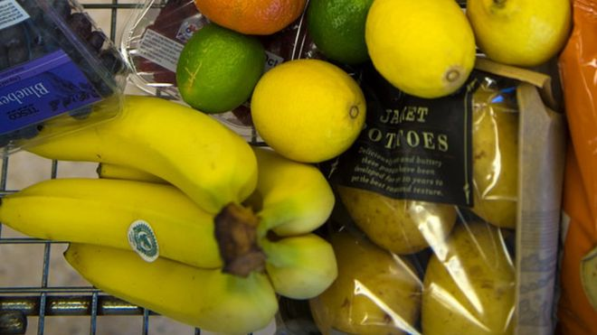Share this with LinkedIn](https://www.bbc.co.uk/news/business-45419805)

Copy this link

<https://www.bbc.co.uk/news/business-45419805>

[Read more about sharing.](https://www.bbc.co.uk/faqs/questions/bbc_online/sharing)

These are external links and will open in a new window

Close share panel

Image copyright Tesco

**Supermarket chain Tesco has angered shoppers in its inner-city stores by hiking the cost of individual bananas.**

The retailer has stopped charging by weight and is instead charging by single banana, meaning the cost of each yellow fruit has more than doubled at its Tesco Metro and Express stores.

The price rise, from around 10p-15p to 25p, has led to a flood of angry complaints on social media.

The grocer blames the increase on "more expensive" leases.

[**The move, first reported in the Mirror**](https://www.mirror.co.uk/news/uk-news/tesco-changed-way-price-loose-13189790), means customers were paying 76p per kilogram at Tesco Metro stores, which worked out to about 10-15p per banana depending on the size. The new 25p price means some bananas cost more than twice as much now.

Customers have been paying a higher price for single bananas in Express stores for some time. Charging per banana rather than by weight has only just been introduced to Tesco Metro stores, to bring them in line with Express stores.

A Tesco spokesperson said: "Due to the higher costs involved in operating our Express and Metro stores there is a small premium on a number of products.

"Our convenience stores are in prime, central locations where leases are more expensive in comparison to out of town Extras and Superstores."

It said it has no plans to roll-out the price change to larger stores.

The supermarket has almost 3,500 stores in the UK of which around 2,700 are convenience stores, including 1,749 Express shops, 776 One-Stop, and 172 Metro stores.

The change in pricing took effect last week and one Twitter user noticed right away that the new 25p price was a considerable premium on the 14p the store charges online.

<https://www.bbc.co.uk/news/business-45419805>