35. Quantitative sales forecasting - limitations
1. Missing words
Since 1945 there have been a number of recessions. Forecasts by a consensus of economists have successfully predicted ______________ of these. If economists can’t predict the economy, how can businesses be expected to do so? The answer, generally, is to accept that ____________________ factors such as economic growth can’t be accounted for. But that shouldn’t stop forecasts being made.
For an existing product, the start is to work out the existing trend by using a moving __________________. Then future sales can be extrapolated forward. With a brand new product, the starting point is market ___________________. Both methods have limitations. Extrapolation works on the assumption that the _____________________ will be like the past. But it often isn’t. And market research results are subject to biased or inadequate sampling and question-setting. Missing words: future, average, sales, none, research, external
2. Methods for analysing trends
Sales figures and forecasts for XT Ltd.
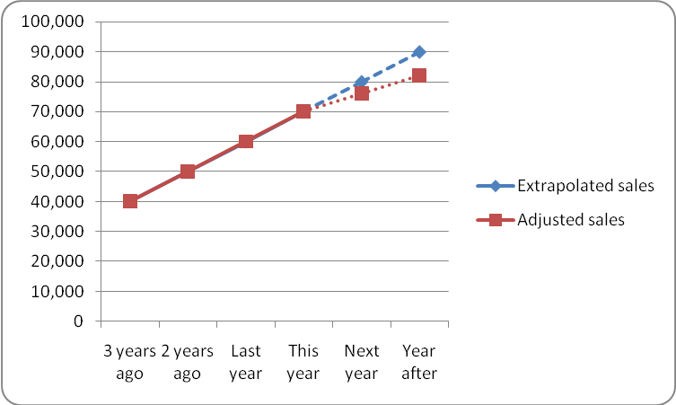
2.1 Identify two possible factors that would make XT Ltd’s management decide on the more cautious sales forecast shown in the ‘adjusted sales’ line.
______________________________________________________________________________________
______________________________________________________________________________________
2.2 Why might it be harder to forecast sales accurately for 2 years’ time than one year’s time?
______________________________________________________________________________________
______________________________________________________________________________________
3. Match two effects to each cause. Write the letters in the Ans column.
Cause | Ans | Effect | Effect
3.1 Trend figures for Easter Egg sales are boosted by cool weather one year |  | a) The business is forced to cut back on staffing levels | e) Production capacity proves too low to cope with demand
3.2 One year on, actual sales prove a lot higher than the extrapolated trend |  | b) H.R. policy focuses on flexible, not full-time, staff | f) The year after, the business is left with unsold stock
3.3 Two years on, actual sales prove much lower than the extrapolated trend |  | c) Uncertainty forces the firm to keep high cash balances | g) Lack of capacity means market share is lost to rivals
3.4 The past pattern of sales is too erratic to give a clue to future trends |  | d) The following year’s production level is set too high | h) Under-utilisation of capacity hits profit margins badly

35. ANSWERS: Quantitative sales forecasting - limitations

1. none … external … average … research … future

2.1
i) Knowledge that a new, strong competitor is arriving from America
ii) Knowledge that new legislation is likely to soften the demand for your product
2.2 Harder because the further ahead you’re forecasting, the greater the likelihood that an unexpected factor will cause sales to be different from the expected level. In 2013 Samsung seemed to be matching Apple in smartphones; they would have expected buoyant sales in 2014 and 2015. In fact 2014 was a bit disappointing and 2015 very much more so

3.1 d) f)
3.2 e) g)
3.3 a) h)
3.4 b) c)

