Aim, Objectives and Mission Statements

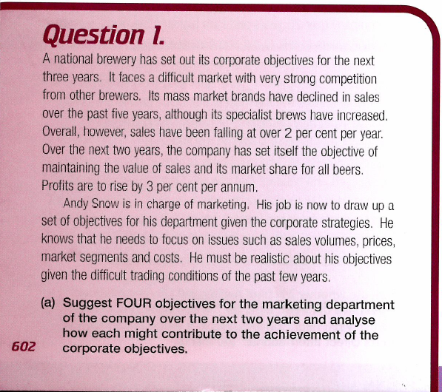

____________________________________________________________________________________________________________________________________________________________________________________________________________________________________________________________________________________________________________________________________________________________________________________________________________________________________________________________________________________________________________________________________________________________________________________________________________________________________________________________________________________________________________________________________________________________________________________________________________________________________________________

______________________________________________________________________________________________________________________________________________________________________________________________________________________________________________________________________________________________________________________________________________________________________________________________________________________________________________________________________________________________________________________________________________________________________________________________

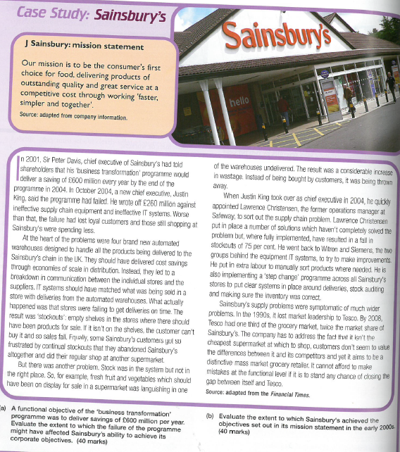

Evaluate the extent to which Sainsbury’s achieved the objectives set out in its mission statement in the early 2000s. [20 marks]