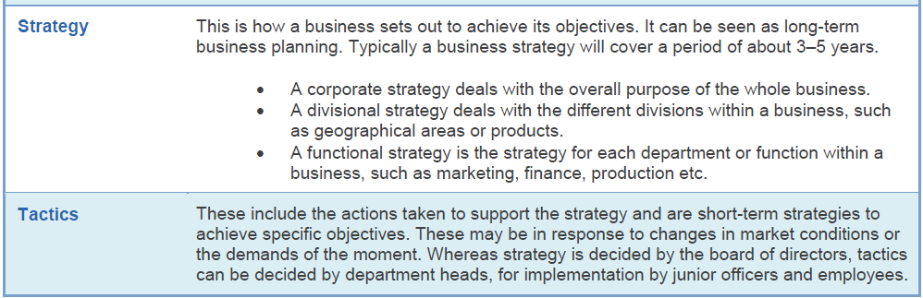STRATEGY AND IMPLEMENTATION KEY TERMS

