**Right and Left Wing - What Does it Mean?**

People are always going on about **left wing** and **right wing** - but what does it mean? Well it basically means what people believe a country should do for its citizens.

**Left wing beliefs** are usually progressive in nature, they look to the future, aim to support those who cannot support themselves, are idealist and believe in equality. People who are left wing believe in taxation to redistribute opportunity and wealth - things like a national health service, and job seeker’s allowance are fundamentally left wing ideas. They believe in equality over the freedom to fail.

**In the UK** the main left wing parties are the Labour Party and the Green Party. They believe in making laws that protect women, ethnic minorities, and gay people against discrimination. They believe that we should tax rich people more to support people less well off, and they believe we should regulate big businesses so they serve people’s interests. They believe that a good welfare system means people are healthier, more able to work, and will put more back into the economy. They also typically believe country-wide tax-funded action on climate change is necessary.

**Right wing beliefs** value tradition, they are about equity, survival of the fittest, and they believe in economic freedom. They typically believe that business shouldn’t be regulated, and that we should all look after ourselves. Right wing people tend believe they shouldn’t have to pay for someone else’s education or health service. They believe in freedom to succeed over equality.

**In the UK** the main right wing parties are the Conservative (or Tory) Party, and UKIP (who focus on the UK not being a part of the European Union). They believe that if you have more money, you should get to keep it, and buy better education and health services for yourself. They believe that businesses should be less regulated, and that the more money they earn, they’ll bring more benefits to the country. In 2008 [2/3 of Tory MPs](http://www.guardian.co.uk/environment/2008/jul/16/climatechange.greenpolitics) didn’t think climate change was a priority, but their leadership says it’s important. They are more likely to focus on energy security (oil and gas are set to run out very soon, and they won’t want to rely on other countries). 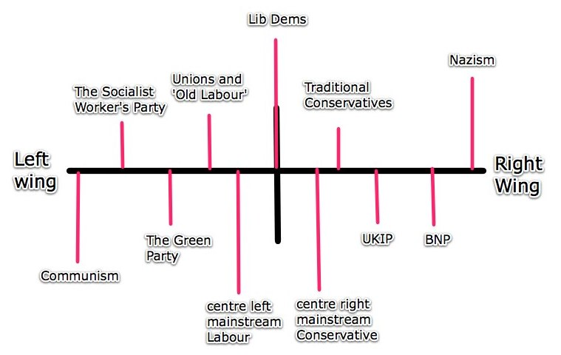

Extreme versions of either have caused the deaths of many.

**The Liberal Democrats** (Lib Dems) are another major party in the UK but people often argue about where they fall, politically. They have some traditionally left wing ideas, and some right wing ones as well, for simplicity I have put them in the middle of this diagram.

There is a slightly more realistic way to look at it which involves 4 wings, one for economic beliefs, and one for social ones - this one places the Lib Dems more realistically - if you want to know more (and to take a test to find out where you are on the scales!) check out the[**Political Compass**](http://www.politicalcompass.org/analysis2)**.**

