The European Union

a) Explain the nature and purpose of the EU?

b) Explain the purpose of the single market?

c) What are the main features of the single market?

d) What are the advantages of the single market for **businesses**?

1.

2.

3.

4.

5.

6.

e) What are the advantages of the single market for **consumers** and **workers**?

1.

2.

3.

4.

5.

6.

f) Explain the reasons why the single market is not yet complete?

g) Explain three **positive** implications of the EU for UK business.

h) Explain three **negative** implications of the EU for UK business.

i) Which UK industries have benefited the **most** from being part of the single market and why?

j) Which UK industries have benefited the **least** from being part of the single market and why?

k) What is the single European currency and how does it benefit EU businesses?

l) What are the drawbacks of the single European currency?

m) What are the drawbacks to UK businesses who trade in the EU of not adopting the single currency?

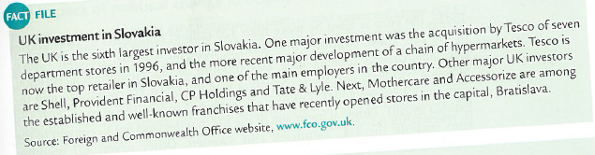

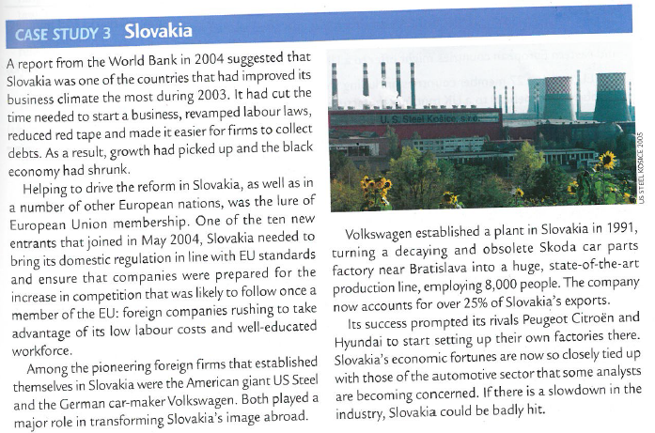

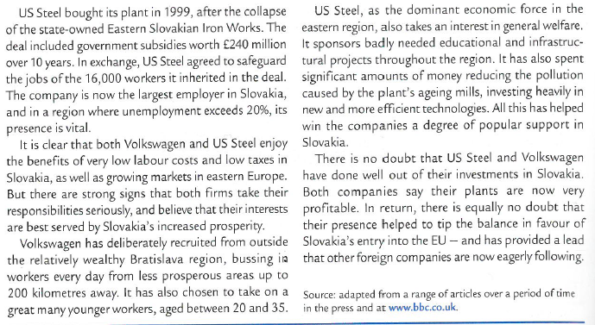

*The EU now has 28 member countries, including Slovakia. To what extent is this enlarged membership beneficial to a UK motor manufacturer that sells its products in the UK, in Europe and to the rest of the world?*