**What is in the government’s controversial new immigration plan?**

Threshold of 70 points need to apply for visa under new rules

* [Chiara Giordano](https://www.independent.co.uk/author/chiara-giordano)
* Wednesday 19 February 2020 16:11

The government has revealed a new points-based [immigration](https://www.independent.co.uk/topic/Immigration) plan which will come into force on 1 January next year.

Under the post-[Brexit](https://www.independent.co.uk/topic/brexit) rules, free movement will be replaced by a minimum salary threshold of £25,600 for most workers – lower than the £30,000 proposed under Theresa May’s premiership.

It is hoped the “firm but fair” system will attract “high-skilled workers” to create a “high wage, high skill, high productivity” economy.

Download the new Independent Premium app

Sharing the full story, not just the headlines

[Download now](https://independent.onelink.me/wgiA/a1620fe)

The Tories have vowed to prioritise people based on their skills rather than where they come from, adding: “For too long, distorted by European free movement rights, the immigration system has been failing to meet the needs of the British people.”

Migrants will be charged about £1,200 for a work visa, or £900 in a shortage occupation – the same fee as paid by non-EU migrants currently.

*So what exactly is in the government’s controversial new immigration plan?*

**How many points do I need?**

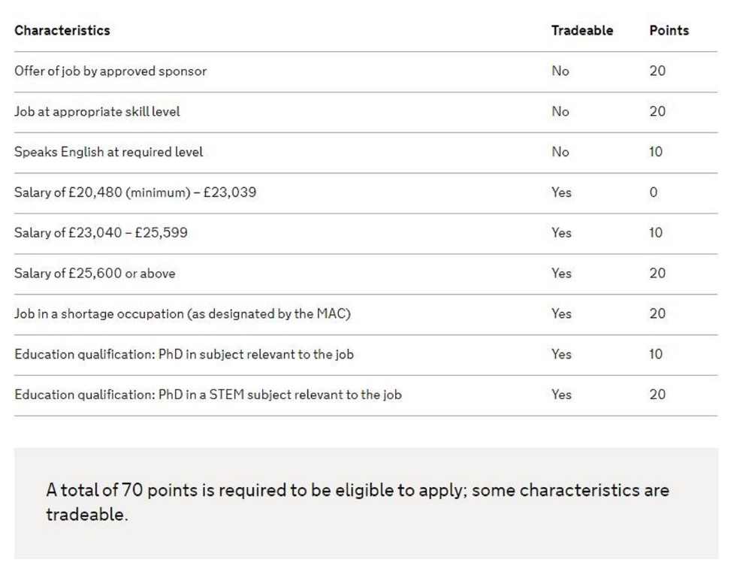All applicants – both EU and non-[EU citizens](https://www.independent.co.uk/topic/eu-citizens) – who want to live and work in the UK will need to gain 70 points to be eligible to apply for a visa.

Points will be awarded for key requirements and they must meet three criteria, which total 50 points.

* Have a job offer from an approved sponsor, such as an employer cleared by the Home Office (20 points).
* Have a job offer that is at a “required skill level” (20 points).
* They can speak English to B1 level, enabling someone to, for example, open a bank account, or cope with “most situations” at home, work or leisure. (10 points).

Those wishing to live and work in the UK from 1 January, 2021, will have to reach a threshold of 70 points under the government's new points-based immigration system. (Home Office)

**How do I earn extra points?**

Those who meet the first three conditions can then earn extra points to reach the threshold of 70 points by having:

* Salary between £23,040 – £25,599 (10 points)
* Salary of £25,600 or above (20 points).
* Job in an occupation where there are staff shortages, designated by the Migration Advisory Committee, such as the NHS, vets, architects (20 points).
* PhD in subject relevant to the job (10 points).
* PhD in a STEM (science, technology, engineering, maths) subject relevant to the job (20 points).

**What about low-skilled workers?**

There will be no temporary or general visa options for low-skilled migrant workers, other than seasonal workers.

The government has argued there are already huge numbers of EU citizens and 170,000 recently-arrived non-EU citizens for such jobs.

However, a pilot scheme for seasonal workers in agriculture will be quadrupled from 2,500 to 10,000 places.

**What qualifications do I need?**

The government has lowered the skill level required to count as “skilled” from graduate level to A-level.

**What about students?**

Students must be able “to support themselves” but will be able to stay on in the UK and work for two years after graduation.

They will need to demonstrate:

* They have an offer from an approved educational institution.
* Can speak English.
* Can support themselves during their studies in the UK.

Specialist occupations:

* Current arrangements for specialist occupations such as religious ministers, artists, musicians and entertainers are expected to broadly remain the same and be extended for EU citizens.

**What if I’m self-employed?**

Self-employed and freelance workers can continue to apply for visas under existing rules and will not need to be sponsored.

**Do I need a visa to visit?**

Visitors, including EU citizens, will be able to come to the UK without a visa for six months but will not be allowed to work.

**What about asylum seekers?**

Asylum applications fall outside the points-based system and are expected to operate under existing rules.

**What if I'm not sponsored?**

There will also be an “unsponsored” visa option where points will also be awarded for factors such as academic qualifications, age and relevant work experience for a small number of highly-skilled workers without a job offer. The route would be capped to begin with.

<https://www.independent.co.uk/news/uk/politics/brexit-new-immigration-rules-explained-eu-citizens-work-points-system-a9344061.html>