# Homework 2 Object-oriented design principles

1. An incomplete class diagram for a system which holds and processes details of vehicles registered in the UK is shown below.

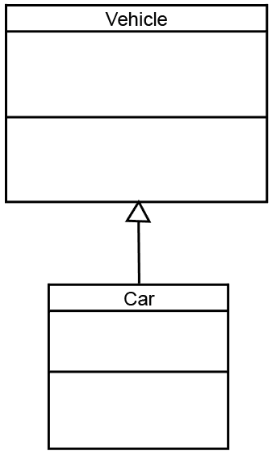

(a) Show on the diagram where the classes Lorry and Motorbike should be added. [2]

(b) State the reason you positioned them as you did. [1]

(c) The registration numbers need to be stored.

State which class should store the registration numbers and give a reason for   
your answer. [2]

(d) Explain the term polymorphism, and give an example of how it could be   
used in the above example. [3]

2. **Composition** and **aggregation** are both “has a” relationships.

(a) Explain the difference between them. [2]

(b) For each of the pairs of classes below, state whether the relationship is **composition** or **aggregation** and draw diagrams to show the relationship.

(i) Team and Player [3]

(ii) Hotel and Room [3]

3. A simple drawing program can draw two different shapes, **Rectangle** and **Circle**.

All **shape** objects have attributes **lineColour** and **fillColour**, and methods **setLineColour()**, **setFillColour()** and **draw()**.

Rectangle objects have attributes **length** and **width**, and methods **getTopLeft()**,   
**getLength()**, **getWidth()**.

Circle objects have attribute **radius** and methods  **getCentre()**, **getRadius().**

The **draw()** method needs to be polymorphic.

Draw a class diagram showing public (+), private (-) and protected (#) attributes and   
methods for each class. [9]

[Total 25 marks]

**Practical exercises**

A class is to be defined that acts as a stack data structure. A class diagram is shown below.

(a) Write the code to declare NodeClass [4]

(b) Write the code to declare StackClass [12]



(c) Test your program code and screen capture your output. [4]

[Total 20 Marks]