## C1 PORTFOLIO

**NAME   
CANDIDATE NUMBER: 1111 CENTRE NUMBER: 64395 C1 PORTFOLIO YEAR**

# QUESTION 1

Outline your initial response to the key extract and practitioner and track how it developed throughout the devising process.

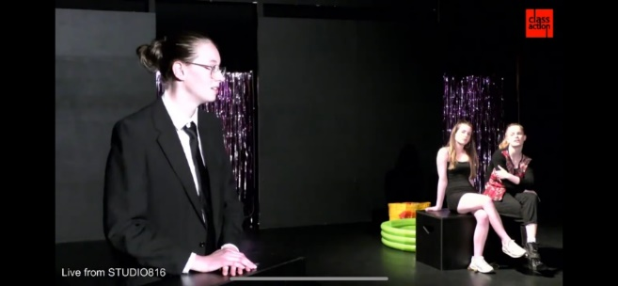Our chosen text was ‘Earthquakes in London[1]’ by Mike Bartlett[2] and our extract was drawn from the end of this work. Features, such as, the relevance of the theme of climate change[3] to contemporary society, the engaging stichomythic dialogue[4] structure, the use of Epic Theatre techniques, and the use of naturalistically drawn characters, drew me to this play. We chose our key extract, in Act 4 pages 138-147, the climax of the play. The extract combined all the action from the previous acts and introduced the new character of Emily, Freya’s unborn child, adding an interesting new dynamic which was developed through the process after studying the speeches of Greta Thunberg. The extract is different to the rest of the text as it does not present the multi-form narrative and includes the denouement[5] of the text. Initially we used the central theme of climate change from our extract and brainstormed ideas surrounding it. We moved through ideas such as a crime scene where the earth had been murdered, carrying scuba gear in preparation for a flood, or having the audience sitting amongst piles of rubbish. We liked the idea of the Earth being murdered; and therefore, crafted the idea of attending a funeral for Mother Earth, Gaia.[6] We really liked that the 3 sisters in Earthquakes in London were all facing the same issue but had individual, specific responses to it and so as part of our refining we created 3 clear characters, one who was aware of the Earth’s decay and was trying to change it, one who was aware of the issue but ignored it and one who was oblivious to the Earth’s decay. Our simple aim was to display different societal responses to climate change.

Our guiding practitioner was Frantic Assembly[7], whose methodologies could be manipulated to suit the epic, chaotic, physical response we were looking for in response to this extract. Primary research led me to live performance work (online, as live) ‘Things I Know To Be True[8]’ and ‘LoveSong[9]’ and live work ‘I Think We Are Alone’. I loved the way Frantic integrated physical theatre with a naturalistic acting style and full character development, and the use of physical 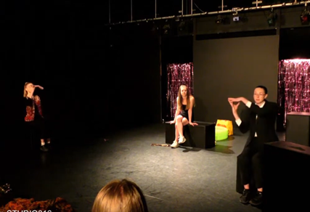theatre to reveal emotions and subtext that weren’t explored linguistically. Practice as research into Frantic’s Building Blocks[10], such as Hymn Hands, Chair Duets, and Ooze demonstrated how simple yet affective the methodologies were, and how they could lend themselves to devising, playing with physicality and form. We chose Frantic Assembly as their recent work has naturalistic characters at its heart and with physical elements added to develop hidden truths. As we refined our work, we built from naturalistic dialogue adding physical theatre methodologies such as Hymn Hands to create a movement section to sign synchronicity reflecting the global effect of the world’s death. Continuing with the theme of a funeral, we used Frantic Assembly’s ‘Things I Know To Be True’ to develop physical ideas for our funeral from the end of the play when the family are preparing to attend their mother’s ceremony. Our intention was to create a funeral for the Earth that was authentic, and strongly reflected the funeral of a beloved family member.

# QUESTION 2

Connect your research materials to key stages in the development process and to performance outcomes.

After reading our extract and the rest of the full-text, the initial research I conducted was on environmental change in response to Bartlett’s central theme.[11] It was this key theme that sparked my interest, and my research had relevance and provided me with the depth of knowledge I was hoping for. I looked at hazards to human health[12] and how humans damage the environment, and at all times I was then looking to see how individuals specifically had reacted to each fact/claim to utilise research in specific character-development.[13] As part of my primary researched I watched Greta Thunberg speeches and spoke to people who had watched them in person - as for me the character of Grace in ‘Earthquakes in London’ resembles Greta. At the 2019 climate action summit[14], Greta expressed her anger about world leaders ignoring the ever-growing issue of climate change. 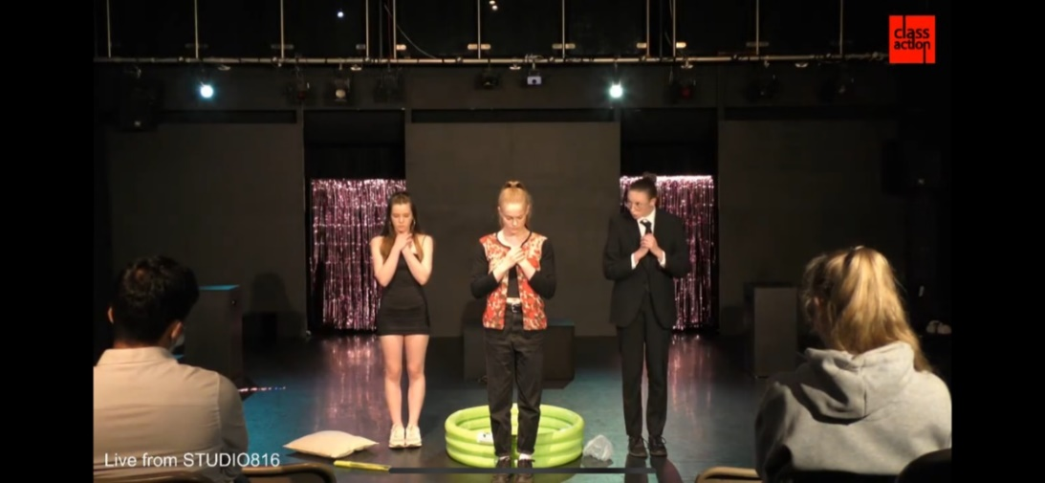This research helped me develop an in depth understanding of environmental change/impact. I then employed a technique used by Frantic, where they send out a questionnaire about a theme to gather verbatim responses. I created a questionnaire,[15] and then as part of practice as research used the responses to write a monologue about societies opinions surrounding climate change.

Our group decided to explore the theme of individual responsibility specifically developing from Freya’s storyline about the power of the individual effecting change. In response to this, Jen researched social manipulation[16] especially regarding the media and attempts to manipulate the individual response. This developed into a theme of ignorance due to fake news in the media.[17] These findings gradually focused on the character of Issa. I then researched political ignorance[18] regarding the Black Lives Matter protests, the power of ignorance,[19] the pursuit of ignorance[20] and how to deal with ignorant people.[21] We didn’t want to make our piece too topical, as our target audience were young adults, and a factual piece wouldn’t catch their attention. As we refined ideas, we discussed the social side of ignorance. This led to a scene idea about the ignorance behind smoking. We then researched reasons people smoke,[22] [23] and collected verbatim material - which we turned into a scene about ignorance surrounding individual choices. It was important for us to have a foundation of strong characters who were developed from research and then fed by verbatim work to make them authentic and thus relatable to our target audience; we let the story grow around the 3 women and their specific personalities.

As we refined and amended, we brainstormed ideas around other themes in Earthquakes in London, and developed the idea of the death of the Earth. From this we researched the doomsday clock,[24] a symbol showing the likelihood of a man-made global catastrophe. The 2020 doomsday clock is at 100 seconds to midnight. This sparked a thought of centring our piece on the question “would you have any regrets if there were only 100 seconds left?” This led to the development of a scene set at a funeral. From this we researched the play Hymns by Chris O’Connell[25], performed by Frantic Assembly, which centres around 4 friends who reconnect at their friend’s funeral. The idea for Gaia being dead came from research into environmentalist James Lovelock and his ‘Gaia Theory’ who inspired Bartlett’s original ideas; the theory proposes that the earth functions as a self-regulating system. As we refined this idea we developed the idea of littering the stage to symbolise the system being put under strain by the actions of individuals.

# QUESTION 3

Evaluate how your chosen role/s emerged and developed from initial ideas through to the final performance

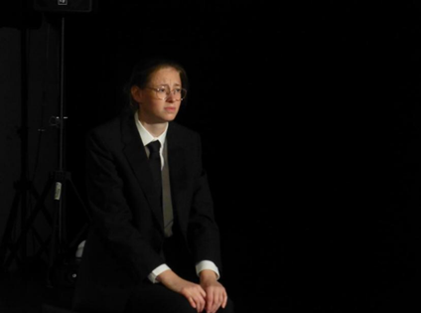We enjoyed the linking factor of the 3 sisters; they were all facing the same issue but in different ways and I think this was a strong initial decision that impacted the success of the piece. We decided to explore this within the framework of ‘time’ and discussed for example that Sarah represented the past as she was trying to make change but knows we’re past the point of no return. I interrogated the character of Emily as she reminded me of Thunberg[26] when convincing Freya to jump off Waterloo Bridge. My character Morgen developed from the characters Emily and Sarah. She is aware of everything that is going wrong and is consciously trying to make change; the character was vital to include in the mix as she successfully shared a lot of the exposition. She is also flavoured by Thunberg to connect with our target audience as they can easily identify with her age and hopefully recognise some of her speeches which are woven into my monologues. This was successful as a couple of audience members noticed the references to her famous speech at the UN climate summit[27].

Her function within our piece, is to keep the other characters in line and make sure Gaia’s[28] funeral goes to plan. We named her Morgen[29] as it means ‘tomorrow’ in Dutch; she is future focused. I found my character’s tension was held in her shoulders as she wants to look presentable and be perceived as organised/strong. I adopted a shadow gesture of fiddling with my hands to try and communicate that she’s still uncertain about her future. I then employed Stanislavski’s[30] actioning[31]. For her tribute, I used verbs such as to interrogate, and to warn which led to her speech being genuine and pained[32]. Feeback that I received conveyed that her speech came across as weighted and helped to show the drastic situation, suggesting that actioning 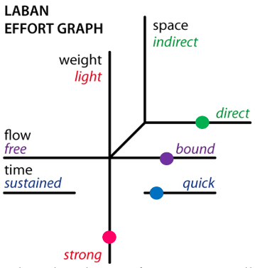was successful.

Furthermore, I researched Laban[33] and plotted a Laban effort graph[34] for my character. My graph highlights that she is has direct use of space and strong weight - strong gait, fast pace, and calculated movements. This reflects that she feels pressured to create the best possible funeral for Gaia. She also utilises quick movements to show the urgency of combatting climate change. I think this was successful because an audience member[35] commented on her movements in contrast to the other characters.

# QUESTION 4

Analyse how your contribution was influenced by the selected theatre practitioner and/or theatre makers, and the impact live theatre has had on your own practical work.

Frantic Assembly[36] was our selected practitioner and their methodologies were the inspiration for our piece. Their ethos focuses on collaboration, empowerment, and a constant desire to improve. We took this vision into our process as we wanted it to be a true collaborative process. Frantic title their exercises ‘Building Blocks; [37]’ and we explored through practice-as-research; Round-By-Through, Hymns Hands, and Lifts[38]. We undertook primary research into these techniques, and I investigated a company called DV8[39] [40] who inspired Frantic’s work early on. I researched DV8’s “Can We Talk About This[41]”, which was a politically motivated project of verbatim physical theatre. We used DV8’s work to inspire a physical moment, developed with Frantic’s Hymns Hands,[42] fusing text and physical work. This occurs as the characters are welcoming the attendees to the funeral, emphasising the moment, and adding choreographed formality to the speech using iconography to suit the funeral mise-en-scene. We also used Fanatic’s technique of listening to music in rehearsals which we found was effective in motivating us when we got stuck and added to the musicality of our delivery, influencing our cadences and pace; successfully demonstrated in our opening section and our shopping sequence. Furthermore, we used aspects of Round-By-Through[43] in our final scene as it physically involved everyone working in close proximity, reflecting that the World’s death affects everyone.

Frantic formed in 1994, a year that the Tory government led us into the 2nd recession in a decade, leaving 3 million citizens unemployed, sending the UK into an overriding mood of angst. This context saw the rise of In-Yer-Face theatre[44] genre, which aimed to shock audiences with extreme language and images and encouraged questioning moral and societal norms. Frantic responded to the 90’s political outrage, leading their work to both reflect and criticise the zeitgeist as our piece does with the climate crisis.

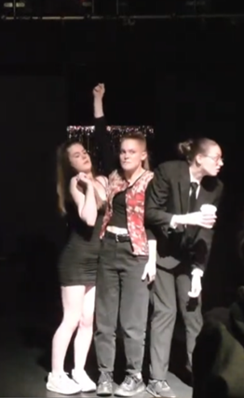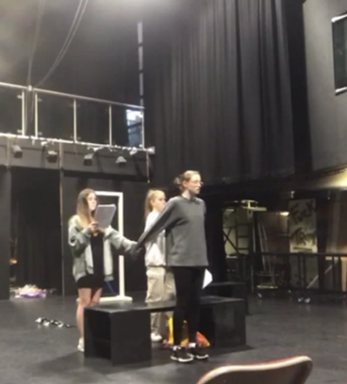I watched a live production of Frantic’s “Things I Know To Be True[45]” and I later revisited this production online when we started our process. From this primary research I was inspired by the subtle, yet effective, integration of physical theatre into an emotionally charged narrative supporting naturalistic character development. I used Frantic’s resource pack[46] to investigate their development process, allowing me to see how they combine their unique movement style, soundtrack, and design. One specific moment that influenced our piece was the sequence when the family prepare to attend their mother’s funeral. The characters all line up and hold hands facing in alternate directions, holding each other up. We used this as repeated physical leitmotif in our piece to emphasise plot points which evoked a struggle within the characters, for example at the end before they step off the barrier. We also took inspiration from ‘The Curious Incident of The Dog in The Night-Time’[47] as Frantic Assembly were the movement directors[48] for the production at the National. We see a scene in Curious Incident where Christopher is seen going through his morning routine. We liked this idea as it would add movement throughout Mae’s eulogy scene to ensure we kept the audience’s attention and visualised text. We changed it to Mae recalling some of her life events and used events and props that represented her neglect for the world. For example, single use plastic bottles and her hatred for public transport which ended littering the stage.

# QUESTION 5

Discuss how social, historical and cultural contexts impacted on your work.

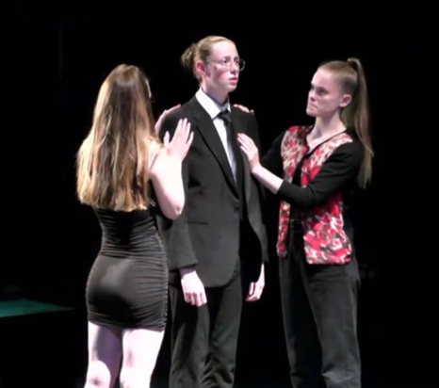Earthquakes in London, by Mike Bartlett, was first performed in 2010 – a year which witnessed Britain’s longest cold spell for almost 30 years[49], a devastating earthquake in Haiti[50] and other extreme weather.[51] These events lent themselves to Mike Bartlett perfectly when writing Earthquakes in London, a socially charged play about the lives of 3 sisters and their father. Bartlett captures the context of the time through the theme of climate change and the world in which the play exists reflects a heightened version of reality in 2010. The first performance was motivation for us to capture the urgency of climate issues without lecturing our audience[52], and to find the comedy within the heavy theme, something Bartlett does often in the original text and in subsequent work. Finding comedy was important to allow us to connect to our target audience of 16–25-year-olds, as it made the characters relatable and helped the audience feel relaxed. After its world premiere in August 2010, Earthquakes was described as a “fast and furious metropolitan crash of people, scenes and decades[53].” This perception of how quickly time moves informed the rapid pace of our piece leading to its frenzied atmosphere and our choice of episodic structure.

Socially, our piece was about the fact that it’s the job of young people, a movement pushed by young activist Greta Thunberg, to make positive change and slow/halt the world’s decay. We wanted to focus on young people as we are the generation whose future will suffer the most significant impact from these centuries of damage[54] and we are a generation to whom Thunberg has given a voice. Our aim for this piece was simply to bring the audience’s awareness, likewise to Bartlett’s, to the state of society dancing and drinking as fast as they can; a state of ignorance. And we examined the key question ‘would you have any regrets if you only had 100 seconds left to live?’ These verbatim responses were woven into the fabric of our piece. Society’s attitude about climate change is positively evolving which is important as young people are pushing for change. Our piece explores the relationship between the individual and their place in society as our three main characters are, exaggerated, representations of different people within society coming together to try and tackle a global issue. Morgen represents activists, Mae represents ignorant people and Issa represents people with a lack of knowledge. Our intention in offering these different sides to the conversation was to try to represent the whole of society rather than just one group of people within society to show that climate change affects everyone, and I believe we were successful in meeting this aim.

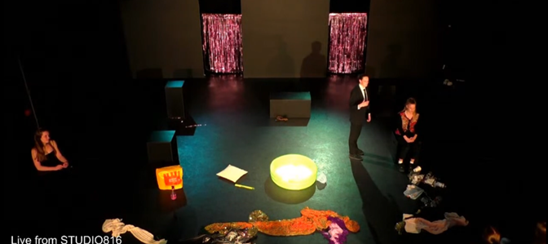Our chosen audience was the theatrically literate 16-25s, who we chose because of the impact of climate change on their generation. I think it’s important to present theatre to younger generations as it provokes self-reflection, which can be used to spark change. Our piece resembled work created by ‘Forced Entertainment[55]’ who create contemporary work that responds to current zeitgeists in an abstract surreal manner. They “seek to create confusion, silence, questions and laughter[56].” These components were reflected in our piece as we included physical comedy when having three people standing in the tiny pool, moments of silence within the funeral scenes and confusion through not explicitly revealing whose funeral it was. The visual aesthetic of the piece was also reminiscent of the chaos and mess created on stage in a Forced Entertainment show.

# QUESTION 6

Evaluate the creative choices you made and whether or not they were successful in performance.

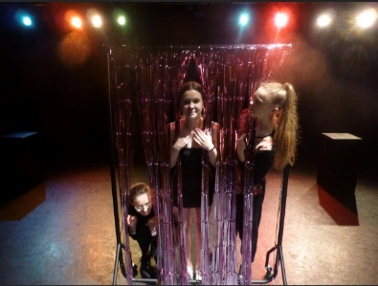The intention of our piece, similair to Bartlett’s[57], was to bring the audience’s awareness to the state of society ‘dancing and drinking as fast as they can[58][59].’ I think we effectively showed this in the shopping[60] scene. This scene had an incredibly fast pace, which showed the ignorance around the passing of time and represented society being swept up in their lives and not having time to stop and notice the reality of the climate crisis. I also think this scene helps to show that everybody is aware of climate change but if 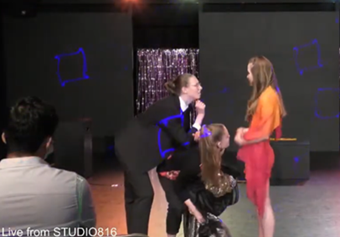they don’t feel it is directly affecting them, for example Mae and Issa, then they don’t care about it[61]. Within this scene, we used key-signifiers such as clothes and a Primark bag to signify the normalisation of fast fashion. To help engage the audience, on the line ‘Starbucks squirting tax avoidance on skinny vanilla latte’s,’ I squirted audience members with water. This was effective as it forced the audience to listen as we were relaying more factual dialogue in that moment[62] and in-tangible feedback[63] supports this. This moment was driven by the individual differences in the three characters and comedy[64] dispersed throughout helped us to avoid lecturing the audience.

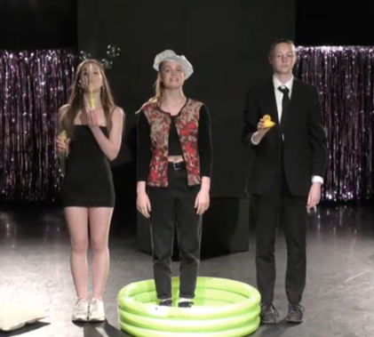In the moment following the eulogy from Jen’s character, Mae, we all stood bunched together in a tiny paddling pool. This moment utilised the performance skill of physical comedy, as 3 people standing in a very small space[65] is humorous. The successful comedic aspect helped to attract our audience's attention and kept them involved in the piece[66]. The paddling pool was not only aesthetically pleasing but was a visual representation of childhood. We hoped to use this symbology in two ways, one to comedically subvert the serious message, if we don’t act now then future generations will face drastic consequence, and two to say that if society are going to act like children and ignore global issues, we will treat them like children. Additionally, the use of this prop was influenced by Frantic Assembly’s work with prop manipulation[67] as we used it firstly as a pool, secondly as a bath, thirdly to visually represent how crowded the funeral was becoming and finally as the barrier that the characters would step off at the end of our piece.

Another successful key moment in our piece was the tribute by my character, Morgen. This speech followed a fast-paced scene about the failings of humanity due to the rise in technology and neglect for reality. The slower pace aided the authenticity of Morgen's plea for help and the use of verbatim-dialogue from Greta Thunberg’s[68] speech[69] further pushed the intention of bringing the audiences awareness to the state of society[70]. We made good use of direct address throughout our piece to 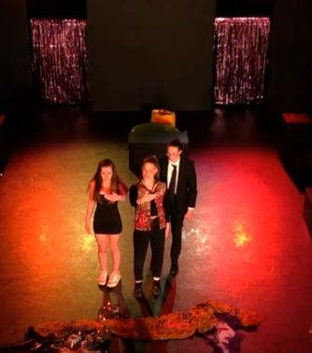immerse the audience into the piece, to confront them directly and to encourage the audience to make change, but here we also cleverly used juxtaposing cut-ins of comedic dialogue from the other two characters to provide light relief from the heavy topic of climate change. This interrupted dialogue was reflective of Bartlett's stichomythic writing style[71] in Earthquakes. But, I think if we only used direct address and attacked the audience it would be too harsh, and we would lose their attention as our piece would no longer be enjoyable to watch.

1. Earthquakes in London by Mike Bartlett (Publisher: Methuen Drama 02/08/2010) ISBN-10 1408132826
2. <https://en.wikipedia.org/wiki/Mike_Bartlett_(playwright)> (Date accessed 04/01/2021) Bartlett’s plays include King Charles III, Artefacts, Bull [which, in October 2013, won Bartlett the Best New Play at The National Theatre Award] and 13.
3. Research into climate change from Wikipedia (Date accessed: 05/01/21)

   <https://en.wikipedia.org/wiki/Environmental_change#:~:text=Environmental%20change%20is%20a%20change,human%20interferences%2C%20or%20animal%20interaction>.
4. Definition of stichomythic dialogue: From the Collins Dictionary <https://www.collinsdictionary.com/dictionary/english/stichomythia>

   Stichomythia: a form of dialogue originating in Greek drama in which single lines are uttered by alternate speakers.
5. Definition of denouement: From the Dictionary

   Denouement: the final part of a play, movie, or narrative in which the strands of the plot are drawn together and matters are explained or resolved.
6. Research into the Gaia hypothesis from Harvard University (Date accessed 25/01/2021)

   <https://courses.seas.harvard.edu/climate/eli/Courses/EPS281r/Sources/Gaia/Gaia-hypothesis-wikipedia.pdf>
7. Research into Frantic Assembly (Date Accessed 29/01/2021)

   <https://www.franticassembly.co.uk/about>

   ‘It is about the ethos of collaboration, of empowerment, of that constant desire to improve. It is about telling stories in a voice we don’t always hear.’
8. Things I Know To Be True by Andrew Bovell (Publisher: Nick Hern Books 08/09/2016) IBSN 1848425767

   First performed in 2016, directed by Scott Graham (co-founder and artistic director of Frantic Assembly) and Geordie Brookman.
9. LoveSong by Abi Morgan (Publisher: Oberon Books 30/09/2011) ISBN-10 1849431612

   First performed in 2011, directed by Scott Graham and Steven Hoggett (founder member of Frantic Assembly)
10. Research on The Frantic Method

    <https://www.franticassembly.co.uk/the-frantic-method> (Date accessed 02/02/2021)
11. From Wikipedia (Date accessed: 05/01/21)

    <https://en.wikipedia.org/wiki/Environmental_change#:~:text=Environmental%20change%20is%20a%20change,human%20interferences%2C%20or%20animal%20interaction>.
12. From World Health Organisation (Date accessed: 05/01/21)

    <https://www.who.int/globalchange/environment/en/>
13. From Wikipedia (Date accessed: 05/01/21)

    <https://en.wikipedia.org/wiki/Human_impact_on_the_environment>
14. From npr (Date accessed: 05/01/21)

    <https://www.npr.org/2019/09/23/763452863/transcript-greta-thunbergs-speech-at-the-u-n-climate-action-summit?t=1609878721330>
15. Questionnaire questions:

    1. How concerned are you about the current environmental state of the planet?
    2. Have you changed your life in anyway to be more sustainable or environmentally friendly?
    3. If you had the opportunity to go to a climate strike/protest would you go? And why?

   
16. From YouTube: 10 PRINCIPLES OF SOCIAL MANIPULATION THEORY by Noam Chomsky.

    <https://www.youtube.com/watch?v=laBNZkQrlLU>
17. From Penn State (Date accessed 20/01/21)

    <https://sites.psu.edu/aspsy/2016/03/19/the-ignorance-of-social-media/>
18. From Vox (Date accessed 20/01/21)

    <https://www.vox.com/first-person/2020/6/23/21299054/black-lives-matter-george-floyd-protests-white-supremacy>
19. Book: The Ignorance Trap by David Swendsen

    ISBN: 9781984567529
20. From YouTube

    <https://www.youtube.com/watch?v=nq0_zGzSc8g>
21. Bret L Simmons (Date accessed 22/01/21)

    <http://www.bretlsimmons.com/2012-02/dealing-with-chronically-ignorant-people/>
22. From Goodreads.com (Date accessed 22/01/21)

    [Smoking Quotes (242 quotes) (goodreads.com)](https://www.goodreads.com/quotes/tag/smoking) 
23. From whyquit.com (Date accessed 22/01/21)

    [Ignorance Killing Millions of Smokers (whyquit.com)](https://whyquit.com/pr/051812.html) 
24. From the Bulletin of the Atomic Scientists (date accessed 29/01/21)

    [Timeline - Bulletin of the Atomic Scientists (thebulletin.org)](https://thebulletin.org/doomsday-clock/past-statements/)
25. Hymns by Chris O’Connell

    ISBN-10: 1840025484
26. Research into Greta Thunberg from Wikipedia (Date accessed 14/02/21)

    <https://en.wikipedia.org/wiki/Greta_Thunberg>
27. I received tangible feedback from a critical audience member who said I liked how Morgen quoted Greta Thunberg in her monologue as it helped to make her character relatable.”
28. Research into the Gaia hypothesis from Harvard University (Date accessed 25/01/2021)

    <https://courses.seas.harvard.edu/climate/eli/Courses/EPS281r/Sources/Gaia/Gaia-hypothesis-wikipedia.pdf>
29. Dutch to English translation <https://dictionary.cambridge.org/dictionary/german-english/morgen>
30. Research into Stanislavski from Wikipedia (Date accessed 29/01/21)

    <https://en.wikipedia.org/wiki/Konstantin_Stanislavski>
31. Research into Stanislavski’s actioning (Date accessed 30/01/21)

    <http://stagecrazyheathermay.blogspot.com/2011/09/actioning-technique-for-actors-to-give.html#:~:text=%22Actioning%22%20came%20from%20Stanislavski%20(,a%20line%20to%20another%20actor>.
32. I received tangible feedback from a critical audience member who said, “truthful and heartfelt and really showed the weight of the situation.”
33. Research into Rudolf Laban from Trinity Laban Conservatoire (Date accessed 02/02/21)

    <https://www.trinitylaban.ac.uk/about-us/history/rudolf-laban/>
34. Research into Laban effort graphs from Wikipedia (Date accessed 03/01/21)

    <https://en.wikipedia.org/wiki/Laban_movement_analysis>
35. I received tangible feedback from an audience member who said “I liked how the character Morgan moved very deliberately in contrast to the character Issa who had more random movements, it really helped to show the difference between the two characters attitudes towards climate change and the situation at hand.”
36. Frantic Assembly’s cofounder and artistic director Scott Graham talks about their first show, risk taking and collaboration.

    <https://www.franticassembly.co.uk/frantic-25>
37. From Frantic Assembly’s website (Date accessed 14/02/21)

    “Performers are encouraged to take a moment back to its simplest truth and build from there.”

    <https://www.franticassembly.co.uk/the-frantic-method#:~:text=The%20Frantic%20Method%20is%20approaching,truth%20and%20build%20from%20there>.
38. The Frantic Method: Creating Choreography from YouTube

    <https://www.youtube.com/watch?v=V7R_V2iCZoY>
39. DV8’s history from DV8’s website (Date accessed 14/02/21)

    <https://www.dv8.co.uk/about-dv8/dv8-history>
40. DV8 are described as “risk takers, who communicated ideas clearly and unpretentiously and produced raw, yet technically demanding work.”
41. Research into DV8’s can we talk about this series from DV8’s website (Date accessed 15/02/21)

    <https://www.dv8.co.uk/projects/can-we-talk-about-this/foreword-by-lloyd-newson>
42. Building Blocks from the National Theatre’s YouTube channel (5:51 Hymns Hands)

    <https://www.youtube.com/watch?v=gUqZPfGIX6U>
43. Building Blocks from the National Theatre’s YouTube channel (0:50 Round-By-Through)

    <https://www.youtube.com/watch?v=gUqZPfGIX6U>
44. In-Yer-Face theatre from Wikipedia (Date accessed 15/02/21)

    <https://en.wikipedia.org/wiki/In-yer-face_theatre>
45. Things I Know To Be True at the Lyric Hammersmith from the Lyric website (Date accessed 16/02/21)

    <https://lyric.co.uk/shows/things-i-know-to-be-true/>
46. Things I know to be true resource pack from Frantic Assembly’s website (Date accessed 18/02/21)

    <https://www.franticassembly.co.uk/resources/things-i-know-to-be-true-resource-pack>
47. The Curious Incident Of The Dog In The Night-time by Mark Haddon (Publisher: Methuen Drama (24/07/2021) ISBN-10 1408173352
48. The Curious Incident of The Dog in The Night-time from Frantic Assembly’s website (Date accessed 22/02/21)

    <https://www.franticassembly.co.uk/productions/the-curious-incident-of-the-dog-in-the-night-time>
49. A news article on Britain’s 2010 cold spell: BBC News (Date Accessed 01/03/21) <http://news.bbc.co.uk/1/hi/uk/8440601.stm>
50. A news article on the 2010 Haiti Earthquake: BBC News (Date Accessed 05/03/21) <http://news.bbc.co.uk/1/hi/world/americas/8458439.stm>
51. News articles on extreme weather in the UK in 2010: BBC News (Date Accessed 12/03/21) <https://www.bbc.co.uk/news/uk-england-cornwall-11772262>

    <https://www.bbc.co.uk/news/uk-12015145>

    <https://www.bbc.co.uk/news/uk-11883714>
52. Reviews from the world premiere of Earthquakes in London in 2010 at the National Theatre: From Headlong Theatre’s website (Date Accessed 21/03/21)<https://headlong.co.uk/productions/earthquakes-london/press/>

    'what's impressive about the piece is its mix of zeitgeist-capturing ambition and irreverent refusal to lapse into tidy-minded preaching,'
53. A blurb about Earthquakes in London: From Headlong Theatre’s website (Date Accessed 24/03/21) <https://headlong.co.uk/productions/earthquakes-london/>
54. Information about UNICEFs ‘Youth for Climate Action’ movement: From UNICEF’s website (Date Accessed 27/03/21)

    <https://www.unicef.org/environment-and-climate-change/youth-action>
55. Information on Forced Entertainment: From Wikipedia (Date Accessed 04/07/21)

    <https://en.wikipedia.org/wiki/Forced_Entertainment#:~:text=Forced%20Entertainment%20is%20an%20experimental%20theatre%20company%20based,Sheffield%2C%20England%2C%20founded%20by%20Tim%20Etchells%20in%201984>
56. Information about Forced Entertainment theatre company: From Forced Entertainment’s website (Date Accessed 07/04/21)

    <https://www.forcedentertainment.com/about/>
57. Information about Mike Bartlett: From Drama Online’s website (Date Accessed 14/04/21)

    <https://www.dramaonlinelibrary.com/person?docid=person_bartlettMike>
58. A quote by environmentalist, futurist, and scientist James Lovelock
59. An article about James Lovelock: From jameslovelock.org

    <http://www.jameslovelock.org/>
60. For this scene I received tangible feedback from an audience member who said my “facial expressions were very funny.”
61. I received tangible feedback from a critical audience member who said “ the shopping scene’s fast pace showed that people choose to ignore climate change because they don’t want to take time to make changes.”
62. I received tangible feedback from an audience member as they said “the water really surprised me, but it helped me engage in the action onstage as I’ve never seen it done before.”
63. Laughter
64. We received intangible feedback from the audience as they laughed during this scene.
65. We received intangible feedback from the audience as they laughed at this moment.
66. I received tangible feedback from a critical audience member who said “the comedy helped to lighten the mood and made me pay attention because it was enjoyable to watch.”
67. A video on creating choreography using props: From the National Theatre’s YouTube

    <https://www.youtube.com/watch?v=mKd9ERhV5SI>
68. Greta Thunberg’s twitter page (Date Accessed 17/04/21)

    <https://twitter.com/GretaThunberg?ref_src=twsrc%5Egoogle%7Ctwcamp%5Eserp%7Ctwgr%5Eauthor>
69. Greta Thunberg’s speech from the 2019 UN climate summit: From YouTube

    <https://www.youtube.com/watch?v=TMrtLsQbaok>
70. I received tangible feedback from a critical audience member who said “I liked how Morgen quoted Greta Thunberg in her monologue, especially on the line ‘your empty words’.
71. A definition of stichomythia: from Britannica’s website (Date Accessed 20/04/21)

    [Stichomythia | drama | Britannica](https://www.britannica.com/art/stichomythia)

   