**NAME** ............................................ Chemistry Class ....................

Chemical Kinetics I

**Topic 9**

1. understand, in terms of collision theory, the effect of a change in concentration, temperature, pressure and surface area on the rate of a chemical reaction

2. understand that reactions only take place when collisions take place with sufficient energy, known as activation energy

3. be able to calculate the rate of a reaction from:

i data showing the time taken for reaction

ii the gradient of a suitable graph, by drawing a tangent, either for initial rate, or at a time, *t*

4. understand qualitatively, in terms of the Maxwell-Boltzmann distribution of molecular energies, how changes in temperature affect the rate of a reaction

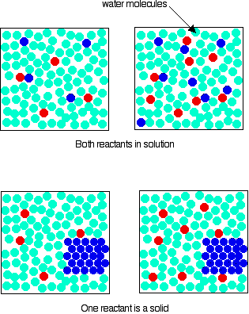**Topic 16**

1. understand the terms:

i rate of reaction

ii rate equation

iii order with respect to a substance in a rate equation

iv overall order of reaction

v rate constant

vi half-life

vii rate-determining step

viii activation energy

ix heterogeneous and homogenous catalyst

2. be able to determine and use rate equations of the form:

rate = *k*[A]*m*[B]*n*, where *m* and *n* are 0, 1 or 2

3. be able to select and justify a suitable experimental technique to obtain rate data for a given reaction, including:

i titration

ii colorimetry

iii mass change

iv volume of gas evolved

v other suitable technique(s) for a given reaction

4. understand experiments that can be used to investigate reaction rates by:

i an initial-rate method, carrying out separate experiments where different initial concentrations of one reagent are used

*A ‘clock reaction’ is an acceptable approximation of this method*

ii a continuous monitoring method to generate data to enable concentration/time or volume-time graphs to be plotted**tudents should:**

5. be able to calculate the rate of reaction and the half-life of a first-order reaction using data from a concentration-time or a volume-time graph

6. be able to deduce the order (0, 1 or 2) with respect to a substance in a rate equation using data from:

i a concentration-time graph

ii a rate-concentration graph

7. be able to deduce the order (0, 1 or 2) with respect to a substance in a rate equation using data from an initial-rate method

New Reference**Chemical Kinetics and Rates of reactions**

****Just as Entropy tells us how much, Kinetics tells us how fast. This is both a L6 topic (topic 9) and an U6 topic (topic 16) so you will need to refer to both Textbooks

**What to do if you get stuck**

If you are struggling with this topic here are a few ideas you can try

1. Read Chapter 9 in the AS Chemistry textbook and
2. See <https://www.youtube.com/watch?v=NhdtqnEfa9w>

and <https://www.youtube.com/watch?v=ExHV_cFWYSM>

<https://www.youtube.com/watch?v=Cq45wB9VmxA> (Topic 9)

2) Try some of the worksheets in the folder on GOL

3) Come to clinic on Friday 1-2pm and/or Tuesday 4.15-5pm for some 1-2-1 support from your teachers.

**What to do if you have time left over**

[](https://twitter.com/WeTeachRevision/status/438710135951593472/photo/1/large)If you have finished all the set work from your teacher but you still have some of your 5 hours left over here are some things to try

1) Go to the worksheets folder on GOL and try some of the **Olympiad** worksheets, the answers are at the back

2) <https://www.youtube.com/watch?v=OvdwQfSYBLU>

3) Read and make notes on Chapter 9 in ‘Why Chemical reactions Happen’ copies are in the library

**Core Practicals 13a Folowing the rate of the iodine propanone reaction by a titrimetric method CPAC 2d, 3a, 4b**

**Core Practicals 13b Investigating a ‘clock reaction’ (Harcourt-Esson, iodine clock) CPAC 1a, 4a,5a**

|  |  |
| --- | --- |
| **CPAC 1:**  **Follows written procedures** | 1. Correctly follows instructions to carry out the experimental techniques or procedures. |
| **CPAC 2:**  **Applies investigative approaches and methods when using instruments and equipment** | (d) Selects appropriate equipment and measurement strategies in order to ensure suitably accurate results. |
| **CPAC 3:**  **Safely uses a range of practical equipment and materials** | 1. Identifies hazards and assesses risks associated with these hazards, making safety adjustments as necessary, when carrying out experimental techniques and procedures in the lab or field. |
| **CPAC 4:**  **Makes and records observations** | 1. Makes accurate observations relevant to the experimental or investigative procedure. 2. Obtains accurate, precise and sufficient data for experimental and investigative procedures and records this methodically using appropriate units and conventions. |
| **CPAC 5:**  **Researches, references and reports** | 1. Uses appropriate software and/or tools to process data, carry out research and report findings. |

**Kinetics – How Fast**

Ref Edexcel A-level Chemistry Book 1 page 265-268

Kinetics is the study of how quickly a reaction will take place, it will not tell us how much of a given product is formed, we will study that in Equilibria, but the study of Kinetics will tell us at what rate the reaction will occur.

Before you start WATCH <https://www.youtube.com/watch?v=7qOFtL3VEBc>

The rate of reaction is the change in concentration over the change in time, i.e. if there is a large change in concentration in a small time period the rate of reaction is fast, If the same change in concentration occurs but over a longer time period the rate of reaction will be slower.

**Watch** <https://www.youtube.com/watch?v=OttRV5ykP7A>

**Collision theory**

For a reaction to take place two things must occur. The particles of reactants must:

• …………………………………………………………………………..

• ………………………………………………………………………….

Factors increasing the rate of reaction

• ……………………........................................................……………

• …………………........................................................………………

• ………………........................................................…………………

• …………………………........................................................………

• …………………………........................................................………

In order to understand why these factors affect the rate we use a model known as collision theory.

**Solid /solid reactions Watch**

Appearance of solid lead nitrate …………………….. solid potassium iodide ………………………..

After shaking together …………………………………………………

Equation:

Predict whether the solutions would behave in the same way……………………………………

Explain the observations ………………………………………………………………………….

**Collision Theory - The correct orientation**

Ref Edexcel A-level Chemistry Book 1 page 268

**Watch** <https://www.youtube.com/watch?v=wbGgIfHsx-I>

Look at the reaction between ethene and hydrogen chloride

CH2=CH2 + HCl 🡪 CH3CH2Cl

The reaction can only happen if the hydrogen end of the hydrogen chloride approaches the carbon double bond. Any other orientation

and the molecules will bounce off each other.

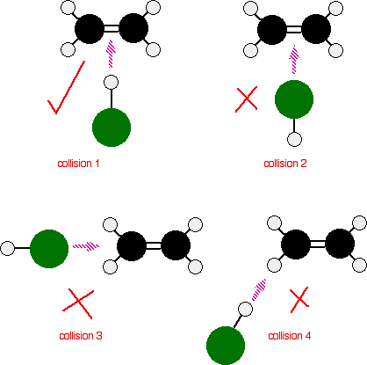

Label the diagram with the dipoles ………

Why does collision 1 have the correct orientation?

………………………………………….

………………………………………….

Why does collision 2 not have the correct orientation?

………………………………………….

………………………………………….

**See p 147 Chemistry 2**

**Collision Theory - Sufficient energy**

It is not enough for the reactants to collide in the correct orientation, they have to collide with an energy greater than or equal to the Activation Energy

Activation Energy is

**Energy profiles and activation energy**

Ref Edexcel A-level Chemistry Book 1 page 270-272

We can see this on an energy profile/energy level diagram.

e.g. for the reaction: H2 + Cl2 🡪 2HCl

Add the following labels to the energy profile below:

• H2 and Cl2

• 2HCl

• Free atoms/transition state 2H + 2Cl

• Energy needed to break bonds

• Energy given out when bonds form

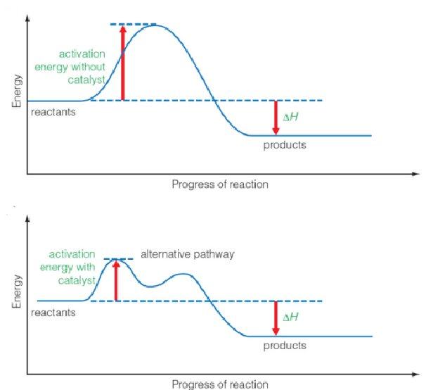

This is an example of an exothermic reaction. If the particles collide with less energy than the activation energy, nothing important happens. They bounce apart. You can think of the activation energy as a barrier to the reaction. Only those collisions which have energies equal to or greater than the activation energy result in a reaction.

Any chemical reaction results in the breaking of some bonds (requiring energy) and the making of new ones (releasing energy). Obviously some bonds have to be broken before new ones can be made. Activation energy is involved in breaking some of the original bonds.

Draw a new energy profile diagram for the endothermic reaction and label it in the same way as above.

e.g. the endothermic reaction 2HI(g) 🡪 H2(g) + I2(g)

We can use collision theory to explain why factors such as temperature, concentration, pressure, surface area and catalysts can alter the rate of a reaction

Ref Edexcel A-level Chemistry Book 1 page 265-268

**Watch** <https://www.youtube.com/watch?v=JpoOfrPKgmM>

Draw particle diagrams to illustrate how the collision theory explains a change in rate for concentration, surface area, temperature and pressure.

**Effect of Concentration**

Higher concentration

Lower concentration

Why does increasing the concentration increase the rate of reaction?

…………………………………………………………………………………………………………

…..............................................………………………………………………………………………

**Effect of Surface area**

Larger surface area

Smaller surface area

Why does increasing the surface area increase the rate of reaction?

…………………………………………………………………………………………………………

………………………………………………………………………………………………………..

**Effect of Temperature on the rate of a reaction**

Higher temperature

Lower temperature

Why does increasing the temperature increase the rate of reaction? (2 reasons)

…………………………………………………………………………………………………………

…………………………………………………………………………………………………………

……………………………………………………………………………………………………..……

……………………………………………………………………………………………………..……

……………………………………………………………………………………………………..……

**Effect of Pressure**

Lower pressure

Higher pressure

Why does increasing the pressure increase the rate of reaction?

…………………………………………………………………………………………………………

…………………………………………………………………………………………………………

…………………………………………………………………………………………………………

**Maxwell-Boltzmann Diagrams.**

Ref Edexcel A-level Chemistry Book 1 page 269-271

Watch <https://www.youtube.com/watch?v=glSIFkGl63E>

Think about the molecules of a gas. How are they moving? ................................................... Do they all have the same energy?............. The Maxwell-Boltzmann distribution describes the distribution of molecular energies in an ideal gas and shows us that for a given temperature the molecules have a range of energies.

We can use this diagram to show the number of molecules with enough energy to overcome the activation energy.

The total number of molecules of gas is shown by ………………………………………………

The number of molecules with more energy than the activation energy are shown by

………………………………………………………………………………………………………

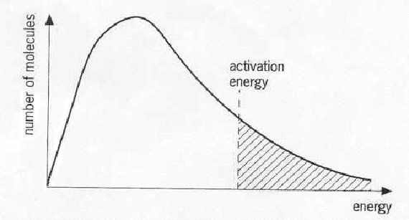These are the molecules which have enough energy to react.

Note: The graph above is a plot of the number of molecules having particular kinetic energies at a constant temperature. The average Kinetic Energy is proportional to the temperature.

Points to notice:-

• No molecules have zero energy.

• Fewer molecules have higher energies so the graph is not symmetrical.

• The graph does not touch the x axis on the right (goes to infinity)

• The area under the curve represents the total number of molecules.

• The shaded area represents the number of molecules with KE greater than, or equal to Ea.

For the reaction to occur, the molecules involved need a minimum amount of energy - the Activation energy (EACT). If a molecule is not in the shaded area, then it will not have the required energy so it will not be able to react (even if it does collide with the correct orientation).

If the number of molecules in our sample (i.e. the concentration) is increased, then the area under the curve increases. Draw a line on the graph above to represent an increase in concentration. What do you notice about the number of molecules that can now react? …………………….................…

How does this relate to the rate of reaction? …………………………………………………………

With a low enough activation energy there will be sufficient molecules of a high enough energy to overcome the activation energy at room temperature. A fast reaction has a ............. activation energy which will be shown by a ........................... shaded area on the Maxwell-Boltzmann graph. Every reaction has an activation energy, reactions that ‘go’ spontaneously at room temperature still have an activation energy. So how do the reacting molecules overcome this activation energy?

**Effect of temperature**

We have seen from our work on collision theory that an increase in temperature increases the rate of reaction because there a greater frequency of collisions with an energy greater than or equal to the activation energy. We can now show this using a Maxwell Boltzmann diagram:-

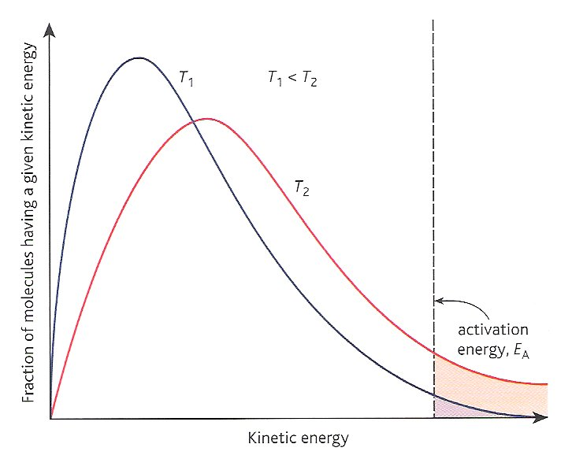A Maxwell Boltzmann diagram for temperature T1 and T2 where T2 is higher than T1:

As the temperature increases, the average energy of the particles increases. Note that the peak of the graph moves………………………………The energy spread of the molecules also increases so there are more molecules with ………………………......…................................... shown by the ............................. shaded area under the curve to the right of the EA value

Remember that the total **number of molecules remains the same so the area under each curve must remain the same.**

**EXAM HELP** When answering questions on the effect of temperature on rates of reaction include the following statements in a logical order.

* As temperature increases the kinetic energy of the particles increases.
* Particles will be moving faster
* The frequency of collisions increases (more collisions per unit time).
* Collisions will have higher energies
* A greater proportion of collisions will have an energy greater than or equal to Ea
* Therefore there are more successful collisions per unit time
* Therefore the **rate** of reaction **increases**.

**Relative Reaction Rates**

Ref Edexcel A-level Chemistry Book 1 page 262-264

Consider the reaction between calcium carbonate and hydrochloric acid

Write the balanced equation for this reaction including state symbols:

………………………………………………………………………………………………………..

Draw and label the apparatus you would use to measure this rate of reaction.

Collection of gas method

<https://www.youtube.com/watch?v=P-jE7KXYfPw>

Loss of mass method

<https://www.youtube.com/watch?v=0RUYNpdnALg>

What measurements would you take and how would you show your results.

…………………………………………………………………………………………………………

…………………………………………………………………………………………………………

…………………………………………………………………………………………………………

The graph below shows the kind of results you should get for this reaction i.e. how the volume of carbon dioxide produced varies against time during a reaction.

This graph is for the conditions in experiment 1. (in the table below).



* Calculate the total number of moles of HCl in each experiment and enter the figures in the table below. Assume that the calcium carbonate is in excess
* Sketch and label similar curves for reactions 2-7 using the same axes on the graph below. **Label each graph** clearly with the **number of the experiment**.

|  |  |  |  |  |  |
| --- | --- | --- | --- | --- | --- |
| Experiment | CaCO3  (size of granules) | [HCl]  (mol dm-3) | Volume HCl (cm3) | Temperature (°C) | Total moles  HCl |
| 1 | small | 2 | 100 | 20 |  |
| 2 | large | 2 | 100 | 20 |  |
| 3 | large | 2 | 50 | 20 |  |
| 4 | small | 4 | 50 | 20 |  |
| 5 | large | 1 | 100 | 20 |  |
| 6 | small | 2 | 200 | 40 |  |
| 7 | powder | 2 | 200 | 40 |  |

Worksheet

Additional practice worksheet ‘Reaction rate problems’

In order to study chemical kinetics we need a method for measuring the rate of the reaction.

For the following, outline the method and give an example:

Ref Edexcel A-level Chemistry Book 2 page 148-150

Include the advantages and disadvantages of each method and a small diagram. (methods with a * are needed in more detail, as they are CP skills)

New exercise

1. **Titration (sampling, quenching and titrating)**

Example …………………………………………………………………………………………

Diagram

Method……………………………………………………………………………………………………………………………………………………………………………………………………………………………………………………………………………………………………………………………………………………………………………………………………………………………………………………………………………………………………………………………………………………………………………………………………………………………………………………………………………………………………………………………………………………………………………………………………………………………………………………

1. **Measuring changes in volume of gas \***

Example …………………………………………………………………………………………

Diagram

Method……………………………………………………………………………………………………………………………………………………………………………………………………………………………………………………………………………………………………………………………………………………………………………………………………………………………………………………………………………………………………………………………………………………………………………………………………………………………………

1. **Measurement of change in mass**

Example ………………………………………………………………………………………..

Method………………………………………………………………………………………………………………………………………………………………………………………………..………………………………………………………………………………………………………………………………………………………………………………………………………………..

1. **Measurement of colour change \***

Example ………………………………………………………………………………………….

Diagram

Method…………………………………………………………………………………………………………………………………………………………………………………………………..

……………………………………………………………………………………………………

……………………………………………………………………………………………………

……………………………………………………………………………………………………

……………………………………………………………………………………………………

**5) Measurement of IR absorption**

Example …………………………………………………………………………………………

Method……………………………………………………………………………………………

……………………………………………………………………………………………………

……………………………………………………………………………………………………

1. **Measurement of conductivity**

Example …………………………………………………………………………………………

Method……………………………………………………………………………………………

…………………………………………………………………………………………………………………………………………………………………………………………………………

We can use the information from the measurements to understand the rate of a particular reaction.

The Rate of a reaction is the change in concentration with respect to time

rate

Looking at a typical reaction

**A + 2B 🡪 C**

New exercise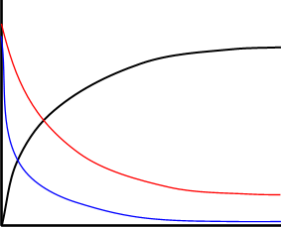

C

Concentration

B

A

Time

Using the graph deduce as much information as you can about A, B and C.

Reactants (A and B)

……………………………………………………………………………………………..

Product (C)

………………………………………………………………………………………………..

* …………………………………………………………………………………………………………………………………………………………………………………………………….

* …………………………………………………………………………………………………………………………………………………………………………………………………..

* …………………………………………………………………………………………………………………………………………………………………………………………………

In order for us to find the rate at a particular time we need to take the tangent to the curve at a particular point

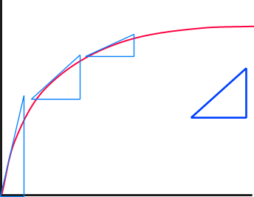

The slope of the gradient of the curve gets less as the reaction slows down with time.

Concentration

y

x

Gradient = y

x

Time

The tangent to the line gives us the rate. We need a point on the graph where we know the concentration accurately.

Where do we know the concentration with the highest degree of accuracy?

……………………………………………………………………………………………………..

What effect would changing the concentration have on the rate?

……………………………………………………………………………………………………..

We can use this to look in more detail at the rate of reaction.

**The initial rate method watch** <https://www.youtube.com/watch?v=RN_f1qp83bM>

Ref Edexcel A-level Chemistry Book 2 page 155-157

If an experiment is carried out using different concentrations of a reactant and keeping all other factors constant, then a series of **graphs** are obtained.

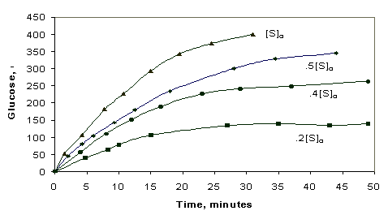

These can be plotted on a single graph where each line represents a different concentration. The only point at which we can be certain of the concentration is at time = 0. By drawing tangents to the curves at time = 0 (Graph A) we can find the the **initial rate** for different concentrations.

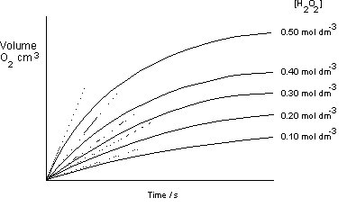

Initial rates

Graph A

concentration

Now, if concentration is plotted against initial rate (Graph B):-

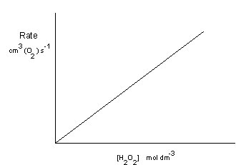Graph B

Initial rate

Concentration

**The shape of the graph** B shows us **how the rate varies with concentration**.

In this case the rate is proportional to the concentration. In other words if you double the concentration you double the rate. This can be expressed as:-

reactant

Concentration

First order

Rate

proportionality sign

Rate  [A]

square brackets mean ‘concentration in mol dm-3

Replacing the proportionality sign with = and a constant we can now say that

constant known as the **‘rate constant’**

Rate = k [A]

This is said to be a **first order reaction** with respect to A, as A is raised to the power 1. We have also introduced a new term k, the rate constant.

The rate constant k depends on the size of the molecules, the speed they are moving, and the fraction of collisions which have both the correct orientation and sufficient energy to ‘get over’ the energy barrier. The value of k has to be determined experimentally and it is usually found to be highly dependant on temperature. We will look at this in pack II.

The value k gives a good indication of the rate of the reaction. A small value of k and the reaction will be slow no matter what you do to the concentrations. If k is a large value the reaction will be fast even at very low concentrations.

For the graph above we can see that the relationship between rate and concentration is a linear one, shown by the straight line graph with a constant gradient.

However when we plot a graph of rate vs. concentration we do not always get a straight line:-

Here the rate is not directly proportional to the concentration of A; instead the rate of reaction is **proportional to the square of the concentration of A.**

Concentration

Second order

Rate

This means that if you doubled the concentration of **A**, the rate would go up 4 times (22). If you tripled the concentration of **A**, the rate would increase 9 times (32). In symbol terms:-

Rate  [A]2

Rate = k [A]2

padding

This is a **second order reaction**

Ref Edexcel A-level Chemistry Book 2 page 151-154

Lastly we need to look at what happens when the concentration has **no effect** on the rate.

Concentration

Zero order

Rate

Rate  [A]

Here we can increase the concentration but it has no effect on the rate of the reaction it is said to be:-

**Zero order** with respect to A

For this reaction Rate = k where the value of k can be found on the intersect of the y axis

New exercise

Re-read the previous page, THINK VERY CAREFULLY- look at the axes - then sketch graphs for:-

|  |  |
| --- | --- |
| **First order** rate vs. concentration  Concentration  Rate | **First order** reactant concentration vs. **time**  Time  Concentration |
| **Zero order** rate vs. concentration  Concentration  Rate | **Zero order** reactant concentration vs. **time**  Time  Concentration |

**The Rate expression**

Ref Edexcel A-level Chemistry Book 2 page 151

Watch

We can combine these different expressions to get an overall rate expression.

Keep [B] constant and find

rate = k1[A]m

Overall rate constant

k = k1 x k2

Consider the reaction:-

Keep [A] constant and find

rate = k2[B]n

aA + bB 🡪 products

Experiments show that the reaction rate can be related to the concentration of individual reactants by a rate equation of the form

**Overall rate equation**:-

rate = k[A]m[B]n

where **m** and **n** are constants, whose values are usually 0, 1 or 2,

**k** is the **overall rate constant**, *with units depending upon the particular rate equation*.

This is **unique** for each reaction at a particular temperature and provides key information about how fast the reaction will proceed.

**m** is the order of reaction with respect to reactant A,

**n** is the order of reaction with respect to reactant B.

The **overall order of reaction** is the sum of the powers of the concentrations of the individual reactants in the rate equation, which is **(m + n)**.

Reactions may commonly be **zero order**, **first order** or **second order** *with respect to a particular reactant*.

* A reaction is zero order with respect to a reactant when changing the concentration of that reactant has no effect on the reaction rate.
* A reaction that is first order with respect to a particular reactant has its rate doubled when the concentration of that reactant is doubled.
* Where doubling the concentration of a reactant results in a quadrupling (x4) of the rate, the reaction is second order with respect to that reactant.

|  |  |  |
| --- | --- | --- |
| Order of Reaction | Reactant concentration doubled.  The rate:- | Reactant concentration tripled.  The rate:- |
| Zero | does not change | does not change |
| 1st | doubles (x2) | triples (x3) |
| 2nd | quadruples (x4) | x 9 |

WorksheetRead: - Introduction to Kinetics

See Worksheets Orders of reaction 4.1.2 and Rate constant units 4.1.3

The information below relates to the reaction between hydrogen and nitrogen(II) oxide at 1073K.

|  |  |  |  |
| --- | --- | --- | --- |
| Experiment Number | Initial concentration of nitrogen monoxide  /mol dm-3 | Initial concentration of hydrogen ions  /mol dm-3 | Initial rate of production of nitrogen  /mol dm-3 s-1 |
| 1 | 0.006 | 0.001 | 0.0030 |
| 2 | 0.006 | 0.002 | 0.0060 |
| 3 | 0.006 | 0.003 | 0.0090 |
| 4 | 0.001 | 0.006 | 0.0005 |
| 5 | 0.002 | 0.006 | 0.0020 |
| 6 | 0.003 | 0.006 | 0.0045 |

Which 2 experiments represent [NO] constant, and [H] doubled? ……………

How does the initial rate depend on [H] ?.....................................................……………………

What is the order of reaction with respect to [H] ?……………………..

Which 2 experiments represent [H] constant and [NO] doubled?............................…………….

How does the initial rate depend on [NO] ? ……………………………………………………..

What is the order of reaction with respect to [NO] ?…………………

Write an overall rate expression for this reaction

What is the overall order of reaction……………………..

Calculate a value for k

What are k’s units?

Please note there is no relationship between the molar quantities and the order of reaction

WorksheetW/S Kinetics calculations 1&2 (grimes) / Extra Questions on Orders of Reactions / More rate questions

**The Half life of first order reactions**

The half life of a chemical reaction is defined as the time taken for the concentration of a component to decrease to half its initial value.

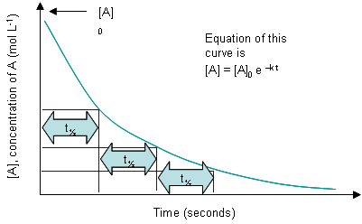

Here is a graph of concentration [A] vs. time.

Look at the time taken in each case for the concentration to fall by half.

What do you notice about it …………………………………

This is a **characteristic of first order reactions** and can be used to identify them.

If the successive half-lives **become longer** then this indicates an **order greater than 1**.

If [A] vs. time is a **straight line** the reaction is **zero order**.

There are two basic types of graphical analysis you need to be familiar with:-

1. A concentration vs. time graph which can be used to calculate the initial rate and calculate half life.
2. A rate vs. concentration graph which can be used to show the order of reaction and hence to derive the rate equation and the rate constant.

**Worksheet**

W/S Extra Graphical problems

You need to be able to define the following terms used in this pack so far:-

New exercise

Rate of reaction:

……………………………………………………………………………………………………………………………………………………………………………………………………………………………………………………………………………………………………………..

Rate equation:

………………………………………………………………………………………………………………………………………………………………………………………………………………………………………………………………………………………………………………

Order of reaction:

………………………………………………………………………………………………………………………………………………………………………………………………………………………………………………………………………………………………………………

Rate constant:

………………………………………………………………………………………………………………………………………………………………………………………………………………………………………………………………………………………………………………

Half life:

………………………………………………………………………………………………………………………………………………………………………………………………………………………………………………………………………………………………………………

**Experiment 1. To find the order of reaction with respect to hydrogen peroxide**

**Introduction**

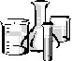Hydrogen peroxide decomposes in the presence of a **catalyst**, manganese(IV) oxide, or the enzyme catalase:

2H2O2(l) 🡪 2H20(l) + O2(g)

The oxygen produced can becollected in a gas syringe.

**The initial rate** can be determined from a graph of volume of oxygen against time. You are provided with a solution of 20 volume hydrogen peroxide which produces 20 times its own volume of oxygen at r.t.p. The gas syringe has a capacity of 100 cm3.

*Position transducer held in a clamp with rod resting against syringe plunger*

**Method**

*Connect position transducer to the data-logger*

Set up the apparatus:-

*Small syringe containing hydrogen peroxide*

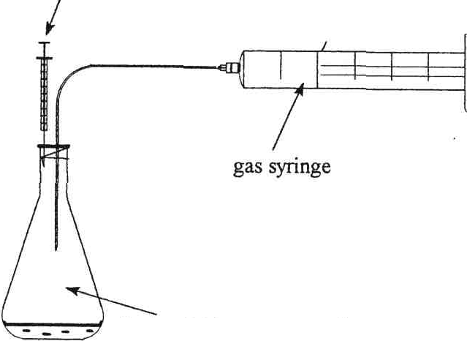

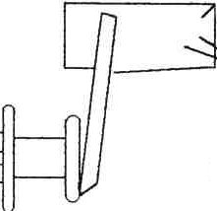

IMPORTANT

Rest the position transducer against the gas syringe plunger.

Use the logger display to check that your angle of rotation of transducer increases from about zero to no more than 340o as you pull gas syringe plunger out.

*gas syringe*

*flask containing**manganese dioxide and water*

*magnetic stirrer*

1. Into the conical flask put

a) a small, weighed mass of manganese(IV) oxide (1/4 spatula) (keep this constant.)

b) 16 cm3 water, measured accurately.

Mass of MnO2 = g

1. Switch on magnetic stirrer.
2. Measure into the syringe 4.0 cm3 20 volume (6 %) hydrogen peroxide 🡪1.66 mol dm-3.
3. When you are ready to record, press **√** and then inject the peroxide into the conical flask.
4. Save data on data-logger by going to ‘file’ and click on ‘save’.
5. Carry out two more experiments halving the concentration of thehydrogen peroxide each time and keeping the total volume constant (by adding water).
6. Once all three experiments are done, connect the data-logger to a computer using the data-logger-USB cable.
7. Open ‘log-it’ software from programs menu and download data ‘fetch data’ command.
8. You may wish to open the table and then you can save data into Excel and your user area to manipulate later.
9. Print out a graph of volume of oxygen against time.

From construction lines drawn on the graph, calculate the initial rate of the reaction.

(See page 7 for the method)

When calculating the initial rate discount any increase in volume as H2O2 is injected,

Use a tangent to the steepest portion of the graph after that point

11) Fill out the following table

|  |  |  |
| --- | --- | --- |
| Concentration of H2O2  mol dm-3 | Initial rate of reaction | |
| Your results | Class average |
| 1.66 |  |  |
| 0.83 |  |  |
| 0.425 |  |  |
| 0.213 |  |  |

1. Draw a concentration vs. initial rate graph and work out the order of reaction with respect to H2O2
   1. What is the order of reaction with respect to hydrogen peroxide? ………………..…
   2. Explain your answer …………………………………………………………………

……………………………………………………………………………………………

* 1. Why do you need to add water to each experiment

……………………………………………………………………………………………

……………………………………………………………………………………………

d What effect does pooling the class results have?

……………………………………………………………………………………………

……………………………………………………………………………………………

*Extension*

MCj04247820000[1]An online Initial rate method to find an order of reaction is found at <http://www.chm.davidson.edu/vce/kinetics/MethodOfInitialRates.html>

**Experiment 2 - The iodine clock reaction Core Practical 13a CPAC 2d,3a,4b**

Ref Edexcel A-level Chemistry Book 2 page 158-159

S2O82-(aq) + 2I-(aq) 🡪 2SO42-(aq) + I2(aq) Equation 1

peroxodisulphate ion

Aim – To find the order of reaction with respect to the S2O82- and I- ion..

**Introduction**

Draw the structural formula for

(i) The sulphate ion SO42- (ii) [Peroxodisulphate ion](http://en.wikipedia.org/wiki/Peroxodisulfate) S2O82-

For the reaction above:-

Reduction half equation

Oxidation half equation

To measure the rate of reaction you are going to do a series of experiments each one with different concentrations of the S2O82- ion or iodide ion.

You will use starch as the indicator, at which point should you add this?

………………………………………………………………………………………………

What is the end point?………………………………………………………………………..

The rate of the reaction can be monitored by adding a constant amount of sodium thiosulphate to react with the iodine produced in the reaction. Then record the time taken for the iodine to appear once the thiosulphate has reacted.

Reaction between iodine and thiosulphate:-

Reduction half equation

Oxidation half equation

Total redox reaction Equation 2

(You **need to know this equation**)

There is a reciprocal relationship between rate and time, i.e. the faster the rate the shorter the time.

**Equipment**

● 100 cm3 of 0.2 mol dm–3 sodium peroxodisulfate solution

● 100 cm3 of 0.2 mol dm–3 potassium iodide solution

● 50 cm3 of 0.05 mol dm–3 sodium thiosulfate solution

● 20 cm3 of 1% starch solution

● distilled/deionised water

● white tile

● four 10 cm3 measuring cylinders

● dropping pipettes

● four 100 cm3 beakers

● four 250 cm3 beakers

● stop clock

**Procedure**

1. Measure 10.0 cm3 of potassium iodide solution into a small beaker standing on a white tile.

2. Add 5.0 cm3 of sodium thiosulfate solution to the potassium iodide solution.

3. Add 10 drops of starch solution to the mixture in the small beaker. Starch acts as the indicator

and must be used in each experiment.

4. Measure out 10.0 cm3 of the sodium peroxodisulfate solution. Pour this into the mixture

prepared in steps 1 and 2. **Start the stop clock**.

5. Stop the clock when a blue colour appears in the beaker and note the time taken.

6. Note the time taken in table 2a or b Use this to record your results.

7. Repeat steps 1–5 using the volumes of sodium peroxodisulfate and potassium iodide solutions

shown in Table 1. The total volume, including the sodium thiosulfate solution, must add up to

25.0 cm3, which can be achieved by adding the correct volume of distilled/deionised water.

**Table 1**

|  |  |  |  |  |
| --- | --- | --- | --- | --- |
| **Mixture** | **Vol. S2O82- /cm3** | **Vol I- /cm3** | **Vol S2O32- /cm3** | **Vol H2O /cm3** |
| **a** | 10.0 | 10.0 | 5.0 | 0.0 |
| **b** | 10.0 | 8.0 | 5.0 | 2.0 |
| **c** | 10.0 | 6.0 | 5.0 | 4.0 |
| **d** | 10.0 | 4.0 | 5.0 | 6.0 |
| **e** | 10.0 | 2.0 | 5.0 | 8.0 |
| **f** | 8.0 | 10.0 | 5.0 | 2.0 |
| **g** | 6.0 | 10.0 | 5.0 | 4.0 |
| **h** | 4.0 | 10.0 | 5.0 | 6.0 |
| **i** | 2.0 | 10.0 | 5.0 | 8.0 |

**Analysis of results**

**Table 2a**

Order of reaction wrtiodide I-

|  |  |  |  |  |
| --- | --- | --- | --- | --- |
| Mixture | Con S2O82- /moldm-3 | Con I- / moldm-3 | Time /s | 1/t (rate) /s-1 |
| a |  |  |  |  |
| b |  |  |  |  |
| c |  |  |  |  |
| d |  |  |  |  |
| e |  |  |  |  |

1. Calculate the concentration of iodide ions in each of the 25.0 cm3 solutions for experiments

(a)–(e). Write these values in Table 2.

2. Use the times recorded in each experiment to work out the rates for these experiments.

Write these values in Table 2a.

3. Plot a graph of rate against concentration. Deduce the order of the reaction with respect to

iodide ions.

**Table 2b**

Order wrt peroxodisulfate S2O82-

|  |  |  |  |  |
| --- | --- | --- | --- | --- |
| Mixture | Con S2O82- /moldm-3 | Con I- / moldm-3 | Time /s | 1/t (rate) /s-1 |
| a |  |  |  |  |
| f |  |  |  |  |
| g |  |  |  |  |
| h |  |  |  |  |
| i |  |  |  |  |

4. Using the data from the first experiment (a) and the data from (f)–(i), work out the concentration

of the peroxodisulfate ion in 25.0 cm3 of solution. Write these values in Table 2b.

5. Work out the rate for each of these concentrations. Write these values in Table 2b.

6. Plot a graph of rate against concentration. Deduce the order of the reaction with respect to

peroxodisulfate ions.

**Questions**

1. Identify the main sources of uncertainty in the procedure used and the measurements recorded

in this experiment. Calculate the percentage uncertainty for any measurements taken.

…………………………………………………………………………………………………………………………………………………………………………………………………………………………………………………………………………………………………………………………………………………………………………………………………………………………………………

2. Suggest ways of minimising these uncertainties.

……………………………………………………………………………………………………………………………………………………………………………………………………………………………………………………………………………………………………………………………………………………………..

3. What is the overall rate equation for this reaction? The equation for the reaction is:

S2O82- + 2I- → 2SO42- + I2

4. A suggested mechanism for the reaction is:

step 1 I- + S2O82- → (S2O8I)3-‑

step 2 (S2O8I)3-‑  + I- → 2SO42- + I2

Which of these steps is the rate-determining step? Use the rate equation to justify your answer.

**Experiment 3 (Investigation 1) Kinetics of the reaction between iodine and propanone Core Practical 13b Titrimetric method CPAC 1a, 4a, 5a**

The following solutions are provided:

0.02 M I2 dissolved in aqueous KI solution;

1. M propanone dissolved in water;
2. M sulphuric acid;

0.5 M sodium hydrogen carbonate solution;

0.01 M sodium thiosulphate solution;

Using these, each pair of students should prepare one of the combinations of solutions indicated below. Clean, dry conical flasks, A and B, should be used for this purpose: As well as 5 conical flasks with 10cm3 of NaHCO3.

|  |  |  |  |  |  |
| --- | --- | --- | --- | --- | --- |
| Sample no | 1 | 2 | 3 | 4 | 5 |
| Flask A:  Volume of I2 solution(cm3)  Flask B:  Volume of H2SO4 solution (cm3)  Volume of propanone solution (cm3)  Volume of distilled water (cm3) | 50.0  25.0  25.0  0 | 50.0  25.0  20.0  5.0 | 50.0  25.0  15.0  10.0 | 50.0  25.0  12.5  12.5 | 50.0  25.0  6.25  18.75 |

Procedure

When you are ready, mix the contents of the flasks A and B, thoroughly and at once start the clock. After about 5 minutes, pipette 10 cm3 of the reaction mixture into one of the flasks containing 10 cm3 of the NaHCO3 solution, noting the time at which this was done. The contents of the flask should be mixed thoroughly and then titrated with the sodium thiosulphate solution. When the mixture nearly colourless two or three drops of a fresh starch solution should be added and then titration is continued until one drop of sodium thiosulphate solution discharges the blue starch-iodine complex colour.

After about 10, 15, 20 and 30 minutes withdraw further 10 cm3 portions of the reaction mixture and carry out the above procedure each time.

Results table

Why is each sample added to sodium hydrogencarbonate solution?

……………………………………………………………………………………………………………………………………………………………………………………………………………………………………………………………………………………………………………..

Plot a graph of volume of thiosulfate (y axis) vs time (x axis). Explain why these results can be used to determine the order of reaction without calculating the concentration of iodine.

……………………………………………………………………………………………………………………………………………………………………………………………………………………………………………………………………………………………………………..

Use your graph to deduce the order of reaction wrt iodine. Justify your answer

……………………………………………………………………………………………………………………………………………………………………………………………………………………………………………………………………………………………………………..

……………………………………………………………………………………………………………………………………………………………………………………………………………………………………………………………………………………………………………..

**Questions**

**Q1.**For a given initial reactant pressure, the half-life for a first order gaseous reaction was found to be 30 minutes.  
 If the experiment were repeated at half the initial reactant pressure, the half-life would be

   **A**     15 minutes.

   **B**     30 minutes.

   **C**     45 minutes.

   **D**     60 minutes.

**(Total for question = 1 mark)**

**Q2.**Four sketch graphs are shown below.

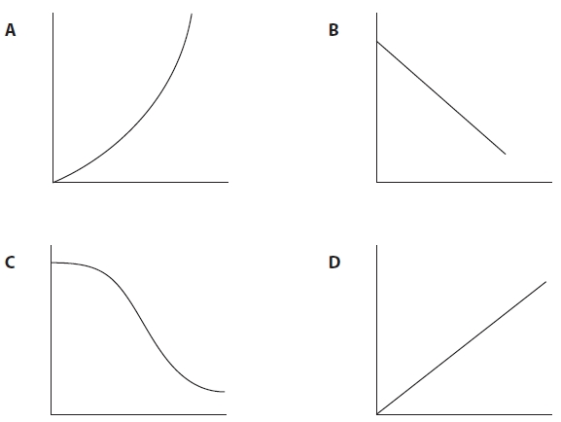

(a)  Which could be a graph of the concentration of a reactant, on the vertical axis, against time for a **zero** order reaction? **(1)**

   **A**

   **B**

   **C**

   **D**

(b)  Which could be a graph of rate of reaction, on the vertical axis, against the concentration of a reactant for a **first** order reaction? **(1)**

   **A**

   **B**

   **C**

   **D**

(c)  Which could be a graph of rate of reaction, on the vertical axis, against the square of the concentration of a reactant for a **second** order reaction? **(1)**

   **A**

   **B**

   **C**

   **D**

(d)  Which could be a graph of the concentration of a reactant, on the vertical axis, against time for a reaction which is catalysed by a product? **(1)**

   **A**

   **B**

   **C**

   **D**    **(Total for question = 4 marks)**

**Q3.**At 556 K, hydrogen iodide decomposes without a catalyst.

The following data were obtained.

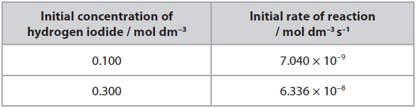

(i)  Deduce the order of reaction with respect to hydrogen iodide when there is no catalyst present. Justify your answer.

**(2)**

.............................................................................................................................................

.............................................................................................................................................

.............................................................................................................................................

.............................................................................................................................................

(ii)  Write the rate equation for the reaction without a catalyst and calculate the rate of reaction when the initial concentration of hydrogen iodide is 0.500mol dm−3.

**(2)**

**Q4.** The graph shows how the concentration of hydrogen iodide changes with time when a platinum catalyst is present.

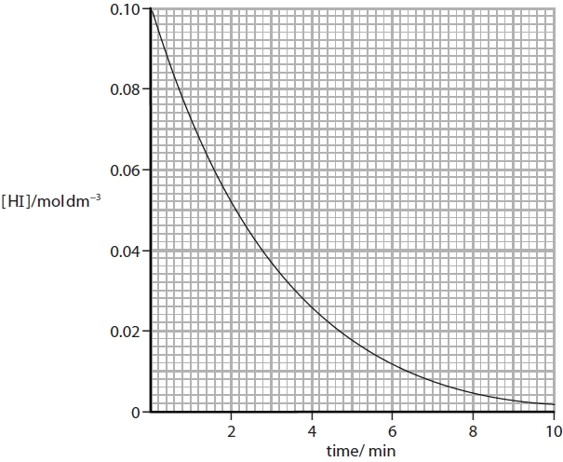

Measure two successive half-lives from the graph, showing your working, and deduce the order of reaction with respect to hydrogen iodide. Justify your answer.

**(2)**

.............................................................................................................................................

.............................................................................................................................................

.............................................................................................................................................

.............................................................................................................................................

.............................................................................................................................................

.............................................................................................................................................

**Q5.**Persulfate ions, S2O82−, oxidize iodide ions in aqueous solution to form iodine and sulfate ions, SO42−.

(a)  Write the ionic equation for this reaction. State symbols are not required.

**(1)**

(b)  The effect of persulfate ion concentration on the rate of this reaction was measured.

A few drops of starch solution and a small measured volume of sodium thiosulfate solution were added to the potassium persulfate solution.

Potassium iodide solution was then added and the time taken for the mixture to change colour was measured.

The reaction was repeated using different concentrations of potassium persulfate, but the same volumes and concentrations of sodium thiosulfate solution and potassium iodide solution.

The rates of the reaction were compared using the reciprocal of the time (1/time) for the mixture to change colour as a measure of the initial rate.

(i)  What is the final colour of the reaction mixture?

**(1)**

.............................................................................................................................................

(ii)  What would happen if the reaction was carried out without the addition of sodium thiosulfate?

**(1)**

.............................................................................................................................................

.............................................................................................................................................

(iii)  Explain why the concentration of iodide ions remains constant until the mixture changes colour.

**(1)**

.............................................................................................................................................

.............................................................................................................................................

(c)  The results obtained from the experiment in part (b) were tabulated as follows.

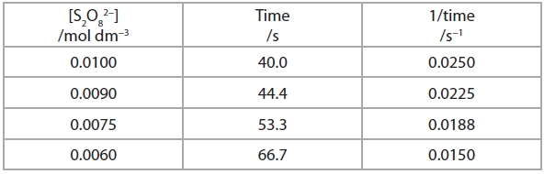

(i)  Plot a graph of 1/time on the vertical axis against the concentration of the persulfate ions. **(2)**



(ii)  1/time is a measure of the initial rate of the reaction.

Deduce the order of the reaction with respect to persulfate ions.

Justify your answer.

**(2)**

.............................................................................................................................................

.............................................................................................................................................

.............................................................................................................................................

.............................................................................................................................................

(iii)  The reaction is first order with respect to iodide ions. Write the overall rate equation for the reaction and deduce the units for the rate constant.

**(2)**

Rate =

Units for the rate constant .....................................

**(Total for question = 10 marks)**

**Q6.** This question is about the kinetics of chemical reactions.

(a)   The rate equation for the reaction between hydrogen and nitrogen monoxide is:

rate = *k*[H2][NO]2

By what factor does the rate increase when the concentration of hydrogen is tripled and that of nitrogen monoxide is doubled?

**(1)**

  **A**   5

  **B**   6

  **C**   12

  **D**   18

(b)   The 'initial rates' method is used to investigate the orders of reaction with respect to reactants **A**, **B** and **C**. The table shows the results obtained.

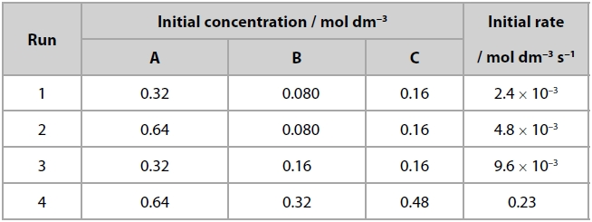

(i)   Deduce the orders with respect to **A** and **B**.

**(2)**

**A**...........................................................

**B**...........................................................

(ii)   Deduce the order with respect to **C** and justify your answer.

**(2)**

.............................................................................................................................................

.............................................................................................................................................

.............................................................................................................................................

.............................................................................................................................................

.............................................................................................................................................

(iii)   Give the rate equation for the reaction.

**(1)**

(iv)   Calculate the rate constant, *k*, to an appropriate number of significant figures. Give units for your answer.

**(3)**

**Q7.**Bromate(V) ions, BrO3−, oxidize bromide ions, Br−, in the presence of dilute acid, H+, as shown in the equation below.



Three experiments were carried out using different initial concentrations of the three reactants.

The initial rate of reaction was calculated for each experiment.

The results are shown in the table below.

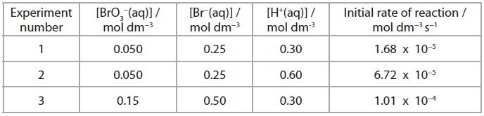

*(a)  (i)   This reaction is first order with respect to BrO3−(aq).  State, with reasons, including appropriate experiment numbers, the order of reaction with respect to

**(5)**

H+(aq)

.............................................................................................................................................

.............................................................................................................................................

.............................................................................................................................................

Br−(aq)

.............................................................................................................................................

.............................................................................................................................................

.............................................................................................................................................

.............................................................................................................................................

(ii)   Write the rate equation for the reaction.

**(1)**

(iii)   Use the data from experiment 1 and your answer to (a)(ii) to calculate the value of the rate constant.  Include units in your answer.

**(3)**

(b)  What evidence suggests that this reaction proceeds by more than one step?

**(1)**

.............................................................................................................................................

.............................................................................................................................................

.............................................................................................................................................

(c)  The initial rate of reaction was obtained from measurements of the concentration of bromine at regular time intervals.  How is the **initial** rate of formation of bromine calculated from a concentration-time graph?

**(2)**

.............................................................................................................................................

.............................................................................................................................................

.............................................................................................................................................

.............................................................................................................................................

**(Total for question = 12 marks)**

**2022**

**NAME ...........................……... HOMEWORK DEADLINE .....................**

Student Number ………… Chemistry Class ………

Student targets from **previous pack**

Chemical Kinetics I

|  |  |
| --- | --- |
| **Task** | Mark |
| **Notes** | /10 |
| – End of pack questions | /42 |
| Revision Notes – or leave until end of Kinetics IIB | /10 |
| Overall grade for work | A* A B C D E U |

Student comments

Tutor comments

Tutor signature Date

Student targets for **next pack**