# Worksheet 2A The Processor

**Task 1**

1. Match the processor components with the correct descriptions:

|  |  |  |
| --- | --- | --- |
| Arithmetic-Logic Unit |  | A single memory location in which intermediate arithmetic and logic results are stored |
| System clock |  | Directs and coordinates the operation of the processor and controls the flow of data within the CPU |
| General purpose registers |  | Memory locations used to assist the operation of the processor in collecting and processing instructions and data |
| Dedicated registers |  | A continuously cycling signal that is used as a timing pulse for all processor components |
| Accumulator |  | Memory locations used to hold values and intermediate results whilst executing an instruction |
| Control Unit |  | Used to carry out the instructions received by the processor and produce the processed output |

**Task 2**

1. An incomplete diagram of processor components is shown below including possible data stored in various registers. The address 027FFF95 contains the instruction ADD R0, R1, #10. Complete the diagram by labelling the name of each component.

*Tip: Think about the contents and connections of each part.*

|  |  |  |
| --- | --- | --- |
| **Memory Address Register** | **General Purpose Registers** | **Control Unit** |
| **Memory Buffer Register** | **Current instruction Register** | **Program Counter** |

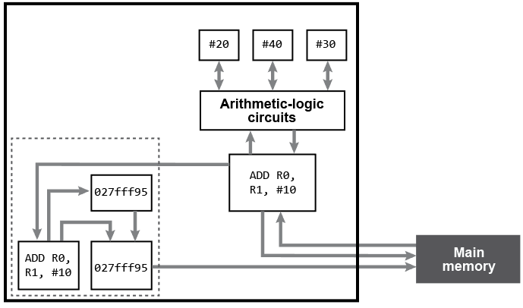

In the spaces below, justify your decisions:

* 1. Memory Address Register:
  2. Memory Buffer Register:
  3. Program Counter:
  4. Current instruction Register:
  5. General Purpose Registers:
  6. Control Unit: