# Worksheet 5 Representing sound Answers

# Task 1 Classifying signals

Below are examples of where signals are used. State whether each would be transmitted as an analogue or digital signal:

|  |  |  |
| --- | --- | --- |
| Signal | Analogue | Digital |
| A radio station broadcasting on the AM frequency | Radio waves are electromagnetic waves. |  |
| A laptop connecting to the Internet through a fibre-optic connection |  | Fibre optic sends pulses of light which represents patterns of 1s and 0s. |
| The speed a car is travelling for display on a speedometer with a needle | Needle is moved based on the amount of voltage generated by an accelerometer. |  |
| The temperature of an oven to be displayed on an LED display |  | Display is digital so analogue temperature likely to be converted before being displayed. |
| The HDMI output of a computer’s graphics card |  | Visual signals sent as bit patterns for each pixel. |
| Pictures from a video camera transmitted to a studio via a microwave transmitter | Microwaves are electromagnetic waves. |  |
| A WiFi router sending a print job to a wireless printer | Uses same principle of radio waves. Digital data is encoded on an analogue signal. |  |

# Task 2 Sampling sound Answers

1. The following two sound samples have been recorded using different resolutions. The first was recorded at a resolution of 2 bits giving four possible wave heights. The second sample was recorded at 4 bits per sample giving 16 possible combinations.

Plot the sample points on each chart that were recorded for the samples and join them up using only horizontal and vertical lines to create a digital representation of the recording. The first three have been done for you.

**Recording A Recording B**

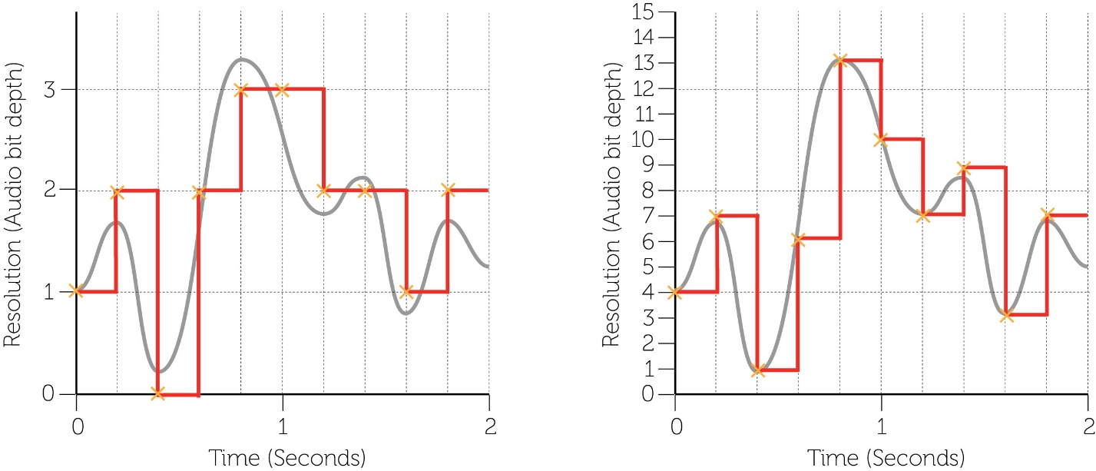

1. How do the two ‘digitised’ recordings compare? Which has greater accuracy and why?

Recording B was recorded at twice the resolution of Recording A. This enables points to be sampled more accurately and therefore the digital representation of the wave is closer to the original.

1. What is the file size of recording A in bits?

2 bits per sample x 5 samples per second x 2 seconds = 20 bits

1. What is the file size of recording B in bits?

4 bits per sample x 5 samples per second x 2 seconds = 40 bits

1. Each sample point in Recording A could be recorded as 0, 1, 2 or 3. To be represented on a disk, the sample points need to be translated into binary. Translate each of the points into their binary representation that would be stored in an audio file.

|  |  |  |  |  |  |  |  |  |  |  |
| --- | --- | --- | --- | --- | --- | --- | --- | --- | --- | --- |
| **Sample** | **0** | **1** | **2** | **3** | **4** | **5** | **6** | **7** | **8** | **9** |
| **Value** | 1 | 2 | 0 | 2 | 3 | 3 | 2 | 2 | 1 | 2 |
| **Binary data value** | 01 | 10 | 00 | 10 | 11 | 11 | 10 | 10 | 01 | 10 |

# Task 3 Nyquist sampling Answers

1. A sound recording of frequency f is being sampled at different rates. Show the waveform of the sound that will be reproduced from the following sampling rates and explain how close the sound will be to the original, identifying any issue with the digital pattern produced:

The first example has been done for you.

|  |  |  |  |
| --- | --- | --- | --- |
| **Sampling frequency** | **Waveform after sampling** | **How close is it to the original?** | **Issues with digital pattern** |
| ***f*** | C:\Users\Rob\Dropbox\PG Online\A Level Series\AQA A Level series\AS AQA Units Incomplete\Unit 3 Data representation - Davison\NyquistWorksheet5.jpg | Not at all similar. | No sound will be reproduced as the cone of the speaker will not move. |
| **3*f*/2** | C:\Users\Rob\Dropbox\PG Online\A Level Series\AQA A Level series\AS AQA Units Incomplete\Unit 3 Data representation - Davison\NyquistWorksheet5.jpg | Not very close at all apart from start and end. | Sound reproduced will likely be unrecognisable |
| **5*f*/2** | C:\Users\Rob\Dropbox\PG Online\A Level Series\AQA A Level series\AS AQA Units Incomplete\Unit 3 Data representation - Davison\NyquistWorksheet5.jpg | Sound will be virtually the same as the original. Some slight distortion but would be hardly noticeable. | Not an exact copy if every detail is important. |
| **5*f*** | C:\Users\Rob\Dropbox\PG Online\A Level Series\AQA A Level series\AS AQA Units Incomplete\Unit 3 Data representation - Davison\NyquistWorksheet5.jpg | Almost identical to the original. There should be no difference detectable. | File size will be a lot larger for very little gain in quality. |

1. State the principle of Nyquist’s theorem:

Sound recordings must be sampled at a rate of at least twice that of the frequency of the original to ensure an accurate reproduction during playback.