# Homework 1 Communication methods

# 1. Define the following terms

(a) protocol [1]

(b) latency [1]

# 2. What method of data transmission is being shown in the diagram below? [1]



3. “Serial data transmission has several advantages over parallel data transmission.”

Discuss this statement. [3]

4. State what type of data transmission is shown in the diagram below and explain the various aspects of the diagram. [4]

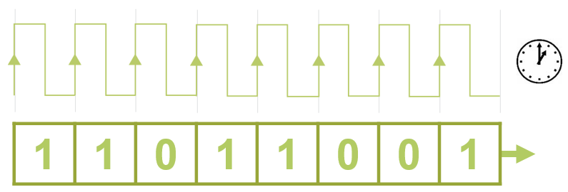

5. A communications channel has a baud rate of 9600bps. A symbol consisting of 8 bits can be encoded at each signal change.

(a) What is the bit rate of the communications channel? [1]

(b) Is this a baseband or broadband mode of operation? [1]

(c) Is the communications channel using serial or parallel transmission? [1]

6. Jo is sitting in an airport trying to access the Internet on a computer terminal for public use. The connection is slow. Why might it be slower than accessing the Internet from his home computer? [2]

[Total 15 Marks]