# Worksheet 1 Communication methods Answers

**Task 1**

1. (a) Darren’s rather old printer is connected via a cable to his computer. He wants to move the printer to the other side of the room and searches the Internet for a 5m cable. He finds several cables with the right connector like the one below.

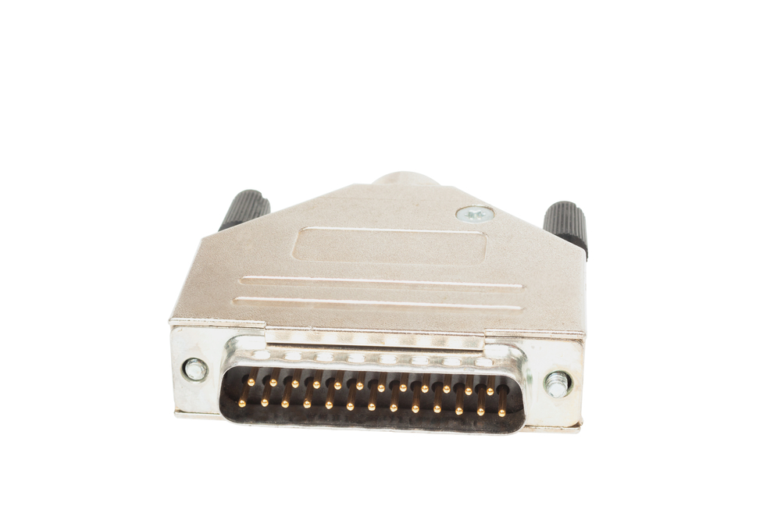

However, he cannot find one that is longer than 1.8m. Why not? What should he do?

Parallel transmission is not reliable over more than about 2m, owing to problems of *skew* and *crosstalk*, so he will not find a longer cable.

He could buy a 5m USB (Universal serial bus) cable and a USB/parallel adapter.

He should probably buy a new printer … not that much more expensive than a new cable and adapter nowadays. The USB interface has replaced the parallel printer port for connections both to printers and to other devices.

(b) Explain why serial transmission is often faster than parallel transmission.

Serial transmission is slower than parallel transmission given the same signal frequency. With parallel transmission you can transfer one word per cycle (e.g. 1 byte = 8 bits) but with a serial transmission only a fraction of it (1 bit).

However, you cannot transmit at very high frequencies on a parallel transmission line because of the problem of *skew*, which increases at higher frequencies.

Also the higher the frequency, the more pronounced *crosstalk* gets, and higher the probability that a corrupted word will need to be retransmitted.

So with serial transmission you can use much higher frequencies which results in a higher transfer rate as more than one bit can be encoded at each frequency.

(c) Where/when is parallel transmission used?

In internal buses connecting components inside the CPU. It used to be commonly used for connecting external disk drives or printers, but nowadays a USB connection is faster and cheaper and many PCs do not have an external parallel port.

**Task 2**

3. (a) Label Figure 1 and Figure 2 to show which type of transmission is shown in each.

**Figure 1:** Synchronous data transmission

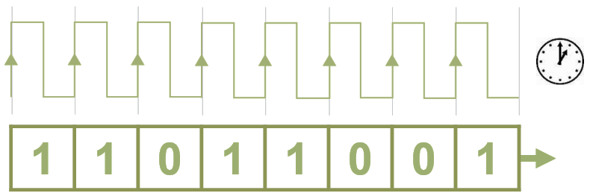

**Figure 2:** Asynchronous data transmission

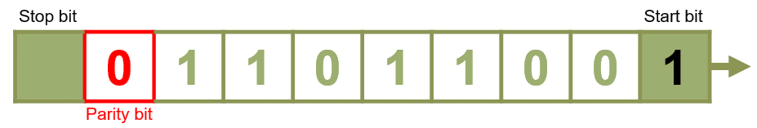

(b) Explain what the start and stop bits are for.

To signal the start and end of a communication

(c) What is the purpose of the parity bit? Explain the difference between **odd** and **even** parity systems.

The parity bit is a check on the accuracy of transmission. If one bit has changed during transmission, the parity bit will be wrong, and the block will be re-transmitted.

With even parity, the total number of 1 bits, including the parity bit, will be even. With odd parity, the total number of 1 bits, including the parity bit, will be odd.

(d) Complete the following table:

|  |  |  |  |
| --- | --- | --- | --- |
| **7 data bits** | **Count of 1 bits** | **8 bits including parity** | |
| **Even** | **Odd** |
| 0000000 | 0 | 00000000 | 00000001 |
| 1011000 | 3 | 10110001 | 10110000 |
| 0011110 | 4 | 00111100 | 00111101 |
| 1111111 | 7 | 11111111 | 11111110 |

(e) Explain why synchronous transmission is faster than asynchronous transmission.

Fewer data bits have to be transmitted, only data bits and no control bits.

4. (a) Define **bit rate** and **baud rate**.

Bit rate: the speed at which data is transmitted serially measured in bits per second

Baud rate: the rate at which a signal changes state in a communications channel measured in bits per second (bps)

(b) Explain why the baud rate is always less than or equal to the bit rate but never greater.

bit rate = baud rate x number of bits per signal

baud rate = bit rate/ number of bits per signal

Number of bits per signal >= 1, therefore baud rate <= bit rate

5. Test the bandwidth of your computer on a speed test site, e.g.

<http://speedtest.zoominternet.net/>

Why do you think upload speed is so much slower than download speed?

Downloading is required much more frequently so most of the bandwidth is reserved for downloading.