# Worksheet 1 Communication methods

**Task 1**

1. (a) Darren’s rather old printer is connected via a cable to his computer. He wants to move the printer to the other side of the room and searches the Internet for a longer cable. He finds suitable several cables like the one below.

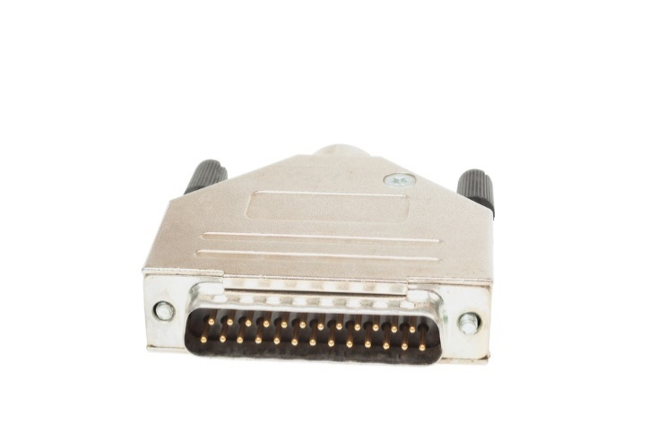

However, he cannot find one that is longer than 1.8m. Why not? What should he do?

(b) Explain why serial transmission is often faster than parallel transmission.

(c) Where or when is parallel transmission used?

**Task 2**

3. (a) Label Figure 1 and Figure 2 to show which type of transmission is shown in each.

**Figure 1:** ___________________ data transmission

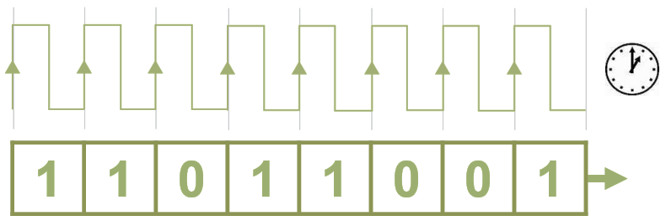

**Figure 2:** ___________________ data transmission

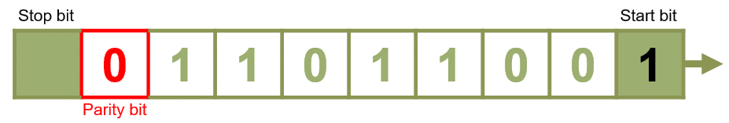

(b) Explain what the start and stop bits are used for.

(c) What is the purpose of the parity bit? Explain the difference between **odd** and **even** parity systems.

(d) Complete the following table:

|  |  |  |  |
| --- | --- | --- | --- |
| **7 data bits** | **Count of 1 bits** | **8 bits including parity** | |
| **Even** | **Odd** |
| 0000000 |  |  |  |
| 1011000 |  |  |  |
| 0011110 |  |  |  |
| 1111111 |  |  |  |

(e) Explain why synchronous transmission is faster than asynchronous transmission.

4. (a) Define **bit rate** and **baud rate**.

(b) Explain why the baud rate is always less than or equal to the bit rate but never greater.

5. Test the bandwidth of your computer on a speed test site, e.g.

<http://speedtest.zoominternet.net/>

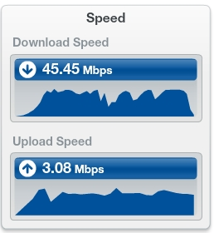

Why do you think upload speed is so much slower than download speed?