**Hangman Technical Solution**

**Code:**

Imports System.IO.File

Public Class Form1

Dim LetterButton(26) As Button

Dim AlreadyGuessed(26) As Boolean

Dim Word As String

Dim guesses As Integer = 0

Dim spaces As String = ""

Dim SpacesLabel As New Label

Dim GallowsCounter As Integer

Private Sub CreateLetters_Click()

For i = 1 To 26

LetterButton(i) = New Button

LetterButton(i).Size = New Size(30, 30)

LetterButton(i).BackColor = Color.WhiteSmoke

If i \ 10 = 0 Then

LetterButton(i).Location = New Size(30 * i, 30)

ElseIf i \ 10 = 1 Then

LetterButton(i).Location = New Size((30 * i) - 285, 60)

ElseIf i \ 10 = 2 Then

LetterButton(i).Location = New Size((30 * i) - 540, 90)

End If

LetterButton(i).Text = Chr(i + 64)

AddHandler LetterButton(i).Click, AddressOf letter_click

Me.Controls.Add(LetterButton(i))

Next

End Sub

Sub GenerateWord()

Dim lineCount = IO.File.ReadAllLines("words.txt").Length

Dim CanBeUsed As Boolean

If lineCount = IO.File.ReadAllLines("usedwords.txt").Length Then

System.IO.File.WriteAllText("usedwords.txt", "")

End If

Do

CanBeUsed = True

Randomize()

Dim LineNumber As Integer = Int((LineCount * Rnd()) + 1)

Dim wordfile As System.IO.StreamReader = System.IO.File.OpenText("words.txt")

Dim line As String = "start"

Dim counter As Integer = 0

Do Until line = Nothing

line = wordfile.ReadLine()

counter += 1

If counter = LineNumber Then

Word = line.ToUpper()

Dim UsedWords As System.IO.StreamReader = System.IO.File.OpenText("usedwords.txt")

Dim usedline As String = "start"

Do Until usedline = Nothing

usedline = UsedWords.ReadLine()

If usedline <> Nothing Then

If usedline = Word Then

CanBeUsed = False

End If

End If

Loop

UsedWords.Close()

End If

Loop

wordfile.Close()

Loop Until CanBeUsed = True

MsgBox(Word)

Dim file As System.IO.StreamWriter

file = My.Computer.FileSystem.OpenTextFileWriter("usedwords.txt", True)

file.WriteLine(Word)

file.Close()

End Sub

Sub CreateSpaces()

SpacesLabel.Size = New System.Drawing.Size(50 * Len(Word), 40)

SpacesLabel.Location = New System.Drawing.Point(500, 90)

SpacesLabel.Font = New Font("Comic Sans MS", 20)

SpacesLabel.BackColor = Color.White

SpacesLabel.Text = spaces

Me.Controls.Add(SpacesLabel)

End Sub

Sub letter_click()

Dim letterguessed As Char

For i = 1 To 26

If LetterButton(i).ContainsFocus Then

letterguessed = Chr(i + 64)

LetterButton(i).BackColor = Color.DarkGray

If AlreadyGuessed(i) <> True Then

guesses += 1

Dim correct As Boolean = False

For character = 1 To Len(Word)

If Word(character - 1) = letterguessed Then

correct = True

spaces = spaces.Remove(2 * (character - 1), 1)

spaces = spaces.Insert(2 * (character - 1), letterguessed)

CreateSpaces()

End If

Next

If correct = False Then

GallowsCounter += 1

Me.Invalidate()

End If

End If

AlreadyGuessed(i) = True

If GallowsCounter = 12 Then

MsgBox("YOU LOSE")

Dim username As String = InputBox("Enter your username")

Dim file As System.IO.StreamWriter

file = My.Computer.FileSystem.OpenTextFileWriter("scoreboard.txt", True)

file.WriteLine(username & " lost to the word: " & Word & " with " & guesses & " guesses")

file.Close()

If InputBox("Do you want to play again? (Y/N)") = "Y" Then

Application.Restart()

Else

System.IO.File.WriteAllText("usedwords.txt", "")

Me.Close()

End If

End If

If Word.ToUpper = spaces.Replace(" ", "") Then

MsgBox("YOU WIN")

Dim username As String = InputBox("Enter your username")

Dim file As System.IO.StreamWriter

file = My.Computer.FileSystem.OpenTextFileWriter("scoreboard.txt", True)

file.WriteLine(username & " guessed the word: " & Word & " with " & guesses & " guesses")

file.Close()

If InputBox("Do you want to play again? (Y/N)") = "Y" Then

Application.Restart()

Else

System.IO.File.WriteAllText("usedwords.txt", "")

Me.Close()

End If

End If

End If

Next

End Sub

Sub UpdateGallows(g)

Dim GallowFile As String = "gallows" & (Str(GallowsCounter)).TrimStart & ".png"

Dim GallowPart As Bitmap = New Bitmap(GallowFile)

If GallowsCounter = 1 Then

g.DrawImage(GallowPart, 100, 500)

Else

g.DrawImage(GallowPart, 100, 265)

End If

End Sub

Private Sub Form1_Paint(sender As Object, e As PaintEventArgs) Handles Me.Paint

Dim g As Graphics = e.Graphics

g.Clear(Color.White)

UpdateGallows(g)

End Sub

Private Sub Form1_Load(sender As Object, e As EventArgs) Handles MyBase.Load

play()

End Sub

Sub play()

guesses = 0

GallowsCounter = 0

Me.Invalidate()

For letter = 1 To 26

AlreadyGuessed(letter) = False

Next

GenerateWord()

For charcter = 1 To Len(Word)

spaces += "_ "

Next

CreateSpaces()

CreateLetters_Click()

End Sub

End Class

**Testing:**

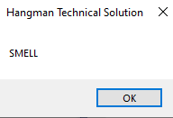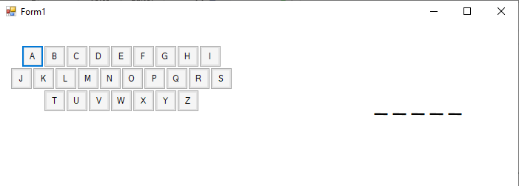

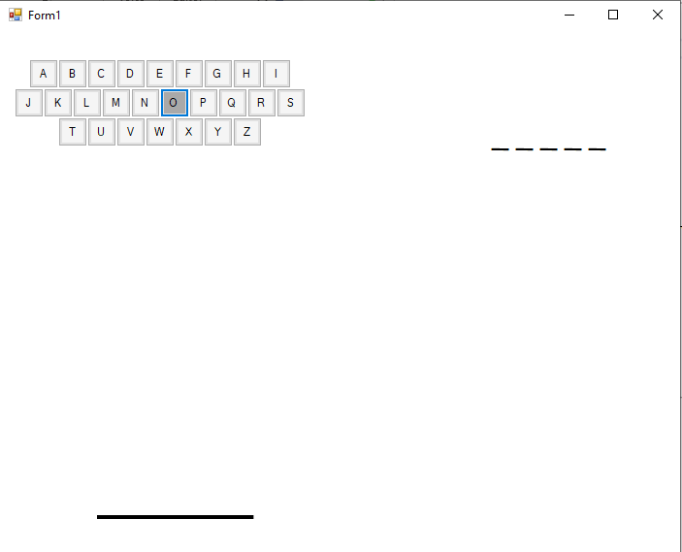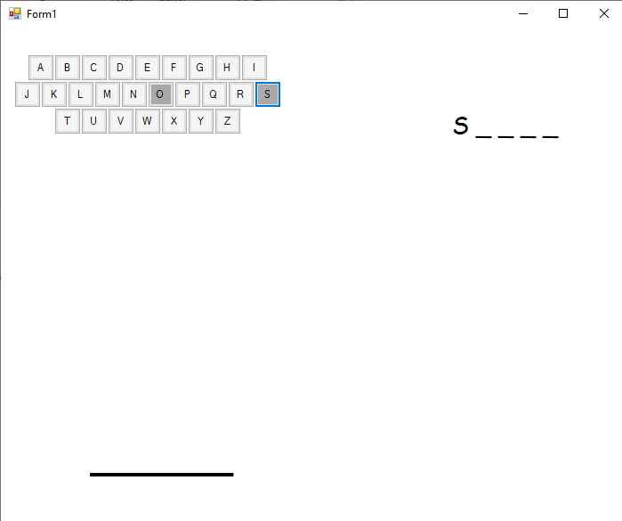

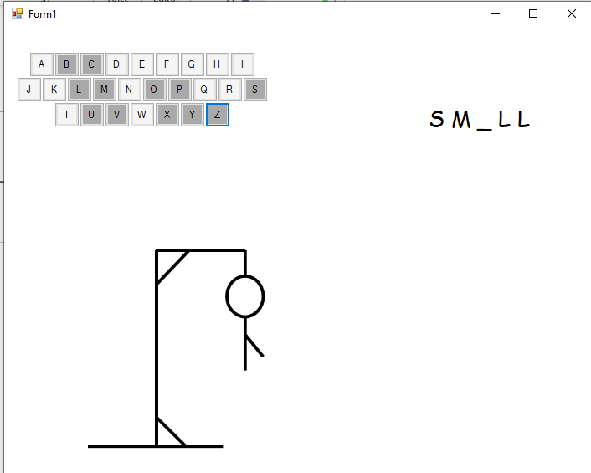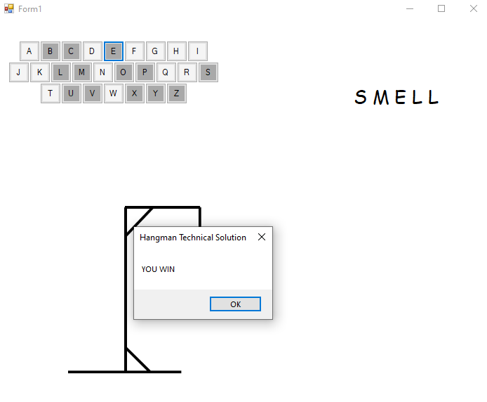

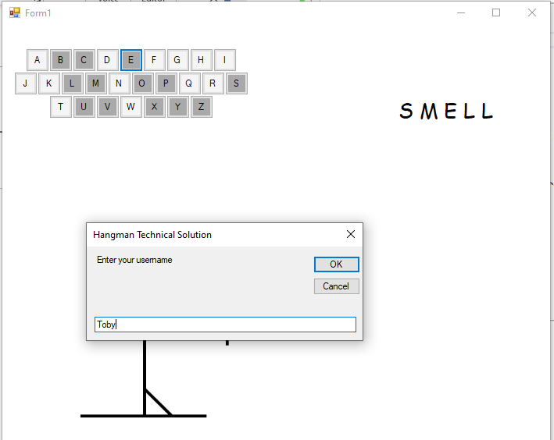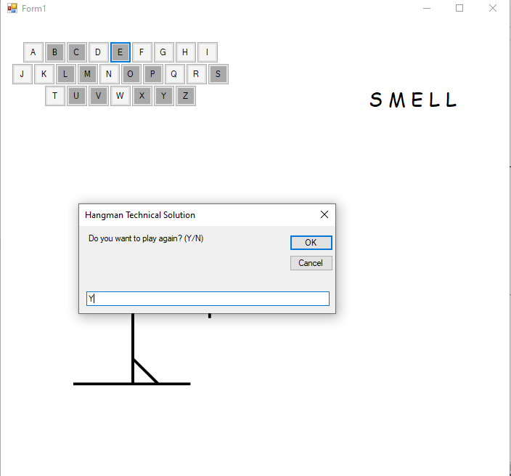

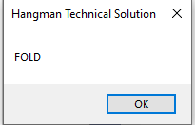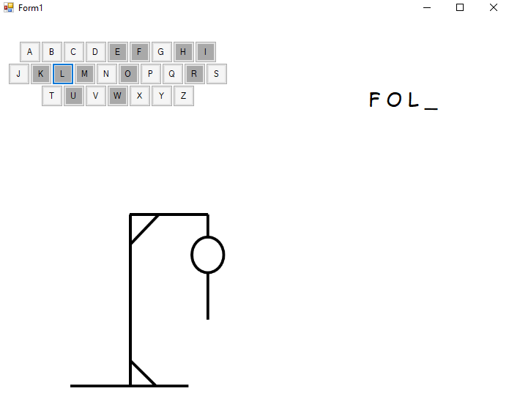

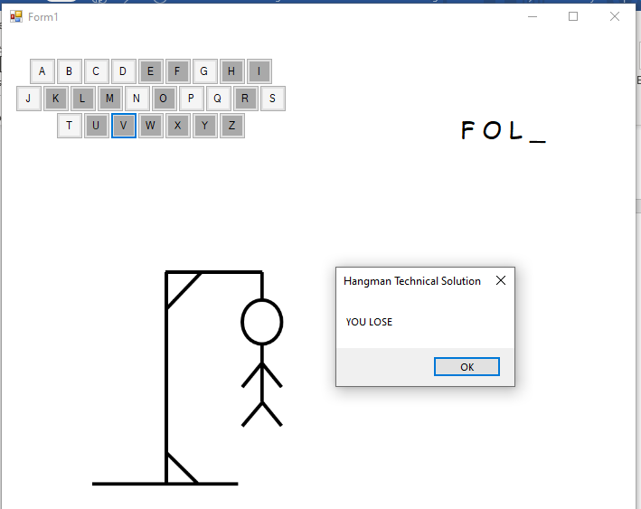

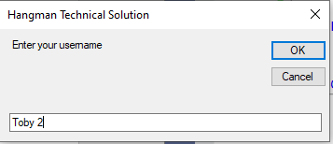

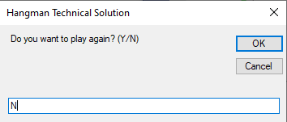

**Files:**

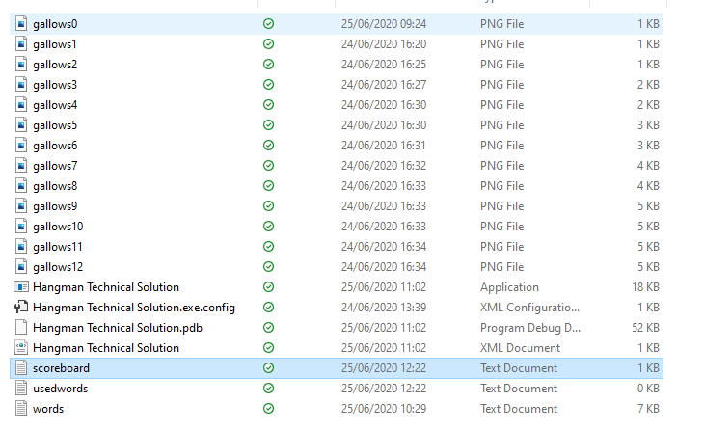

Gallows6.txt **:**

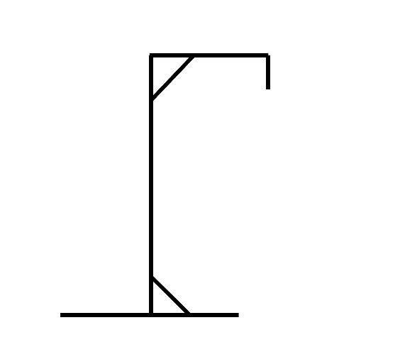

Words.txt: Scoreboard.txt :

