Q1.
(a) Look at the truth table below.

 | Input A | Input B | Output Q
 | 0 | 0 | 1
 | 0 | 1 | 0
 | 1 | 0 | 0
 | 1 | 1 | 0

What logic gate does the table represent?
........................................................................................................................
(1)

(b) An interior light in a two-door car is controlled by two switches that the driver can turn on or off and two sensors, one per door.
The switches are named A and B.
The door sensors are named C and D.
The interior light is named L.
If a door is open the output of its sensor is on.
If a door is closed the output of its sensor is off.
• If both switches A and B are off then the light L is always off.
• If switch A is on the light L is always on.
• If switch B is on and switch A is off then:
○ the light L turns on if one or more of the car doors is opened
○ the light L turns off if both of the doors are closed.
The following symbols are used to represent logic gates:
 |  | 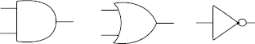
 | AND |  | OR | NOT

(i) Using only AND, OR and NOT gates draw a logic circuit for this system in the box below. You may not need to use all three types of gate.
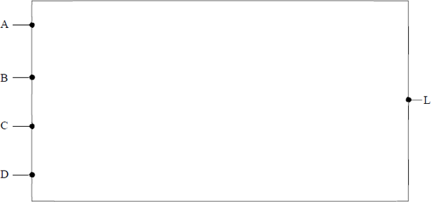
(3)

(ii) Write a Boolean expression to represent the logic of the interior light system.
...............................................................................................................
(1)

(c) Simplify the Boolean expression below, showing your working.
........................................................................................................................
........................................................................................................................
........................................................................................................................
........................................................................................................................
........................................................................................................................
........................................................................................................................
........................................................................................................................
........................................................................................................................
........................................................................................................................
(3)
(Total 8 marks)

Q2.
Simplify the Boolean expression:
Show your working.
................................................................................................................................
................................................................................................................................
................................................................................................................................
................................................................................................................................
................................................................................................................................
(Total 3 marks)

Q3.
(a) Complete the truth tables for the following logic gates.

 | OR Gate |  |  |  | XOR Gate
 | Input A | Input B | Output Q |  | Input A | Input B | Output Q
 | 0 | 0 |  |  | 0 | 0
 | 0 | 1 |  |  | 0 | 1
 | 1 | 0 |  |  | 1 | 0
 | 1 | 1 |  |  | 1 | 1

(2)

(b) Represent the Boolean equation Q = A + B·. as a logic circuit by drawing a diagram of it in the space below.
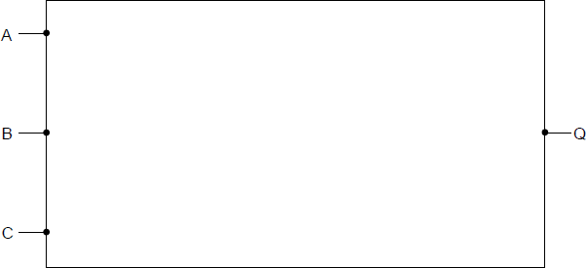
(3)

(c) Simplify the Boolean expression:
B·(A + )
Show your working.
........................................................................................................................
........................................................................................................................
........................................................................................................................
........................................................................................................................
(3)
(Total 8 marks)

Q4.
Write the following Boolean expressions in their simplest forms.
(a)

........................................................................................................................
(1)

(b)

........................................................................................................................
(1)

(c)

........................................................................................................................
(1)

(d) A . (B+1)
........................................................................................................................
(1)
(Total 4 marks)

Q5.
(a) Complete the truth tables for the following logic gates.

 | NAND Gate
 | Input  X | Input  Y | Output  Q
 | 0 | 0
 | 0 | 1
 | 1 | 0
 | 1 | 1

 | NOR Gate
 | Input  X | Input  Y | Output  Q
 | 0 | 0
 | 0 | 1
 | 1 | 0
 | 1 | 1

(2)

(b) Represent the Boolean equation Z = . + C in the form of a logic circuit by drawing a diagram in the space below using the following symbols.
 | 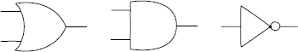
 | OR | AND | NOT

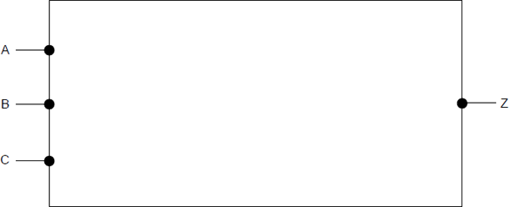
(3)

(c) Simplify the Boolean expression below.
Show each stage of your working.
........................................................................................................................
........................................................................................................................
........................................................................................................................
........................................................................................................................
........................................................................................................................
(3)

Final answer ..................................................................................................
(1)
(Total 9 marks)

Q6.
The diagram below shows a logic circuit.
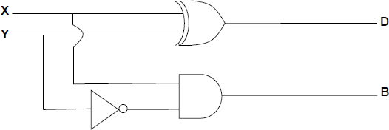
(a) Write a Boolean expression for D.
........................................................................................................................
(1)

(b) Write a Boolean expression for B.
........................................................................................................................
(1)

(c) The diagram below shows a different logic circuit.
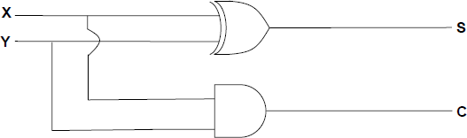
(i) Complete the truth table below for the logic circuit in the diagram above.

 | Inputs |  | Outputs
 | X | Y | C | S
 | 0 | 0
 | 0 | 1
 | 1 | 0
 | 1 | 1

(2)

(ii) What arithmetic function does the logic circuit in the diagram above perform?
...............................................................................................................
(1)

(d) Without using a truth table, simplify the Boolean expression below.
( X + Y ) . ( X + )
Show the stages of your working.
........................................................................................................................
........................................................................................................................
........................................................................................................................
........................................................................................................................
........................................................................................................................
........................................................................................................................
........................................................................................................................
........................................................................................................................
........................................................................................................................
........................................................................................................................
........................................................................................................................
(3)
Final answer ..................................................................................................
(1)
(Total 9 marks)

Q7.
(a) Complete the truth tables for the following logic gates.

 | AND Gate |  |  |  | XOR Gate
 | Input X | Input Y | Input Q |  | Output X | Input Y | Output Q
 | 0 | 0 |  |  | 0 | 0
 | 0 | 1 |  |  | 0 | 1
 | 1 | 0 |  |  | 1 | 0
 | 1 | 1 |  |  | 1 | 1

(2)

(b) A line-following robot has three sensors. It moves along a black line on a white background whilst the following conditions are met:
• the ultrasonic sensor U does not detect any obstacle
• either, but not both, of the infrared sensors L and R are on the black line.
Sensor U returns 1 if it detects an obstacle and 0 if the path is clear.
Sensors L and R each return 1 if they detect black and 0 if they detect white.
A logic circuit will process the input from the sensors and produce an output M.
M should be 1 if the robot is to move and 0 if the robot should stop.
(i) Represent the output M as a Boolean expression.
M = ........................................................................................................
(3)

(ii) The following symbols are used to represent logic gates:

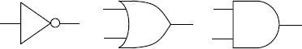
NOT OR AND

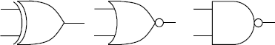
XOR NOR NAND

Using a combination of any of the above logic gates draw a logic circuit for this system in the box below. You will not need to use all of the different types of logic gates.
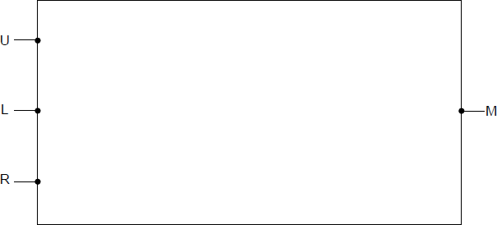
(3)

(c) Apply De Morgan’s Law(s) to the following expression and simplify the result.
Show the stages of your working.
........................................................................................................................
........................................................................................................................
........................................................................................................................
........................................................................................................................
(2)

Final answer ..................................................................................................
(1)
(Total 11 marks)

Q8.
(a) Represent the Boolean equation Q = as a logic circuit by drawing a diagram in the space below using only the following symbols:
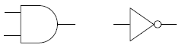

 | AND | NOT

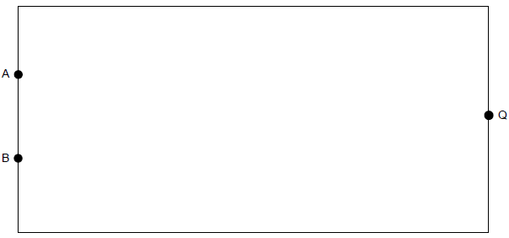
(3)

(b) Use the following truth tables to demonstrate that A + B =

 | A | B | A + B |  | A | B
 | 0 | 0 |  |  | 0 | 0
 | 0 | 1 |  |  | 0 | 1
 | 1 | 0 |  |  | 1 | 0
 | 1 | 1 |  |  | 1 | 1

(4)

(c) What is the name commonly associated with the statement A + B = ?
........................................................................................................................
(1)

(d) Simplify the Boolean expression below.
A.B. + A.
Show each stage of your working in the space below.

(2)

Final answer ..................................................................................................
(1)
(Total 11 marks)

Q9.
(a) State the names of the logic gates represented by each of the three truth tables below.

 | Input A | Input B | Output
 | 0 | 0 | 0
 | 0 | 1 | 0 | Logic gate name ....................................
 | 1 | 0 | 0
 | 1 | 1 | 1

 | Input A | Input B | Output
 | 0 | 0 | 1
 | 0 | 1 | 0 | Logic gate name ....................................
 | 1 | 0 | 0
 | 1 | 1 | 0

 | Input A | Input B | Output
 | 0 | 0 | 0
 | 0 | 1 | 1 | Logic gate name ....................................
 | 1 | 0 | 1
 | 1 | 1 | 0

(3)

(b) Simplify the following Boolean expressions.
(i) B . (A+)
...............................................................................................................
...............................................................................................................
(1)

(ii) A . B + B
...............................................................................................................
...............................................................................................................
(1)

(iii)
...............................................................................................................
...............................................................................................................
(2)

(c) Draw a logic circuit for the following Boolean expression:
Q = (A ⊕ B) . B
You will need to make use of the symbols below when drawing your logic circuit.
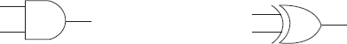
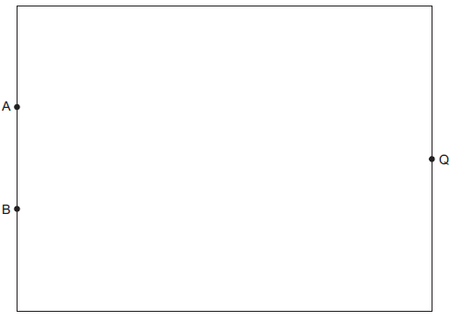
(2)
(Total 9 marks)

Q10.
(a) Complete the truth tables for the following logic gates.
OR gate

 | Input A | Input B | Output
 | 0 | 0
 | 0 | 1
 | 1 | 0
 | 1 | 1

NAND gate

 | Input A | Input B | Output
 | 0 | 0
 | 0 | 1
 | 1 | 0
 | 1 | 1

(2)

(b) Represent the following Boolean equation as a logic circuit by completing the diagram below.
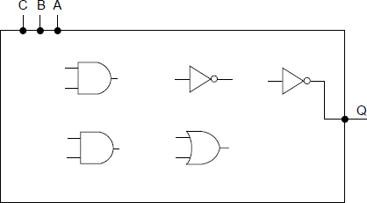
(5)

(c) Simplify the following expression.
Show each stage of your working in the space below.
(2)

Final answer .......................................................................................................
(1)
(Total 10 marks)

Q11.
(a) Complete the truth table below for a NAND gate.

 | NAND gate
 | Input A | Input B | Output
 | 0 | 0
 | 0 | 1
 | 1 | 0
 | 1 | 1

(1)

(b) Multiplexors are used in electronic switching.
A 2-to-1 multiplexor has a Boolean equation where A and B are two inputs, S is the selector input, and Q is the output.
(i) Complete the truth table for the above Boolean equation.

 | S | A | B |  |  | B.S | Q
 | 0 | 0 | 0
 | 0 | 0 | 1
 | 0 | 1 | 0
 | 0 | 1 | 1
 | 1 | 0 | 0
 | 1 | 0 | 1
 | 1 | 1 | 0
 | 1 | 1 | 1

(3)

(ii) Draw a circuit for the Boolean equation in the rectangle below.
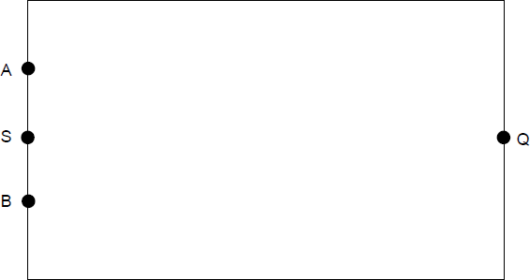
(4)

(iii) By considering its inputs and outputs, describe what the 2-to-1 multiplexor circuit does.
...............................................................................................................
...............................................................................................................
...............................................................................................................
(1)
(Total 9 marks)

M1.
(a) NOR (Gate)
I case of answer i.e. nor is allowed
1

(b) (i) Solution 1:
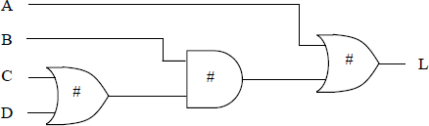
Solution 2:
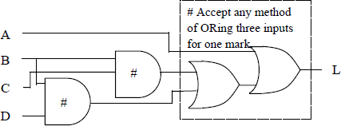

Solution 3 (solution 1 plus check for A off):
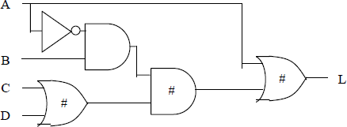

Solution 4 (solution 2 plus check for A off):
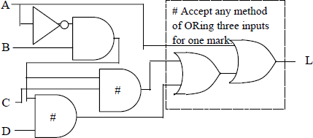

1 mark for each correctly linked gate that is marked with a #
A 3-input OR gate
P1 for any unnecessary gates in a solution that would otherwise get 3 marks.
P1 for any solution that would not correctly implement the logic but would otherwise get 3 marks.
Mark from left to right until first mistake encountered then from right to left. When marking left to right award 1 mark for each gate correctly connected to its inputs. When marking right to left award 1 mark for each gate correctly connected to its output.
3

(ii) A + B.(C+ D)
A + B.C+ B.D
A + .B. (C+ D)
A + .B.C+ .B.D
A Insertion of extra brackets that do not affect logic of expression
Note: Expression does not need to match diagram drawn in (i).
A alternative notations :
• For X.Y allow X AND Y, X ∧ Y , X ∩ Y, XY
• For X+Y allow X OR Y, X ∨ Y , X ∪ Y
• For allow NOT X, ¬X
1

(c) Algebraic Solution:
+ B. [Application of DeMorgan’s Law 1 mark]
A.B + B. [Common term B taken out 1 mark]
B.(A + ) // B.1
B [Correct answer 1 mark]
A alternative notations :
• For X.Y allow X AND Y, X ∧Y , X ∩ Y, XY
• For X+Y allow X OR Y, X∨ Y , X∪Y
• For X allow NOT X, ¬X

Truth Table Solution:
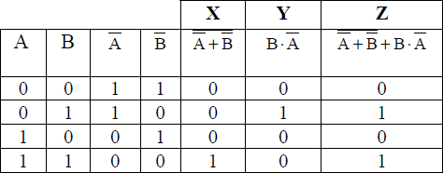
1 mark for both columns X and Y correct1 mark for column Z correct1 mark for correct answer (B)
A Rightmost column labelled as L or Q
3
[8]

M2.
Algebraic Solution:

 | Method 1 | Method 2
 | + A  = + + A  = 1 +  = 1 | + A  =  =  =  = 1

1 mark for an application of a DeMorgan’s law
1 mark for realisation that A + + = 1 + or = (must be written in method, not just inferred that student has done this if arrives at correct answer)
1 mark for correct answer
Truth table solution:

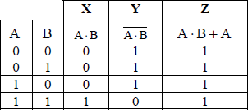

1 mark for column Y correct
1 mark for column Z correct
1 mark for correct answer
Any other method:
If student has used any other method to arrive at correct answer then award marks as follows:
1 mark for correct answer, no working out
2 marks for correct answer with working out, not all steps shown.
3 marks for correct answer with all steps of working out shown.
A True for 1, False for 0
A alternative notations :
• For X.Y allow X AND Y, X∧Y ,X∩Y, XY
• For X+Y allow X OR Y, X∨Y , X∪Y
• For allow NOT X, ¬X
[3]

M3.
(a)
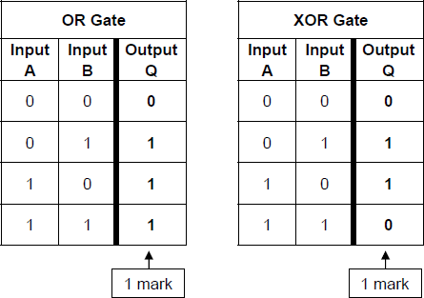
1 mark for each correct output column
A True for 1, False for 0
2

(b)
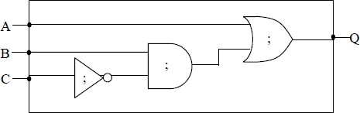
1 mark for NOT gate correctly linked to input C;
1 mark for AND gate correctly linked to B and as input;
A if AND gate linked directly to C
1 mark for OR gate with inputs from A and the output of an AND gate and output connected to Q;
3

(c) Algebraic solution:
B.( A + )
B.A + B. [1 mark for expansion of brackets ]
B.A + 0 [1 mark for identifying that B. = 0 ]
B.A [1 mark for correct answer]
Truth table solution:
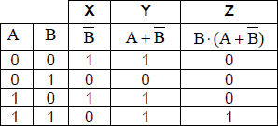
1 mark for both columns X and Y correct
1 mark for column Z correct
1 mark for correct answer (B.A)
Any other method:
If student has used any other method to arrive at correct answer then award marks as follows:
1 mark for correct answer, no working out
2 marks for correct answer with working out, not all steps shown.
3 marks for correct answer with all steps of working out shown.
A True for 1, False for 0
A alternative notations :
• For X.Y allow X AND Y, X∧Y ,X∩Y, XY
• For X+Y allow X OR Y, X∨Y , XUY
• For allow NOT X, ¬X
3
[8]

M4.
becomes A + B ;
A (A+B);
A A OR B;
B+ B. becomes B ;
A B+ A. becomes A ;
A (B+1) becomes A ;
1 mark for each
[4]

M5.
(a)
 | NAND | NOR
 | 1 | 1
 | 1 | 0
 | 1 | 0
 | 0; | 0;

2

(b)
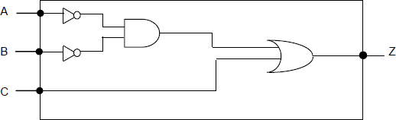
1 mark for NOT gates on both A and B;
1 mark for AND with inputs from and ;
A inputs from A and B
1 mark for OR gate with inputs from AND gate output and C and output connected to Z;
3

(c)
; ; 2 marks – 1 each for De Morgans rule for each side of the central OR (award the mark for right hand expression, even if double NOT over B is not cancelled)
Recognising NOT A OR NOT A is NOT A, and producing a correct expression
+1; Recognising B or NOT B is 1
Final answer 1 ;
Alternative answer
; Application of De Morgan’s to entire expression
; Cancellation of NOTs; 1 mark – De Morgans on entire expression
Recognising A and A is A
Recognising B ANDed with its complement is 0
Recognising 0 AND anything is 0
Final answer 1 ;
Note: Marks can be awarded for the skills above if seen but Max 3 (out of 4) for whole question if working has errors in it
A T, True for 1 and F, False for 0
A alternative notations :
• For X.Y allow X AND Y, X ∧ Y,X∩Y, XY
• For X+Y allow X OR Y, X v Y, X U Y
• For allow NOT X, ¬X
Or by truth table M = marking point
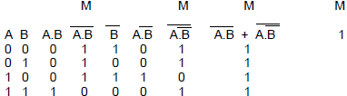
Max 3 for stages, 1 for final answer
4
[9]

M6.
(a) X Y;
A alternative notations:
X XOR Y
X EOR Y
X AND NOT Y OR NOT X AND Y
Acceptable notation for symbols :
For X.Y allow X∧Y, X∩Y, XY
For X+Y allow XvY,XUY
For X allow ~X
1

(b) ;
A alternative notations : X AND NOT Y;
1

(c) (i)
 | Inputs |  | Outputs
 | X | Y | C | S
 | 0 | 0 | 0 | 0
 | 0 | 1 | 0 | 1
 | 1 | 0 | 0 | 1
 | 1 | 1 | 1 | 0

One mark for C column;
One mark for S column;
2

(ii) Addition // adder;
A sum;
1

(d)
[Fully expanding brackets – 1 mark]
[Recognising X.X = X OR Y. = 0 –1 mark]
[Taking X outside brackets – 1 mark]
X[Final Answer, 1 mark]

Alternative Answer : (Distributive)
 |  | [Use of distributive law – 1 mark]
 |  | [Recognising Y . = 0 – 1 mark]
 | X + 0 = X | [ 1 mark ]
 | X | [Final Answer, 1 mark]

Alternative Answer : (De Morgan’s)
 |  | [Use of De Morgan’s – 1 mark]
 |  | [Two further applications of De Morgan’s]
[Taking X outside brackets – 1 mark]
[Recognising ~Y + Y = 1 – 1 mark]
 |  | [Recognising X.1=X – 1 mark]
 | X=Q | [Final answer, 1 mark]

Max 3 for working/method;
1 for final answerX on own with no working gains 1 mark.
Max 4
[9]

M7.
(a)
 | AND Gate
 | Input X | Input X | Output Q
 | 0 | 0 | 0
 | 0 | 1 | 0
 | 1 | 0 | 0
 | 1 | 1 | 1

 | XOR Gate
 | Input X | Input X | Output Q
 | 0 | 0 | 0
 | 0 | 1 | 1
 | 1 | 0 | 1
 | 1 | 1 | 0

1 mark for each of the output columns
2

 | (b) | (i)

[Brackets are not necessary]
1 mark for use of correct operands (L,R,U);
1 mark for use of XOR with L,R;
1 mark for NOT U anded with other part;

alternative:

1 mark for use of correct operands (L,R,U);
1 mark for alternative XOR expression;
1 mark for AND NOT U;

alternative:

1 mark for use of correct operands (L,R,U);
1 mark for alternative XOR expression;
1 mark for AND NOT U;
Acceptable notation for symbols
~ for NOT
X.Y allow X AND Y, XэY,X)Y, XY
X+Y allow X OR Y, X(Y, X*Y
3

(ii)
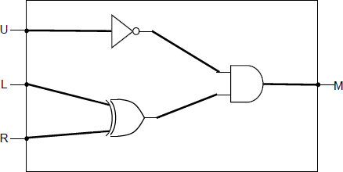

L, R connected to XOR gate;
U connected to NOT gate;
Output of a two input AND gate connected to M;
Max 2 if circuit does not reflect the correct logic
Alternative :
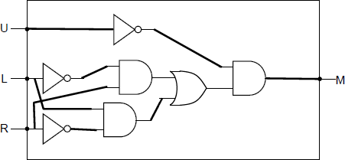

U connected to NOT gate;
Correct gates used for L and R before last AND gate;
Output of a two input AND gate connected to M;
Alternative :
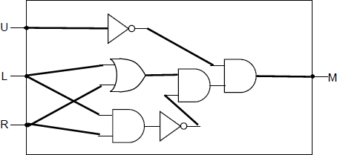
Marked as above alternative.
3

(c) Solution 1:
 | 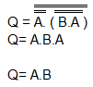 | [Application of De Morgan’s Law –1 mark]  [allow simplification of double nots at same time]  [Simplification of A.A to A –1 mark]  [Correct solution – 1 mark]

Solution 2:
 | 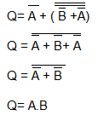 | [Application of De Morgan’s Law –1 mark]  [allow simplification of double nots at same time]  [Simplification of NOT A OR NOT A to NOT A – 1 mark]  [De Morgan’s again to correct solution – 1 mark]

1 mark for De Morgan;
1 mark for simplification;
1 mark for final answer;
Other notations as for section (b)
No working marks for truth table solution (asked to use De Morgan’s in question)
3
[11]

M8.
(a)
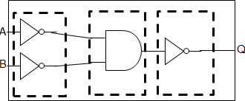
1 mark – logic of first part satisfies NOT A, NOT B;
1 mark – inputs into an AND gate;
1 mark – output from AND gate passes through a NOT gate and connected to Q;
3

(b)
 | A | B | A + B
 | 0 | 0 | 0
 | 0 | 1 | 1
 | 1 | 0 | 1
 | 1 | 1 | 1

1 mark for correct A + B column;

 | A | B
 | 0 | 0 | 1 | 1 | 1 | 0
 | 0 | 1 | 1 | 0 | 0 | 1
 | 1 | 0 | 0 | 1 | 0 | 1
 | 1 | 1 | 0 | 0 | 0 | 1

1 mark for columns and column being correct;
1 mark for column being correct;
1 mark for column being correct;
Note: Can follow through into column from previous two
4

(c) De Morgan's (law);
1

(d) Mark allocation:
One mark for taking either A, NOT C or A AND NOT C
outside of brackets to produce a correct expression;
One mark for eliminating B in a valid way;
One mark for correct final answer;
Example One:
A.B. + A.
A (B. + ) - taking A outside of brackets;
A ((B + 1)) ( B + 1 ) = 1
Simplifying to remove B using B + 1 = 1 ;
B. + =
Simplifying to remove B using B. + = ;
A A( (B + 1))→ A.;
Final answer A.
Example Two:
A.B. + A.
A.(B + 1) – taking outside of brackets;
(B + 1 ) = 1; - simplifying to remove B
A A.(B + 1)→ A.
Final answer A.
Truth Table Method

 | A | B | C |  | A. | A.B.+ A.
 | 0 | 0 | 0 |  | 0 | 0
 | 0 | 0 | 1 |  | 0 | 0
 | 0 | 1 | 0 |  | 0 | 0
 | 0 | 1 | 1 |  | 0 | 0
 | 1 | 0 | 0 |  | 1 | 1
 | 1 | 0 | 1 |  | 0 | 0
 | 1 | 1 | 0 |  | 1 | 1
 | 1 | 1 | 1 |  | 0 | 0

(student answer may have more columns than this)
A mark for having correct column for A.B. + A.;
A mark for having correct column for A.;
Final answer A.
3
[11]

M9.
(a) AND;
NOR;
XOR; A EXOR // EOR // NEQ // exclusive OR;
3

(b) (i) B
1

(ii) B
1

(iii) 0;;
Award 1 mark if De Morgan's has been applied once correctly but candidate does not end up simplifying to 0
Example:
Example:
2

(c)
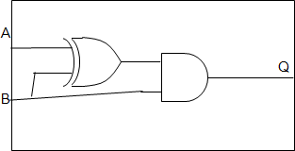
Inputs A and B connected to an XOR gate;
Input from B and output of XOR gate connected to an AND gate with output going to Q;
2
[9]

M10.
(a) OR gate

 | Input A | Input B | Output
 | 0 | 0 | 0
 | 0 | 1 | 1
 | 1 | 0 | 1
 | 1 | 1 | 1

NAND gate

 | Input A | Input B | Output
 | 0 | 0 | 1
 | 0 | 1 | 1
 | 1 | 0 | 1
 | 1 | 1 | 0

1 mark for correct output OR gate;
1 mark for correct output NAND gate;
2

(b)
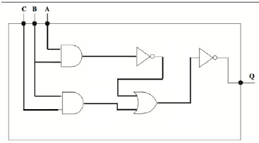
1 mark for inputs A and B connected to AND gate;
1 mark for inputs B and C connected to AND gate;
1 mark for output of AND (A,B input) as only connection going to NOT gate;
1 mark for output of NOT gate plus the AND gate (B,C input) going to OR gate;
1 mark OR gate as only connection going to NOT gate and output only connection to Q;
5

(c) MAX 2 if working out is not logically sound
Example 1:
Having applied De Morgan’s correctly;
Having factorised;
Final answer: B ;
Example 2:
Having applied De Morgan’s correctly;
Expanded bracket;
Simplified elements
Having used C + C.D = C to simplify
Having used C + C.D = C to simplify again
Final answer: B ;
Truth Table Answer

 | A | B
 | 0 | 0 | 0 | 0 | 0
 | 0 | 1 | 0 | 1 | 1
 | 1 | 0 | 0 | 0 | 0
 | 1 | 1 | 1 | 0 | 1
 |  |  | X | Y | Z

1 mark for both columns marked X and Y above; (column X could be labelled A.B )
1 mark for final column Z;
1 mark for final answer: B;
3
[10]

M11.
(a)
 | Input A | Input B | Output
 | 0 | 0 | 1
 | 0 | 1 | 1
 | 1 | 0 | 1
 | 1 | 1 | 0

One mark for having correct values in Output column;
1

(b) (i)
 | S | A | B |  | A. | B.S | Q
 | 0 | 0 | 0 | 1 | 0 | 0 | 0
 | 0 | 0 | 1 | 1 | 0 | 0 | 0
 | 0 | 1 | 0 | 1 | 1 | 0 | 1
 | 0 | 1 | 1 | 1 | 1 | 0 | 1
 | 1 | 0 | 0 | 0 | 0 | 0 | 0
 | 1 | 0 | 1 | 0 | 0 | 1 | 1
 | 1 | 1 | 0 | 0 | 0 | 0 | 0
 | 1 | 1 | 1 | 0 | 0 | 1 | 1

Marking:
One mark for the A. column being correct;
One mark for the B.S column being correct;
The final Q column should follow through from the previous two columns as an OR statement;
3

(ii)
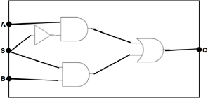
One mark for NOT gate with input from S;
A just a circle on AND gate input from S
One mark for AND gate with input from NOT S and A;
A if no NOT gate from S
One mark for AND gate with input from B and S;
One mark for output from AND gates going into OR gate with output connect to Q;
4

(iii) A multiplexor selects one of several input lines / wires and forwards / duplicates the Boolean value on this one line onto a single line / wire;
If S is 1 then input B is output otherwise input A is output // if S is 0 then input A is output otherwise input B is output;
Note:
1 can be mapped to on / true / high
0 can be mapped to off / false / low
MAX 1
[9]

