**Secret Messages code mock Feb 2014 Mark Scheme**

**Question 1**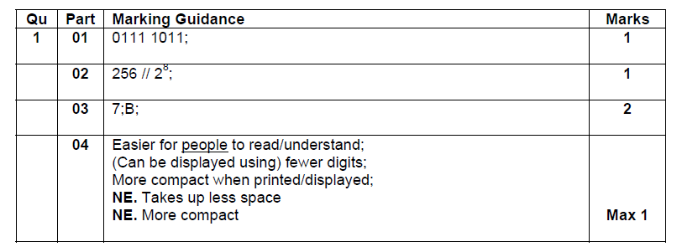

**Question 2**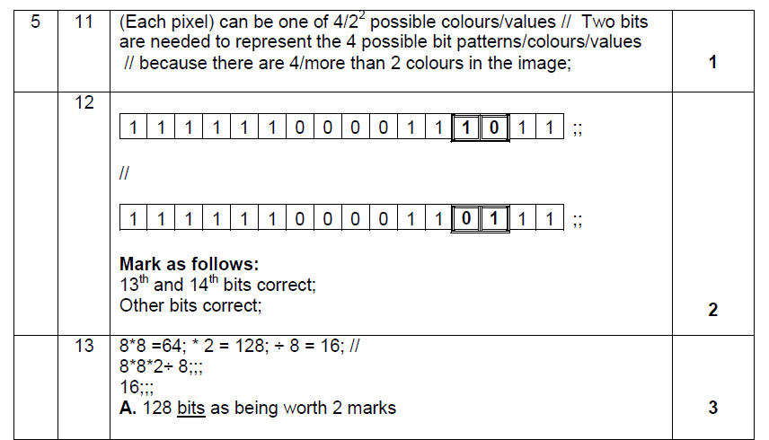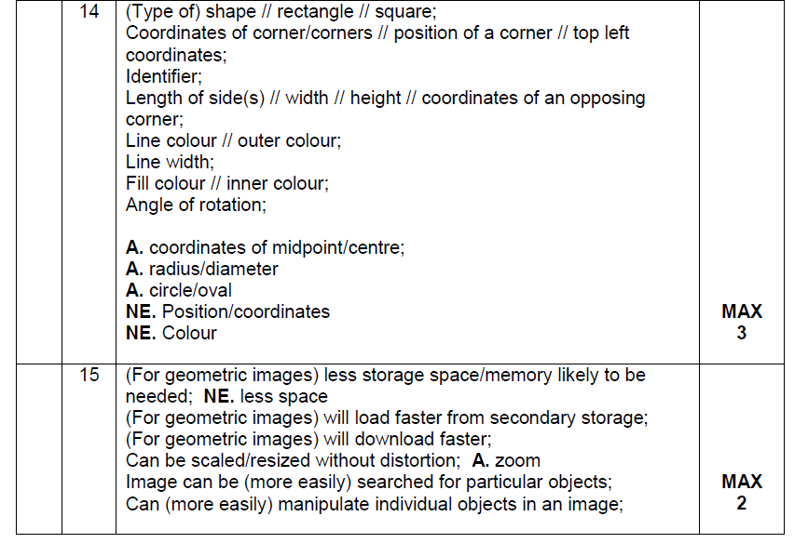

**Question 3**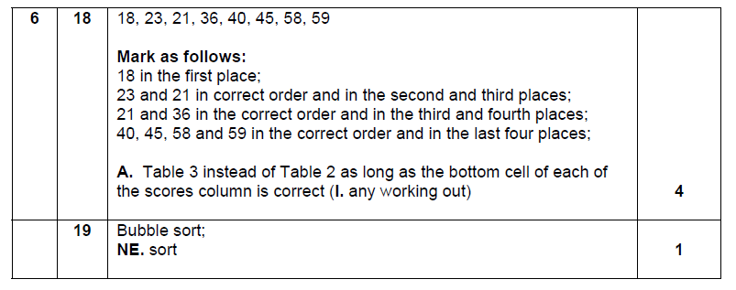

**Question 4**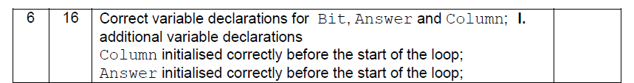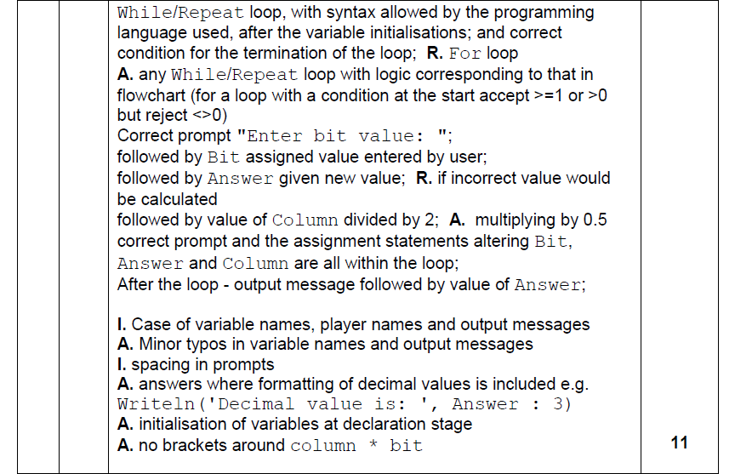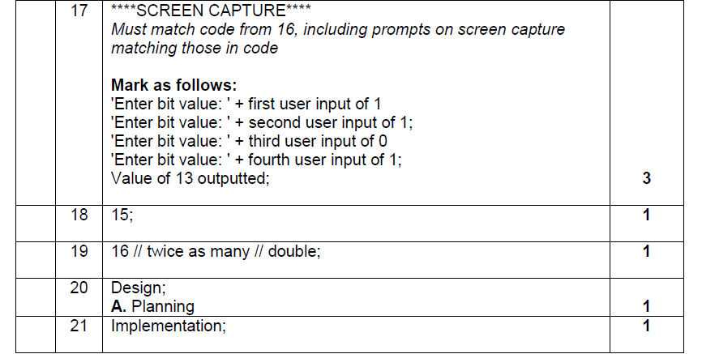

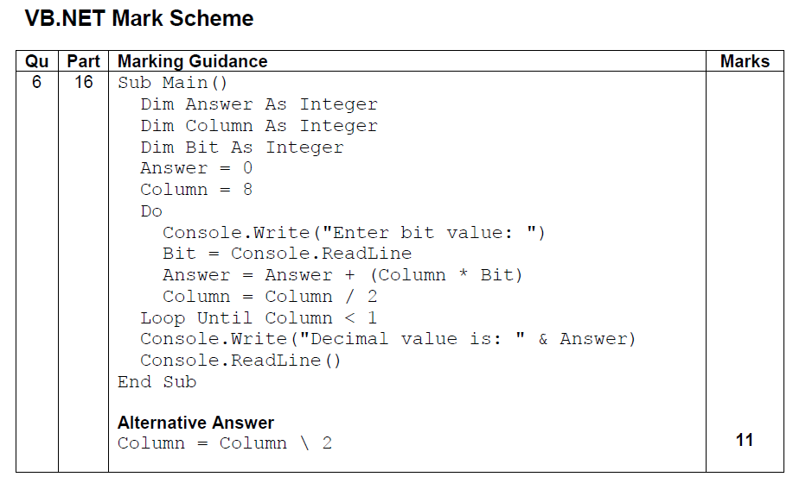

**Question 5**

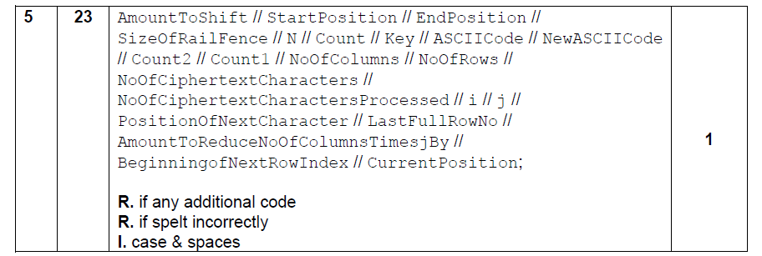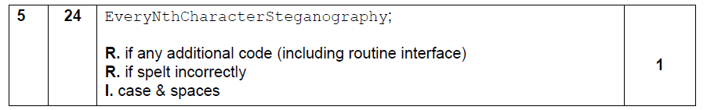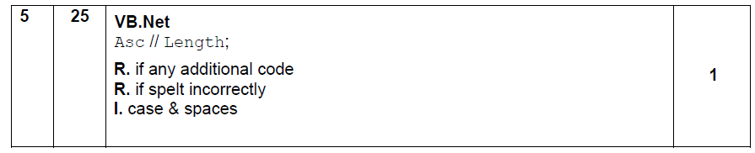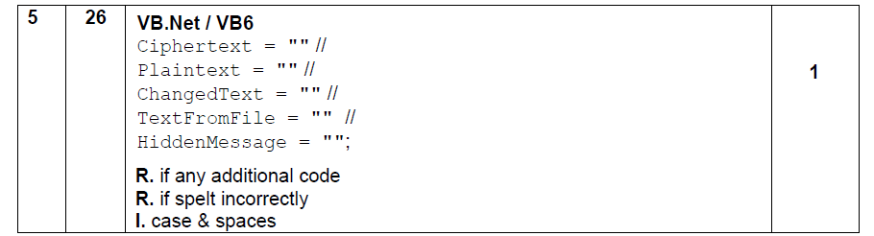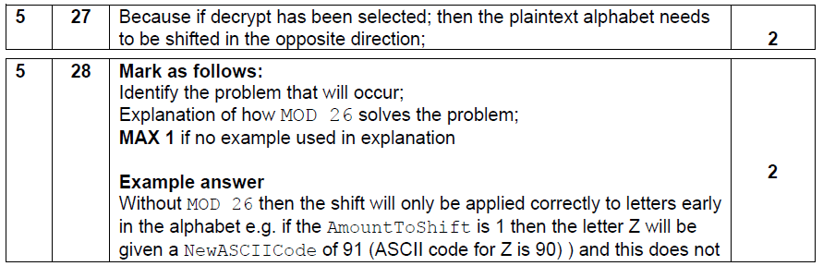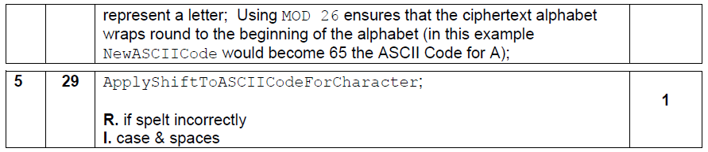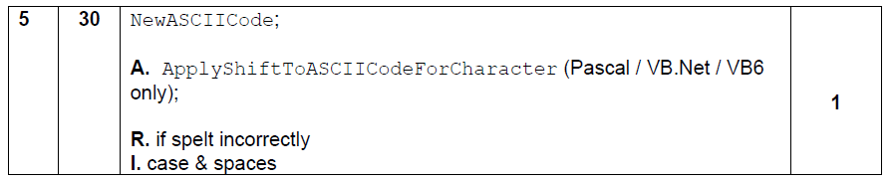

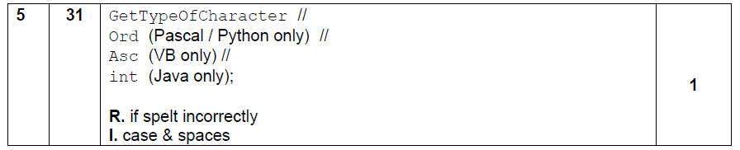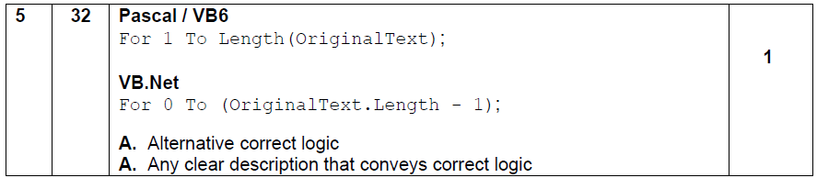

**Question 6**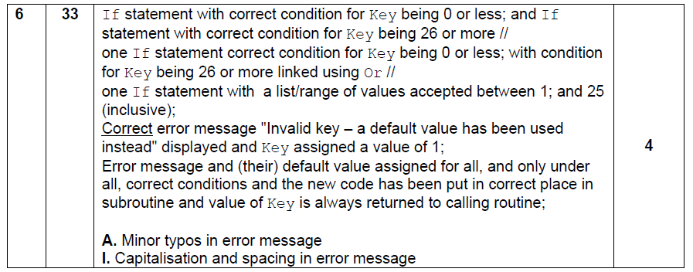

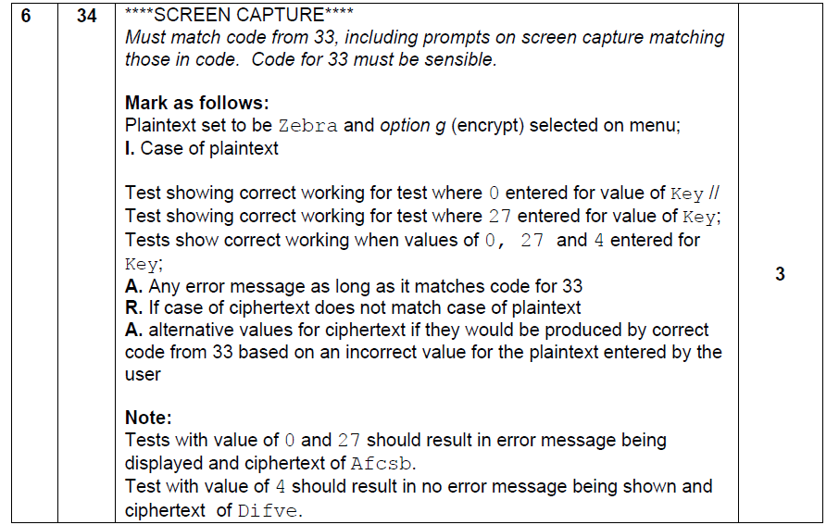

**VB.NET**

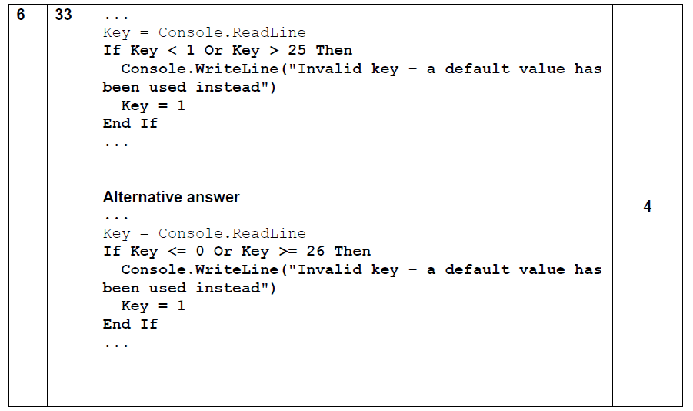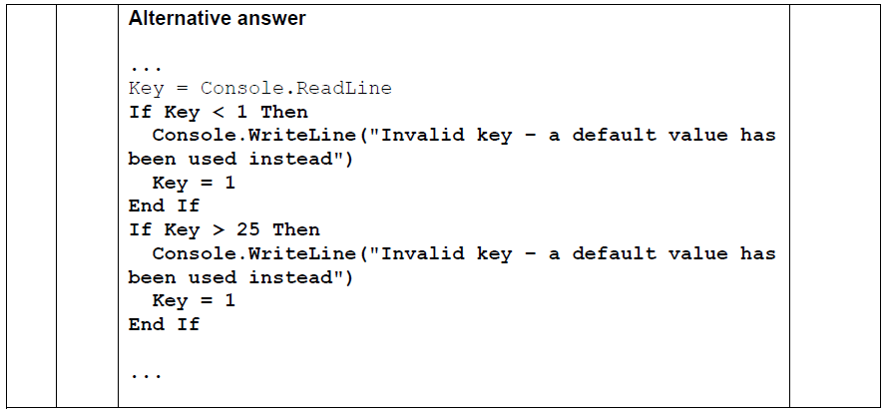

**Question 7**

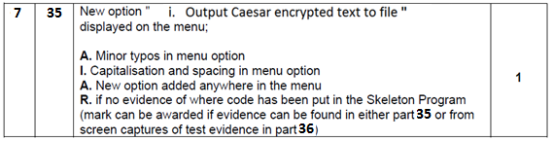

Case "i"

Dim Answer As Char = "Y"

FileOpen(1, "CaeserEncrypted.txt", OpenMode.Output)

Do

Plaintext = GetTextFromUser()

AmountToShift = GetKeyForCaesarCipher()

Ciphertext = UseCaesarCipher(Plaintext, AmountToShift)

PrintLine(1, Ciphertext)

Console.Write("Do you want to enter more text?(Y/N)")

Answer = Console.ReadLine

Loop Until Answer = "N"

FileClose(1)

Variable declaration Answer As Char 1 mark

File Opened to output text 1 mark

Use of Do….Loop Until 1 mark

Correct use of GetTextFromUser() 1 mark

Correct use of GetKeyForCaesarCipher() 1 mark

Correct use of UseCaesarCipher() 1 mark

Correct use of PrintLine() 1 mark

Prompt and input of Answer 1 mark

Correct termination of loop 1 mark

File closed 1 mark Total 10 marks

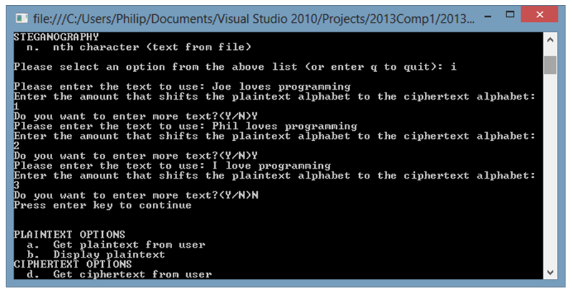

Correct input of “Joe loves programming” and shift = 1 1 mark

Correct responses “Y/Y/N” 1 mark

Correct 2nd & 3rd entry 1 mark Total 3 marks

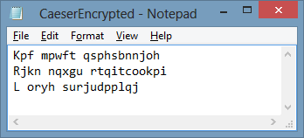

1 mark for each **perfectly** correct line in text file. 3 marks

**Question 8**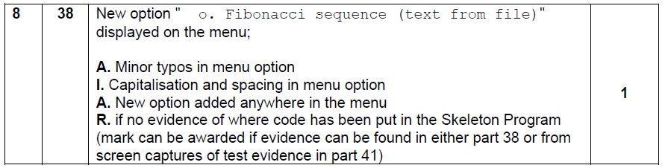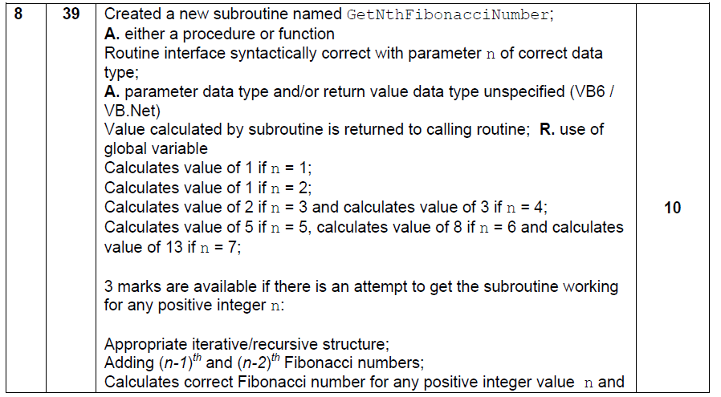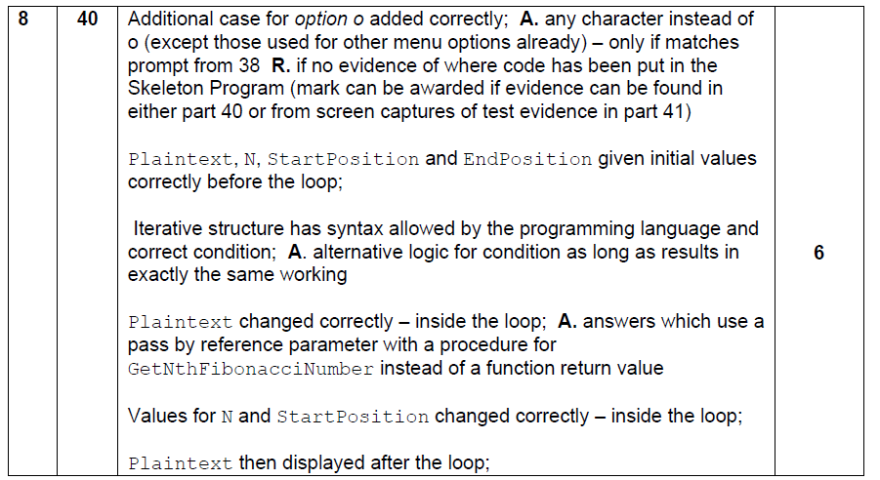

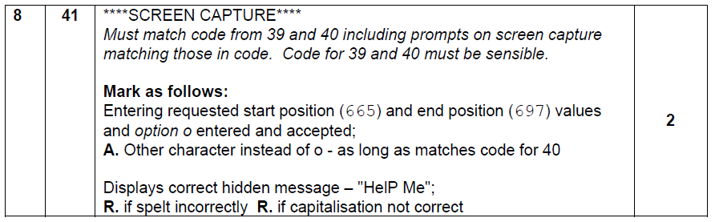

**VB.NET**

