7517 Mapped Revision Questions by Topic

Paper 2 Topics

Data Representation 1

Computer Systems 17

Computer Organisation and Architecture 25

Consequences of users of computing 39

Communication and Networking 43

These questions are a mix of previous spec questions matched to the current exam and questions taken from additional specimen questions of this spec.

Completing as many as possible of these questions will help you identify areas of weakness to work on.

|  |  |  |  |  |
| --- | --- | --- | --- | --- |
| Paper 2 | ☹ | 😐 | ☺ | Notes |
| Data Representation |  |  |  |  |
| Computer Systems and Architecture |  |  |  |  |
| Computer Organisiation |  |  |  |  |
| Consequences of Users |  |  |  |  |
| Communication and Networking |  |  |  |  |

|  |  |  |  |  |  |  |  |  |  |
| --- | --- | --- | --- | --- | --- | --- | --- | --- | --- |
|  | ✓ |  | ✓ |  | ✓ |  | ✓ |  | ✓ |
| Q1 |  | Q11 |  | Q21 |  | Q31 |  | Q41 |  |
| Q2 |  | Q12 |  | Q22 |  | Q32 |  | Q42 |  |
| Q3 |  | Q13 |  | Q23 |  | Q33 |  | Q43 |  |
| Q4 |  | Q14 |  | Q24 |  | Q34 |  | Q44 |  |
| Q5 |  | Q15 |  | Q25 |  | Q35 |  | Q45 |  |
| Q6 |  | Q16 |  | Q26 |  | Q36 |  | Q46 |  |
| Q7 |  | Q17 |  | Q27 |  | Q37 |  | Q47 |  |
| Q8 |  | Q18 |  | Q28 |  | Q38 |  |  |  |
| Q9 |  | Q19 |  | Q29 |  | Q39 |  |  |  |
| Q10 |  | Q20 |  | Q30 |  | Q40 |  |  |  |

# Data Representation

**Q1.** (a)     Represent the denary number 123 in binary using 8 bits.

Answer ...............................................................

**(1)**

(b)     How many different denary numbers can be represented using 8-bit binary?

Answer ...............................................................

**(1)**

(c)     What is the hexadecimal equivalent of the denary number 123?

Answer ...............................................................

**(2)**

(d)     Why are bit patterns often displayed using hexadecimal instead of binary?

........................................................................................................................

........................................................................................................................

**(1)**

**(Total 5 marks)**

**Q2.**

(a)     Convert the denary values 27 and –19 into 8-bit binary integers using two’s complement format.

|  |  |  |  |  |  |  |  |  |  |  |
| --- | --- | --- | --- | --- | --- | --- | --- | --- | --- | --- |
|  | 27 |  |  |  |  |  |  |  |  |  |
|  | –19 |  |  |  |  |  |  |  |  |  |

**(3)**

(b)     Add together your **two** 8-bit binary values.

|  |  |  |  |  |  |  |  |  |  |  |  |
| --- | --- | --- | --- | --- | --- | --- | --- | --- | --- | --- | --- |
|  | 27 |  |  |  |  |  |  |  |  |  |  |
|  | –19 |  |  |  |  |  |  |  |  |  |  |
|  | Result |  |  |  |  |  |  |  |  |  |  |

**(2)**

(c)     The result has an additional bit.

(i)      Give the name of this bit .......................................................................

**(1)**

(ii)     How can it be used? .............................................................................

...............................................................................................................

**(1)**

(d)     State your binary values for 27 and –19 in Hexadecimal.

  27..................................................................................................................

–19..................................................................................................................

**(2)**

**(Total 9 marks)**

**Q3.**

(a)     What is the decimal equivalent of the hexadecimal number D616? Show your working.

........................................................................................................................

........................................................................................................................

........................................................................................................................

........................................................................................................................

**(2)**

(b)     Represent the decimal value 9.37510 as an unsigned binary fixed point number, with 4 bits before and 4 bits after the binary point.

........................................................................................................................

........................................................................................................................

........................................................................................................................

........................................................................................................................

**(2)**

(c)     Represent the decimal value -6710 as an **8-bit two’s complement binary integer.**

........................................................................................................................

........................................................................................................................

........................................................................................................................

........................................................................................................................

**(2)**

(d)     A computer represents numbers using 8-bit two’s complement binary.

Using this representation perform the calculation:

|  |  |  |
| --- | --- | --- |
|  |  | 010010002 011000112 + |
|  | Answer: |  |

**(1)**

(e)     What problem has resulted from performing the calculation using 8-bit two’s complement binary?

........................................................................................................................

........................................................................................................................

**(1)**

**(Total 8 marks)**

**Q4.**The diagram below shows the contents of a memory location.

|  |  |  |  |  |  |  |  |
| --- | --- | --- | --- | --- | --- | --- | --- |
| 1 | 0 | 1 | 0 | 0 | 1 | 1 | 1 |

(a)     What is the denary equivalent of the contents of this memory location if it represents an **unsigned binary integer**?

*Use the space below for rough working*.

Answer ...............................................................

**(1)**

(b)     What is the denary equivalent of the contents of this memory location if it represents an **unsigned binary fixed point number**, with 4 bits before and 4 bits after the binary point?

*Use the space below for rough working*.

 Answer ...............................................................

**(2)**

(c)     What is the denary equivalent of the contents of this memory location if it represents a **two’s complement binary integer**?

*Use the space below for rough working*.

 Answer ...............................................................

**(2)**

(d)     What is the **hexadecimal** equivalent of the binary pattern shown in diagram above?

*Use the space below for rough working*.

 Answer ...............................................................

**(1)**

**(Total 6 marks)**

**Q5.**

(a)     A binary pattern might represent a decimal *integer* or a decimal *real number.* In a computing context, give an example of

(i)      a decimal integer ..................................................................................

(ii)     a decimal real number ..........................................................................

(iii)     The binary data 00110111 represents an unsigned real number in fixed point form, with the binary point between bits 1 and 2, e.g. 1101.11. Convert this number into decimal, showing all your working.

**(4)**

(b)     Convert the binary data 10110111 00111110 into hexadecimal.

**(1)**

(c)     Give **one** example of where hexadecimal numbers are used, and explain why they are used here rather than binary numbers.

.......................................................................................................................

.......................................................................................................................

.......................................................................................................................

.......................................................................................................................

**(2)**

**(Total 7 marks)**

**Q6.**How many bytes are in a Kilobyte?

.................................................................................................................................

**(Total 1 marks)**

**Q7.**

(a)     How many bytes are 1 Kilobyte? ...................................................................

**(1)**

(b)     A computer system uses 2 bytes to store a number.

(i)      What is the largest pure binary integer it can store? ............................

**(1)**

What is the bit pattern if the number 37 is to be stored as

(ii)     a pure binary integer?



**(1)**

(c)     The ASCII coding system uses seven bits to code a character.

The character digits 0 to 9 are assigned the decimal number codes 48 to 57.

An extra bit is used as a parity bit.

A computer system uses the most significant bit (MSB) as a parity bit for each byte and works with **even** parity.

(i)      What is the bit pattern if the digits 37 are to be stored as characters?



**(3)**

(ii)     Explain how the parity bit is used by this computer system.

..............................................................................................................

..............................................................................................................

..............................................................................................................

**(2)**

**(Total 8 marks)**

**Q8.**The figure below shows a very small part of a sound wave recorded through a microphone connected to a computer.

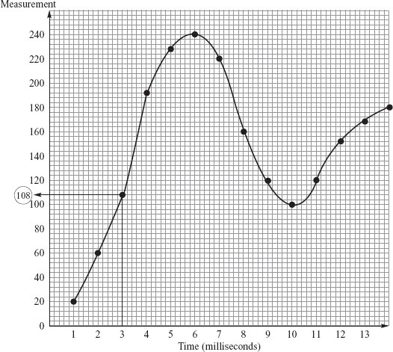

The dots each represent a recorded measurement of the sound wave. The recorded measurements are stored in main memory shown in the table below, with the first measurement stored in main memory location 700.

|  |  |  |
| --- | --- | --- |
|  | **Memory Address** | **Measurement** |
|  | 700 | 0001 0100 |
|  | 701 | 0011 1100 |
|  | 702 | (e) |
|  | 703 | 1011 1101 |
|  | 704 | 1110 0011 |
|  | 705 | 1111 0000 |
|  | 706 | 1101 1100 |
|  | 707 | 1010 0000 |
|  | 708 | 0111 0111 |
|  | 709 | 0110 0100 |

(a)     Name **two** items of essential software which **must** be in the main memory at the time this recording process takes place.

1 .......................................................................................................................

2 .......................................................................................................................

**(2)**

(b)     (i)      Explain what is meant by the **sampling rate**.

.................................................................................................................

**(1)**

(ii)     Study the figure above and state what the sampling rate is for this recording.

(1000 milliseconds = 1 second).

.................................................................................................................

**(1)**

(c)     Study the table above. How many bits are allocated to each sample?

..........................................................................................................................

**(1)**

(d)     (i)      State **one** advantage of increasing the number of bits allocated to each sample.

.................................................................................................................

**(1)**

(ii)     State **one** disadvantage of increasing the number of bits allocated to each sample.

.................................................................................................................

**(1)**

(e)     Study the figure above. What will be the binary value stored at location 702 shown in the table?

..........................................................................................................................

**(1)**

(f)      In the table each of the binary values represents part of a sound file.

          Give **three** other possible interpretations of one or more bytes held in main memory when the computer is being used for any application (excluding part of a picture or other media file).

1 ......................................................................................................................

2 ......................................................................................................................

3 ......................................................................................................................

**(3)**

**(Total 11 marks)**

**Q9.**A performance by a music band is to be recorded and distributed on CD.

**Figure 1** shows three samples stored in a computer's memory that have been taken from an analogue signal as part of the recording process. A sampling rate of 44,000Hz (Hertz) has been used.

1Hz is one sample per second.

**Figure 1**

|  |  |
| --- | --- |
|  | 0000  0001  1000  1110 |
|  | 0000  0001  1000  1110 |
|  | 0000  0001  1000  0011 |

(a)     What sampling resolution has been used?

**(1)**

(b)     If the original analogue signal lasts 100 seconds, how many bytes of storage will be required to store all the samples taken in the recording process?

*You may use the space below for rough working. You may get some marks for your working, even if your answer is incorrect.*

**(3)**

(c)     The average human can hear frequencies up to 20,000Hz (Hertz).

Explain why a sampling rate of 44,000Hz has been chosen for the recording.

**(2)**

(d)     The CD recording is processed to create a version of the performance that can be downloaded from the band’s website.

The sound quality of the version of the recording stored on the web server is not as good as the sound quality of the CD version.

State **one** possible cause of this reduction in sound quality.

**(1)**

**(Total 7 marks)**

**Q10.**

(a)  The diagram represents a computer system which is used to both record and playback sound files.

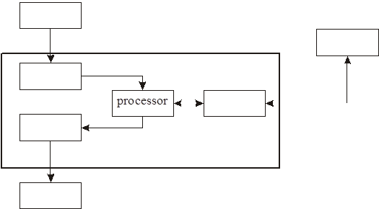

The components in the diagram above are:

1  Loudspeaker

2  Digital to analogue converter

3  Secondary storage

4  Microphone

5  Main memory

6  Analogue to digital converter

Label the components in the diagram, using the numbers 1 to 6.

**(6)**

(b)  (i)  Explain what is meant by synthesised sound.

..............................................................................................................

..............................................................................................................

**(1)**

(ii)  Give an example where synthesised sound would be produced and used.

..............................................................................................................

..............................................................................................................

**(1)**

**(Total 8 marks)**

**Q11.**In vector graphics the type, dimension and position of every graphic element making up an image are recorded, such as the start and end points, the thickness and colour of a line.

(a)     How is a colour image represented in bit-mapped graphics?

.......................................................................................................................

.......................................................................................................................

.......................................................................................................................

.......................................................................................................................

**(2)**

(b)     Give **one** advantage of vector graphics over bit-mapped graphics.

.......................................................................................................................

.......................................................................................................................

**(1)**

**(Total 3 marks)**

**Q12.**To record sound a computer needs to convert the analogue sound signal into a digital form. During this process samples of the analogue signal are taken. The diagram below shows part (0.02 seconds) of an analogue sound wave.

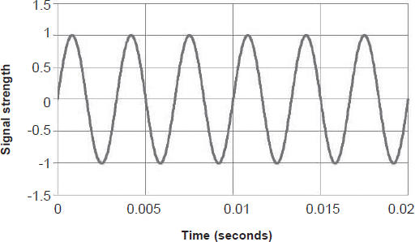

The **frequency** of an analogue sound wave is determined by how many waves of oscillation occur per second and is measured in Hertz (Hz) – the number of waves of oscillation per second.

(a)     If the part of the analogue sound shown in the diagram above is the highest frequency in the entire sound to be sampled, what is the **minimum sampling rate** (in Hz) that should be used?

*Use the space below. You may get some marks for your working even if your answer is incorrect.*

**(2)**

(b)     Describe clearly the steps taken by an ADC (analogue-to-digital converter) in the conversion of an analogue sound wave to an equivalent digital signal.

........................................................................................................................

........................................................................................................................

**(3)**

(c)     MIDI is an alternative method for storing sound digitally that does not use sound waves; instead, information about each musical note is stored.

State **one** advantage of using the MIDI representation for storing sound digitally.

........................................................................................................................

........................................................................................................................

**(1)**

(d)     State an item of data, other than the note itself, that might be stored about a musical note in a MIDI file.

........................................................................................................................

**(1)**

**(Total 7 marks)**

**Q13.**Images are often represented in a computer’s main memory using bitmapped graphics. Bitmapped images consist of **pixels.** A pixel is the smallest addressable part of an image.

(a)     What is meant by the **resolution** of a bitmapped graphic image?

........................................................................................................................

........................................................................................................................

........................................................................................................................

........................................................................................................................

**(2)**

(b)     What is meant by the **colour depth** of a bitmapped graphic image?

........................................................................................................................

........................................................................................................................

........................................................................................................................

........................................................................................................................

**(2)**

(c)     An image has 10 x 10 pixels. It is stored in an image format that is limited to 16 colours.

Calculate the image size in bytes.

........................................................................................................................

**(2)**

(d)     Instead of using bitmapped graphics, images may be represented in a computer’s main memory using vector graphics.

State **one** advantage of vector graphics compared with bitmapped graphics.

........................................................................................................................

........................................................................................................................

**(1)**

**(Total 7 marks)**

**Q14.**

(a)     Bitmapped graphic images are composed of **pixels**.

State what is meant by a pixel.

**(2)**

(b)     Any black and white image will require only a single bit to encode each pixel.

**Figure 1** shows a black and white bitmapped image.  
**Figure 2** shows the memory locations where the image is stored.  
The first byte used for the pixel data is at location 187.  
The pixel data are stored row-by-row, starting with row 1:

•        black pixels are encoded with the bit set to 1

•        white pixels are encoded with the bit set to 0 .

**Figure 1**

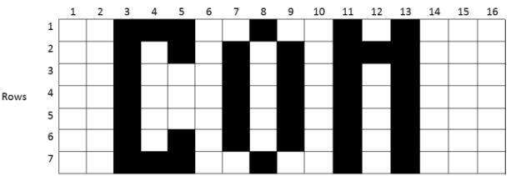

**Figure 2**

|  |  |
| --- | --- |
| **Location** | **Contents** |
| 187 | 0011 1001 |
| 188 | 0010 1000 |
| 189 |  |
| 190 |  |
| : |  |
| : |  |
| : |  |
| 200 | 0010 1000 |

(i)      What will be the contents of location 189 in **binary**?

*Use the grid for rough working.*

|  |  |  |  |  |  |  |  |  |
| --- | --- | --- | --- | --- | --- | --- | --- | --- |
|  |  |  |  |  |  |  |  |  |

**(1)**

(ii)     What will be the contents of location 190 in **denary**?

**(1)**

(c)     Colour images can also be encoded as bitmaps.

(i)      Explain how the colour of each pixel is encoded.

**(1)**

(ii)     How many bits are required to store each pixel for a 256-colour image?

**(1)**

(d)     The image in **Figure 3** was created with a vector graphics program.

**Figure 3**

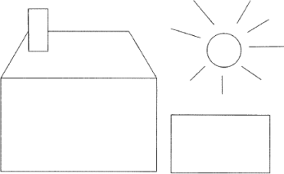

(i)      Describe how a vector graphics program stores the data about the image.

**(2)**

(ii)     Name **three** properties that would be stored for a circle object.

**(3)**

**(Total 11 marks)**

**Q15.**A bitmapped image consists of pixels.The diagram below shows a bitmapped representation of an image of a winking, happy face consisting of red, blue, black and white pixels only.

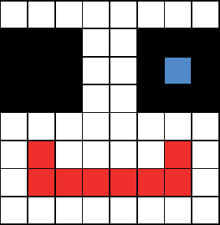

(a)     Why must at least two bits be used to represent each pixel?

........................................................................................................................

........................................................................................................................

**(1)**

(b)     The second line of pixels (from the top) shown in the image above has been represented in a computer’s memory as the bit pattern 1111 1100 0011 1111. A black pixel is coded as 11.

Suggest a suitable 16-bit bit pattern that could be used to represent the third line of pixels (from the top) in the image above.

|  |  |  |  |  |  |  |  |  |  |  |  |  |  |  |  |  |
| --- | --- | --- | --- | --- | --- | --- | --- | --- | --- | --- | --- | --- | --- | --- | --- | --- |
|  |  |  |  |  |  |  |  |  |  |  |  |  |  |  |  |  |

**(2)**

(c)     What, in bytes, is the minimum file size for the bitmapped image above?

*Use the space below. You may get some marks for your working even if your answer is incorrect.*

**(3)**

(d)     Instead of representing the face as a bitmapped image, vector graphics could have been used.

State **three** items of data that would need to be stored about an eye object, similar to those shown in the image above, if it is to be represented using vector graphics.

........................................................................................................................

........................................................................................................................

........................................................................................................................

**(3)**

(e)     Describe **two** advantages of using vector graphics instead of bitmaps to represent an image.

........................................................................................................................

........................................................................................................................

........................................................................................................................

........................................................................................................................

**(2)**

**(Total 11 marks)**

# Computer Systems

**Q16.**

(a)     The table below lists some components of a computer system.

Put **one** tick on each row to identify each component as either:

•        software

•        hardware

•        hardware and software.

|  |  |  |  |  |
| --- | --- | --- | --- | --- |
|  | **Component** | **Software** | **Hardware** | **Hardware and software** |
|  | Wireless router |  |  |  |
|  | Compiler |  |  |  |
|  | Keyboard |  |  |  |

**(3)**

(b)     System software performs the tasks needed to operate the hardware. The operating system and library programs are system software.

(i)      State **one** role of the operating system.

...............................................................................................................

**(1)**

(ii)     State **one** purpose of library programs.

...............................................................................................................

**(1)**

(c)     A company is looking at purchasing some bespoke software to help them run their ordering and purchasing activities.

(i)      State **one** advantage of purchasing bespoke software.

...............................................................................................................

...............................................................................................................

**(1)**

(ii)     State **one** disadvantage of purchasing bespoke software.

...............................................................................................................

...............................................................................................................

**(1)**

**(Total 7 marks)**

**Q17.**An operating system is designed to hide the complexities of the hardware from the user and to manage the hardware and other resources.

Give **three** different types of management of either hardware or other resources that are performed by an operating system.

1 ..............................................................................................................................

.................................................................................................................................

2 ..............................................................................................................................

.................................................................................................................................

3 ..............................................................................................................................

.................................................................................................................................

**(Total 3 marks)**

**Q18.**A computer system consists of both *hardware and software.*

(a)     What is meant by:

(i)      hardware: ............................................................................................

..............................................................................................................

**(1)**

(ii)     software? .............................................................................................

..............................................................................................................

**(1)**

(b)     One classification of software is *system software.*

(i)      What is meant by system software?

..............................................................................................................

..............................................................................................................

**(1)**

(ii)     Give **one** example of system software.

..............................................................................................................

**(1)**

(iii)     Name **one** other software classification.

..............................................................................................................

**(1)**

(iv)    Give **one** example of this **type** of software. (Not a product name.)

..............................................................................................................

**(1)**

**(Total 6 marks)**

**Q19.**

(a)     Explain the purpose of an operating system.

........................................................................................................................

........................................................................................................................

........................................................................................................................

........................................................................................................................

........................................................................................................................

**(2)**

(b)     Discuss the differences between operating systems designed for desktop computers and operating systems designed for embedded systems.

In this question you will also be assessed on your ability to use good English and to organise your answer clearly in complete sentences, using specialist vocabulary where appropriate.

........................................................................................................................

........................................................................................................................

........................................................................................................................

........................................................................................................................

........................................................................................................................

........................................................................................................................

........................................................................................................................

........................................................................................................................

........................................................................................................................

........................................................................................................................

........................................................................................................................

**(4)**

**(Total 6 marks)**

**Q20.**A programmer developing a new application will choose a high level programming language. Typical modern software will provide an �environment� in which all aspects of the application�s development can be done.

(a) What feature must all program development environments have for the initial creation of the program code?

..........................................................................................................................

**(1)**

(b) The next stage in the development may use a **compiler.**

Explain what a compiler does, and suggest **one** output which may result from the compilation process, other than the executable code.

..........................................................................................................................

..........................................................................................................................

Output: .............................................................................................................

**(3)**

(cAn alternative to a compiler is an **interpreter**.

Explain how an interpreter attempts to run a program.

.........................................................................................................................

.........................................................................................................................

.........................................................................................................................

**(2)**

(d) The program development environment has **both** a compiler and interpreter.

(i) Give **one** advantage of using an interpreter.

................................................................................................................

................................................................................................................

**(1)**

(ii) Give **one** advantage of using a compiler.

................................................................................................................

................................................................................................................

**(1)**

**(Total 8 marks)**

**Q21.**The role of an operating system is often said to be twofold:

1.       To provide a virtual machine.

2.       To manage the resources of the computer.

(a)     What is meant by “to provide a virtual machine”?

.......................................................................................................................

.......................................................................................................................

**(1)**

(b)     Name **three** types of resource managed by the operating system.

1 ....................................................................................................................

2 ....................................................................................................................

3 ....................................................................................................................

**(3)**

**(Total 4 marks)**

**Q22.**When writing a program, a programmer could use an assembly language, a high level imperative language or a high level declarative language.

Outline the major differences in each of these **three** approaches. For each language type, your answer could include:

•        advantages and disadvantages compared to other language types

•        how the programmer would express their programs

•        what translation software could be used, if applicable

•        a situation where it might be the most appropriate choice.

In your answer you will be assessed on your ability to use good English and to organise your answer clearly in complete sentences, using specialist vocabulary where appropriate.

.................................................................................................................................

.................................................................................................................................

.................................................................................................................................

.................................................................................................................................

.................................................................................................................................

.................................................................................................................................

.................................................................................................................................

.................................................................................................................................

.................................................................................................................................

.................................................................................................................................

.................................................................................................................................

.................................................................................................................................

.................................................................................................................................

.................................................................................................................................

.................................................................................................................................

.................................................................................................................................

.................................................................................................................................

.................................................................................................................................

.................................................................................................................................

**(Total 8 marks)**

**Q23.**The diagram below shows program code developed using different generations of programming languages.

|  |  |
| --- | --- |
|  | **Program 1 (with comments)** |
|  | //Calculate FirstVar := 47; SecondVar := FirstVar + 2; FourthVar := ThirdVar; |

|  |  |
| --- | --- |
|  | **Program 2 (with comments)** |
|  | AB2F ; Load value 2F into accumulator BC5D ; Store contents of accumulator at address 5D E402 ; Add value 2 to accumulator BCFF ; Store contents of accumulator at address FF AC61 ; Load accumulator with contents of address 61 BC4A ; Store contents of accumulator at address 4A |

(a)     What generation of programming language was used to write **Program 1**?

........................................................................................................................

**(1)**

(b)     Machine code can be represented in different numeric formats.

(i)     Which numeric format is used by the machine code program in **Program 2**?

...............................................................................................................

**(1)**

(ii)     State **one** reason for using this format.

...............................................................................................................

**(1)**

(iii)     The machine for which **Program 2** has been written has limited addressing capability.

What are the lowest and highest memory addresses that can be addressed by this machine?

Lowest address: ...................................................................................

Highest address: ...................................................................................

**(1)**

(c)     Give an example of a situation for which it would be appropriate to write a program in a low level language (ie machine code or assembly language).

........................................................................................................................

........................................................................................................................

**(1)**

(d)     Explain the differences between a compiler and an interpreter

........................................................................................................................

........................................................................................................................

........................................................................................................................

........................................................................................................................

........................................................................................................................

........................................................................................................................

........................................................................................................................

........................................................................................................................

........................................................................................................................

........................................................................................................................

........................................................................................................................

........................................................................................................................

........................................................................................................................

........................................................................................................................

**(4)**

**(Total 9 marks)**

**Q24.**A programmer could use either an assembly language or a high level language to code programs for sale.

(a)     Give **two** limitations of using assembly language to code a program.

1 .....................................................................................................................

........................................................................................................................

2 .....................................................................................................................

........................................................................................................................

**(2)**

(b)     If a program is coded using a high level language, then either a compiler or an interpreter will need to be used.

Give **two** advantages of using a compiler, rather than an interpreter, to prepare a runnable program ready for sale.

1 .....................................................................................................................

........................................................................................................................

........................................................................................................................

2 .....................................................................................................................

........................................................................................................................

........................................................................................................................

**(2)**

**(Total 4 marks)**

**Q25.**

(a)     Machine code is the first generation of programming languages. All other generations of programming languages need a program translator before the program can be executed. Name a type of translator suitable for:

(i)      Second generation language programs:

..............................................................................................................

**(1)**

(ii)     Third generation language programs:

..............................................................................................................

**(1)**

(b)     Imperative *high level languages* are third generation.

Give **two** characteristics of high level languages that distinguish them from second generation languages.

1 ...................................................................................................................

2 ...................................................................................................................

**(2)**

(c)     In one high level language an example of a constant definition would be

CONST              VatRate = 17.5;

State **one** advantage of using a named constant, like VatRate, rather than the actual value (17.5) in a high level language program.

.......................................................................................................................

.......................................................................................................................

**(1)**

(d)     (i)      Name an imperative high level language which you have studied.

..............................................................................................................

**(1)**

For the language you have named in (d) (i) above, give an example, using the correct syntax, of:

(ii)     iteration: ...............................................................................................

..............................................................................................................

..............................................................................................................

**(2)**

(iii)     selection: ..............................................................................................

..............................................................................................................

..............................................................................................................

**(2)**

**(Total 10 marks)**

# Computer Organisation and Architecture

**Q26.**

(a)     Complete the truth tables for the following logic gates.

OR gate

|  |  |  |  |
| --- | --- | --- | --- |
|  | **Input A** | **Input B** | **Output** |
|  | 0 | 0 |  |
|  | 0 | 1 |  |
|  | 1 | 0 |  |
|  | 1 | 1 |  |

NAND gate

|  |  |  |  |
| --- | --- | --- | --- |
|  | **Input A** | **Input B** | **Output** |
|  | 0 | 0 |  |
|  | 0 | 1 |  |
|  | 1 | 0 |  |
|  | 1 | 1 |  |

**(2)**

(b)     Represent the following Boolean equation as a logic circuit by completing the diagram below.



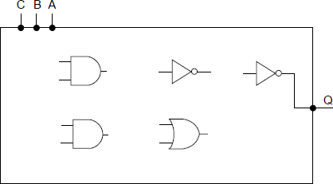

**(5)**

(c)     Simplify the following expression.



Show each stage of your working in the space below.

**(2)**

Final answer .......................................................................................................

**(1)**

**(Total 10 marks)**

**Q27.**

(a)     Complete the truth tables for the following logic gates.

|  |  |  |  |  |  |  |  |
| --- | --- | --- | --- | --- | --- | --- | --- |
|  | **AND Gate** | | |  | **XOR Gate** | | |
|  | **Input X** | **Input Y** | **Input Q** |  | **Output X** | **Input Y** | **Output Q** |
|  | 0 | 0 |  |  | 0 | 0 |  |
|  | 0 | 1 |  |  | 0 | 1 |  |
|  | 1 | 0 |  |  | 1 | 0 |  |
|  | 1 | 1 |  |  | 1 | 1 |  |

**(2)**

(b)     A line-following robot has three sensors. It moves along a black line on a white background whilst the following conditions are met:

•        the ultrasonic sensor U does not detect any obstacle

•        either, but not both, of the infrared sensors L and R are on the black line.

Sensor U returns 1 if it detects an obstacle and 0 if the path is clear.  
Sensors L and R each return 1 if they detect black and 0 if they detect white.

A logic circuit will process the input from the sensors and produce an output M.

M should be 1 if the robot is to move and 0 if the robot should stop.

(i)      Represent the output M as a Boolean expression.

M = ........................................................................................................

**(3)**

(ii)     The following symbols are used to represent logic gates:

|  |  |
| --- | --- |
|  |  |
|  | NOT                          OR                            AND |

|  |  |
| --- | --- |
|  |  |
|  | XOR                        NOR                        NAND |

Using a combination of any of the above logic gates draw a logic circuit for this system in the box below. You will **not** need to use all of the different types of logic gates.

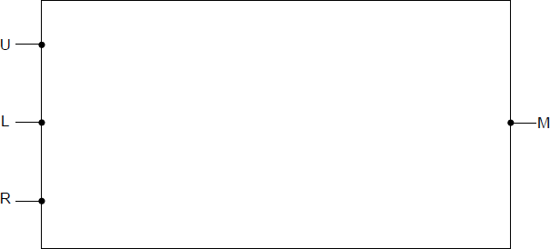

**(3)**

(c)     Apply De Morgan’s Law(s) to the following expression and simplify the result.



Show the stages of your working.

........................................................................................................................

........................................................................................................................

........................................................................................................................

**(2)**

Final answer ..................................................................................................

**(1)**

**(Total 11 marks)**

**Q28.**

(a)     Complete the truth tables for the following logic gates.

|  |  |  |  |
| --- | --- | --- | --- |
|  | **NAND Gate** | | |
|  | **Input X** | **Input Y** | **Output Q** |
|  | 0 | 0 |  |
|  | 0 | 1 |  |
|  | 1 | 0 |  |
|  | 1 | 1 |  |

|  |  |  |  |
| --- | --- | --- | --- |
|  | **NOR Gate** | | |
|  | **Input X** | **Input Y** | **Output Q** |
|  | 0 | 0 |  |
|  | 0 | 1 |  |
|  | 1 | 0 |  |
|  | 1 | 1 |  |

**(2)**

(b)     Represent the Boolean equation Z =  .  + C in the form of a logic circuit by drawing a diagram in the space below using the following symbols.

|  |  |  |  |
| --- | --- | --- | --- |
|  |  | | |
|  | OR | AND | NOT |

 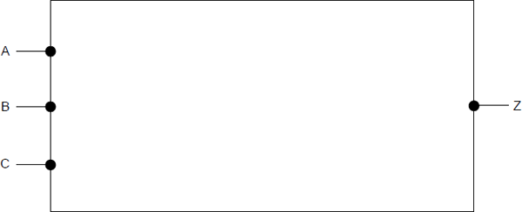

**(3)**

(c)     Simplify the Boolean expression below.



Show each stage of your working.

........................................................................................................................

........................................................................................................................

........................................................................................................................

........................................................................................................................

........................................................................................................................

**(3)**

Final answer ..................................................................................................

**(1)**

**(Total 9 marks)**

**Q29.**

An integrated circuit manufacturer is looking to develop a new processor.

(a)     What would be the direct consequence on potential performance of

increasing the width of the data bus? ...........................................................

........................................................................................................................

increasing the width of the address bus? .....................................................

........................................................................................................................

increasing the clock speed? .........................................................................

........................................................................................................................

**(3)**

(b)     A company has designed a new peripheral and is developing the I / O controller for it.

(i)      What do we mean by the term peripheral?

...............................................................................................................

...............................................................................................................

**(1)**

(ii)     The I / O controller is an electronic circuit consisting of three parts. One of these parts is known as the I / O port.

What is the role of the I / O port?

...............................................................................................................

...............................................................................................................

**(1)**

(iii)    Describe another part of the I / O controller.

...............................................................................................................

...............................................................................................................

**(1)**

(iv)    Peripheral devices are not directly connected to the processor but make use of the system bus.

Give **two** reasons why it is **not** sensible to connect peripherals directly to the processor.

Reason 1 .............................................................................................

...............................................................................................................

Reason 2 ..............................................................................................

...............................................................................................................

**(2)**

**(Total 8 marks)**

**Q30.**The diagram below shows the processor registers and busses that are used during the fetch part of the fetch-execute cycle, together with the main memory. The values stored in memory locations 0 to 6 in the main memory are machine code instructions.

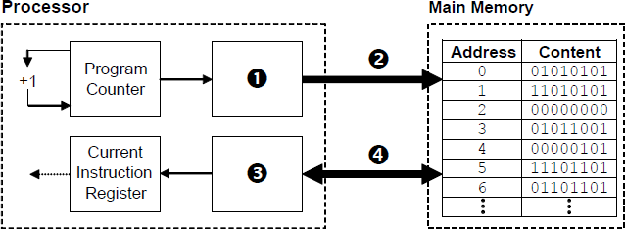

(a)     Name the components that are labelled with the numbers 1 to 4. In the case of register names, the full names must be stated.

|  |  |  |
| --- | --- | --- |
|  | **Number** | **Component Name** |
|  |  |  |
|  |  |  |
|  |  |  |
|  |  |  |

**(4)**

(b)     Explain what happens during the decode and execute stages of the fetch-execute cycle.

........................................................................................................................

........................................................................................................................

........................................................................................................................

........................................................................................................................

........................................................................................................................

........................................................................................................................

**(3)**

(c)     The machine code instructions in the main memory in the diagram above are shown in binary.  
When programmers look at machine code instructions they usually prefer to view them in hexadecimal.

State **one** reason why this is the case.

........................................................................................................................

........................................................................................................................

**(1)**

(d)     The machine code instructions in the main memory in the diagram above were produced when an assembly language program was translated into machine code.

(i)      What type of program translator was used to do this?

...............................................................................................................

**(1)**

(ii)     Most computer programs are initially written in an imperative high level language rather than assembly language.

Explain why this is the case.

...............................................................................................................

...............................................................................................................

...............................................................................................................

...............................................................................................................

...............................................................................................................

...............................................................................................................

**(3)**

**(Total 12 marks)**

**Q31.**The figure below shows the fetch-execute cycle. Steps 2a and 2b occur at the same time.

|  |  |  |
| --- | --- | --- |
|  |  | **Step 1**: MAR ← [PC]    **Step 2a:** PC ← [PC] + 1    **Step 2b:** MBR ← [Memory]addressed    **Step 3**: CIR ← [MBR]    **Step 4**: Decode Instruction    **Step 5**: Execute Instruction |

(a)     State the full names of **two** of the special purpose registers that are used in the fetch part of the fetch-execute cycle.

Register 1: .....................................................................................................

Register 2: .....................................................................................................

**(2)**

(b)     Explain the role of the address bus, data bus and main memory during Steps 1 and 2b.

........................................................................................................................

........................................................................................................................

........................................................................................................................

........................................................................................................................

........................................................................................................................

**(2)**

(c)     Give **one** reason why Steps 2a and 2b are able to occur at the same time.

........................................................................................................................

........................................................................................................................

**(1)**

**(Total 5 marks)**

**Q32.**Some of the components of a computer system are:

Peripherals:

keyboard                     1

monitor                        2

1/0 Ports:

VDU controller            3

keyboard controller     4

Memory:

main memory              5

secondary storage      6

System Bus:

Data Bus                     7

Address Bus               8

(a)     In the diagram below, identify each component by writing its number, given in the list above, in the appropriate circle.

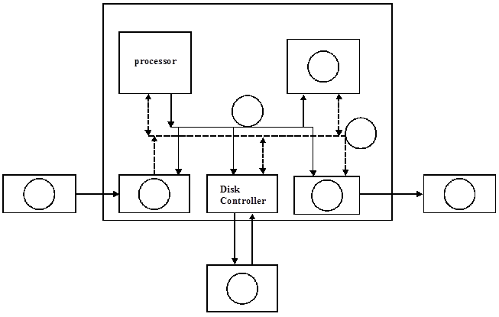

**(6)**

(b)     The above computer system uses the *stored program concept*. Explain this term.

.......................................................................................................................

.......................................................................................................................

.......................................................................................................................

**(2)**

**(Total 8 marks)**

**Q33.  
Figure 1** and **Figure 2** show two different versions of a **small section of a program.**

**Figure 1**                 **Figure 2**

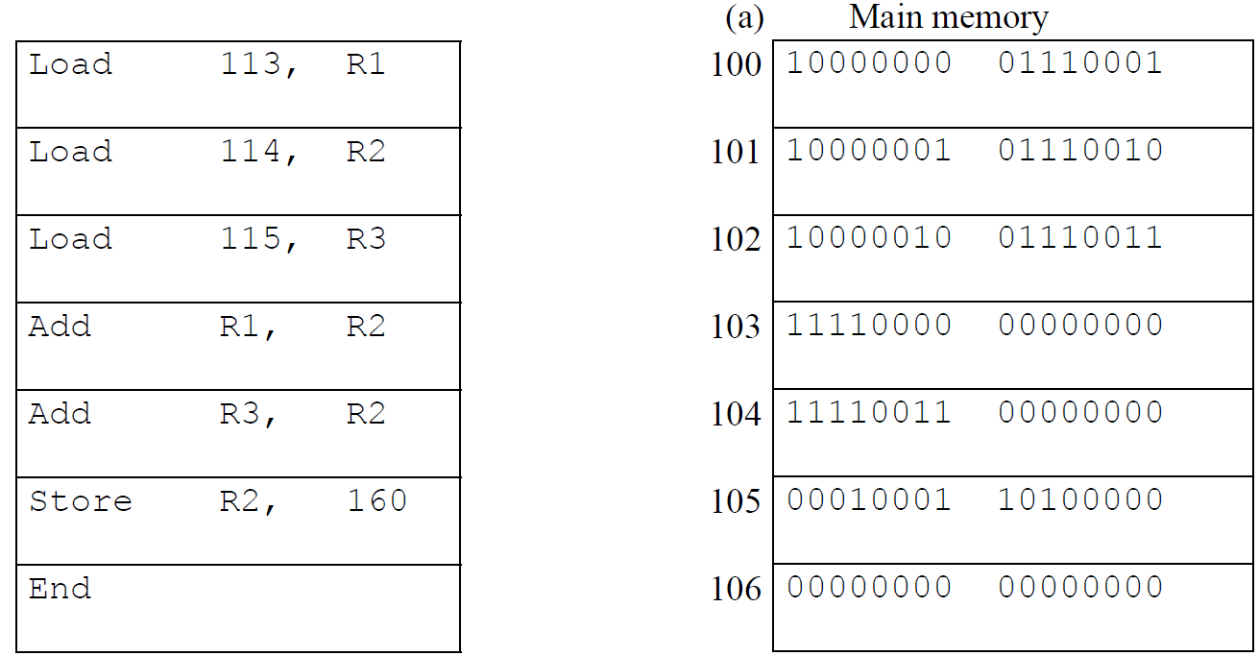

(a)     In **Figure 2** the label is missing from the column showing 100 to 106.

What should this label be? ..............................................................................

**(1)**

(b)     What generation of programming language is shown in **Figure 1**?

.........................................................................................................................

**(1)**

(c)     The code as written by the programmer is shown in **Figure 1**. A translator program is needed to produce a version of the code the processor can execute.

(i)      What is this translator program called?

................................................................................................................ **(1)**

(ii)     Following the translation process various outputs will be produced.

One output from this translation is the machine code executable file.

Name **one** other possible output ............................................................ **(1)**

(d)     Many digital computers operate on the stored program concept.

Explain the *stored program concept*.

.........................................................................................................................

.........................................................................................................................

.........................................................................................................................

**(4)**

**(Total 8 marks)**

**Q34.**

A supermarket uses many hardware devices as part of its daily operations.

A key component at the checkout area is the bar code reader (scanner).

If a product’s bar code cannot be read by the bar code reader the checkout operator will have to enter the bar code manually.

(a)     Name **two** hardware devices that could be used to manually enter a bar code.

Device 1 ...........................................................................................................

Device 2 ...........................................................................................................

**(2)**

(b)     Most supermarket product bar codes follow the International Article Number standard  
which has 13 digits: 12 of these digits are for data and the last one is a check digit.



Describe the principles of operation of a bar code reader **and** how the software in the bar code reader will use the check digit when processing a product.

In your answer you will also be assessed on your ability to use good English, and to organise your answer clearly **in complete sentences**, using specialist vocabulary where appropriate.

........................................................................................................................

........................................................................................................................

........................................................................................................................

........................................................................................................................

........................................................................................................................

........................................................................................................................

........................................................................................................................

........................................................................................................................

........................................................................................................................

........................................................................................................................

........................................................................................................................

........................................................................................................................

**(6)**

**(Total 8 marks)**

**Q35.**

A supermarket uses many hardware devices as part of its daily operations.

A key component at the checkout area is the bar code reader (scanner).

If a product’s bar code cannot be read by the bar code reader the checkout operator will have to enter the bar code manually.

(a)     Name **two** hardware devices that could be used to manually enter a bar code.

Device 1 ...........................................................................................................

Device 2 ...........................................................................................................

**(2)**

(b)     Most supermarket product bar codes follow the International Article Number standard  
which has 13 digits: 12 of these digits are for data and the last one is a check digit.



Describe the principles of operation of a bar code reader **and** how the software in the bar code reader will use the check digit when processing a product.

In your answer you will also be assessed on your ability to use good English, and to organise your answer clearly **in complete sentences**, using specialist vocabulary where appropriate.

........................................................................................................................

........................................................................................................................

........................................................................................................................

........................................................................................................................

........................................................................................................................

........................................................................................................................

........................................................................................................................

........................................................................................................................

........................................................................................................................

........................................................................................................................

........................................................................................................................

........................................................................................................................

**(6)**

**(Total 8 marks)**

**Q36.**A Radio Frequency Identification (RFID) system is made up of a transponder built into an RFID tag and an interrogator or reader. One example of use is to detect unauthorised removal of library books from a library.

Explain the principles of operation of this RFID system.

.................................................................................................................................

.................................................................................................................................

.................................................................................................................................

.................................................................................................................................

**(Total 2 marks)**

**Q37.**

(a)     Give **two** differences between primary and secondary storage.

1 .....................................................................................................................

........................................................................................................................

2 .....................................................................................................................

........................................................................................................................

**(2)**

(b)     Explain the principles of operation of a hard disk drive.

Your answer to this question will also be assessed on your ability to organise your answer clearly and coherently in complete sentences, using specialist vocabulary where appropriate.

........................................................................................................................

........................................................................................................................

........................................................................................................................

........................................................................................................................

........................................................................................................................

........................................................................................................................

........................................................................................................................

........................................................................................................................

........................................................................................................................

........................................................................................................................

........................................................................................................................

........................................................................................................................

........................................................................................................................

........................................................................................................................

**(6)**

**(Total 8 marks)**

# Consequences of users of computing

**Q38.**

The phrase “Internet of Things” is used to describe the connection of many everyday devices such as home heating controls, utility meters, cars and environmental sensors to the Internet. It is believed that tens of billions of devices will be connected to the Internet of Things by the end of the decade.

One anticipated use of the Internet of Things is to monitor the food that consumers have inside their fridges. This data could be gathered automatically from consumers’ devices by retailers who sell food. Retailers could use the data to analyse consumer consumption habits or automatically prepare deliveries for customers.

In the context of an Internet connected fridge, discuss the technologies that will be required to make the Internet of Things work.

You may wish to consider how the data might be captured, how networking technologies are changing to provide the necessary infrastructure, and how the data gathered by retailers could be stored and processed, from a hardware and software viewpoint.

.................................................................................................................................

.................................................................................................................................

.................................................................................................................................

.................................................................................................................................

.................................................................................................................................

.................................................................................................................................

.................................................................................................................................

.................................................................................................................................

.................................................................................................................................

.................................................................................................................................

.................................................................................................................................

.................................................................................................................................

.................................................................................................................................

.................................................................................................................................

.................................................................................................................................

**(Total 12 marks)**

**Q39.**

(a)     Below is a numbered list of the names of some of the legislation that applies in situations where computers are used:

1. Copyright, Designs and Patents Act  
2. Computer Misuse Act  
3. Regulation of Investigatory Powers Act  
4. Health and Safety Regulations  
5. Data Protection Act

For each of the situations given below, identify the relevant legislation which is being followed. Write the number that corresponds to the appropriate legislation in the box given after each situation.

Marcus wanted an MP3 of a recent song so he went to an online music store. After paying he was able to immediately download the purchased song.

|  |  |  |
| --- | --- | --- |
|  | Legislation |  |

A new workstation is installed in an office and an assessment is performed regarding the lighting for the workstation and the positioning of the desk, monitor and chair.

|  |  |  |
| --- | --- | --- |
|  | Legislation |  |

Mr Smith hands over his 50-character encryption key in response to a request from the authorities investigating a fraud case.

|  |  |  |
| --- | --- | --- |
|  | Legislation |  |

**(3)**

(b)     The operators of a number of multi-storey car parks have installed systems to scan and recognise number plates. The system is used at both the entrance and exit of the carparks so that the arrival and leaving times can be recorded.

Customers can set up an account so that money is automatically debited when their car number plate is recognised as the car leaves the car park.

Customers who do not have an account can use their mobile phones to pay the car parking fees by sending a text message to a specified number with their number plate details and length of stay.

As these car parks are based around the UK the company also collects location-specific data.

(i)      The number plate recognition system uses CCTV cameras and OCR software.

What is the full name of the technique known by the abbreviation OCR?

...............................................................................................................

**(1)**

(ii)     The company will need to follow the Data Protection Act as they will be storing personal data.

What is meant by personal data?

...............................................................................................................

**(1)**

(iii)    Why might the storing of number plate details, mobile phone numbers and location-specific data be a concern for privacy campaigners?

...............................................................................................................

...............................................................................................................

...............................................................................................................

...............................................................................................................

**(2)**

**(Total 7 marks)**

**Q40.**A well established use for robots in industry is the spraying of car bodies on a car production line.

A robotics researcher is investigating the feasibility of developing and installing in a car a computer-based control system to take over completely the driving of the car on public highways.

She has identified some of the inputs into the control system already:

•        detailed map

•        current weather report.

And some of the outputs:

•        position of steering wheel (in degrees from the vertical)

•        forces on accelerator and brake pedals.

Discuss why automated car control is a harder programming problem to solve than developing programmed control of a robot for spraying car bodies on a car production line.

For full marks your discussion must cover both programming problems.

.................................................................................................................................

.................................................................................................................................

.................................................................................................................................

.................................................................................................................................

.................................................................................................................................

**(Total 4 marks)**

**Q41.**Electronic Funds Transfer (EFT) makes it possible for a company in the UK to pay for goods manufactured in Malaysia without needing physically to exchange money in the form of coins, notes or cheques. The transfer is carried out electronically by messages sent between the company’s bank and the supplier’s bank.

(a)     Why must EFT systems be available for use 24 hours a day?

.......................................................................................................................

.......................................................................................................................

**(1)**

(b)     EFT messages are encrypted before being sent. Give **one** reason why this is done in this context.

.......................................................................................................................

.......................................................................................................................

**(1)**

(c)     Some governments have passed laws that require banks to lodge with them the encryption keys that are used to decrypt EFT messages. Give **one** reason why this is done.

.......................................................................................................................

.......................................................................................................................

**(1)**

**(Total 3 marks)**

# Communication and Networking

**Q42.**

(a)     State what is meant by **serial transmission** of data.

..........................................................................................................................

..........................................................................................................................

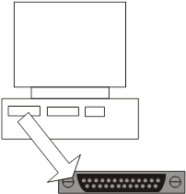

**(1)**

(b)     (i)      The figure above shows a port on the back of a PC which is used for the **parallel** **transmission** of data; typically between the PC and a printer.

More than eight of the port lines are used during a data transfer.

State **two different** uses for the lines.

1 .............................................................................................................

2 .............................................................................................................

**(2)**

(ii)     When would it be **inappropriate** to use parallel data transmission, even when the communicating device has a parallel port?

................................................................................................................

................................................................................................................

**(1)**

(c)     Define **asynchronous data transmission**.

..........................................................................................................................

..........................................................................................................................

**(1)**

**(Total 5 marks)**

**Q43.**

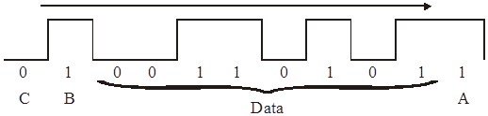

(a)     The figure above represents asynchronous data being transmitted using odd parity in the direction of the arrow. Give the name and the purpose of each of the following bits.

(i)      bit A

Name ....................................................................................................

Purpose.................................................................................................

..............................................................................................................

**(2)**

(ii)     bit B

Name ....................................................................................................

Purpose.................................................................................................

..............................................................................................................

**(2)**

(iii)     bit C

Name ....................................................................................................

Purpose.................................................................................................

..............................................................................................................

**(2)**

(b)     What is meant by:

(i)      baud rate; .............................................................................................

..............................................................................................................

**(1)**

(ii)     bit rate; .................................................................................................

..............................................................................................................

**(1)**

(iii)     bandwidth? ...........................................................................................

..............................................................................................................

**(1)**

(c)     The baud rate and the bit rate of a communication channel may be different.

Explain how this can occur.

.......................................................................................................................

.......................................................................................................................

.......................................................................................................................

.......................................................................................................................

**(2)**

**(Total 11 marks)**

**Q44.**

(a)     Data can be transmitted using parallel or serial transmission. Give **two** reasons why data is normally transmitted over long distances using serial transmission.

1 ....................................................................................................................

.......................................................................................................................

2 ....................................................................................................................

.......................................................................................................................

**(2)**

(b)     In the context of serial data transmission describe what is meant by

(i)      Baud Rate;

..............................................................................................................

..............................................................................................................

**(1)**

(ii)     Bit Rate;

..............................................................................................................

..............................................................................................................

**(1)**

(iii)     Bandwidth?

..............................................................................................................

..............................................................................................................

**(1)**

(c)     What is the relationship between bit rate and bandwidth?

.......................................................................................................................

.......................................................................................................................

**(1)**

**(Total 6 marks)**

**Q45.**

(a)     A small organisation has several computers in an office physically wired together to form a local area network (LAN) as shown below.

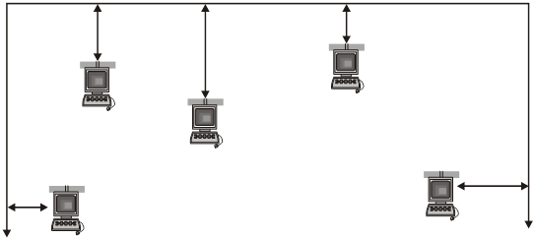

What is the name of this network topology?

........................................................................................................................

**(1)**

(b)     The network could instead be physically wired together where the centrally located computer is a server as shown below.

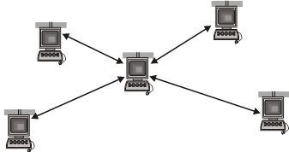

What is the name of this network topology?

.........................................................................................................................

**(1)**

(c)     (i)      State **one** advantage of network (a) compared with network (b) above, and give a reason.

Advantage ......................................................................................................

Reason ...........................................................................................................

........................................................................................................................

**(2)**

(ii)     State one advantage of network (b) compared with network (a) above, and give a reason.

Advantage..............................................................................................

Reason ..................................................................................................

...............................................................................................................

**(2)**

**(Total 6 marks)**

**Q46.**A systems analyst is planning a system for the administration of student courses to be used in an office in a college. The system must allow users at ten workstations to access and update a central database.

(a)     The analyst initially plans to use either a peer-to-peer or a server-based network.

Explain why a server-based network is likely to be more appropriate than a peer-to-peer network in this situation.

........................................................................................................................

........................................................................................................................

........................................................................................................................

........................................................................................................................

........................................................................................................................

........................................................................................................................

**(2)**

(b)     After considering other alternatives, the analyst finally decides to use a thin-client network.

Explain how a thin-client network works and how the use of a thin-client network instead of a traditional rich-client (thick-client) network will affect the selection of the hardware to be used by the system.

In your answer you will be assessed on your ability to use good English, and to organise your answer clearly in complete sentences, using specialist vocabulary where appropriate.

........................................................................................................................

........................................................................................................................

........................................................................................................................

........................................................................................................................

........................................................................................................................

........................................................................................................................

........................................................................................................................

........................................................................................................................

........................................................................................................................

........................................................................................................................

........................................................................................................................

........................................................................................................................

........................................................................................................................

........................................................................................................................

**(4)**

(c)     The system will be networked within the college. This network will then be connected to the Internet so that staff who are out of the college can log in and access the system.  
This connection will use a gateway.

What is the purpose of the gateway?

........................................................................................................................

........................................................................................................................

**(1)**

**(Total 7 marks)**

**Q47.**The diagram below shows the topology of a particular computer network that is divided up into segments.

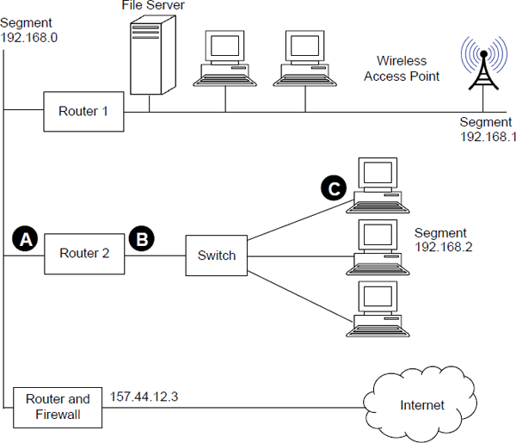

(a)     Suggest suitable IP addresses for:

(i)      the “Router 2” port labelled **A**: ................................................................

(ii)     the “Router 2” port labelled **B**: ...............................................................

(iii)    the computer network interface card labelled **C**: ...................................

**(3)**

(b)     What physical network topology is used within segment 192.168.2 to connect the computers to the switch?

........................................................................................................................

**(1)**

(c)     When the computers in segment 192.168.2 were configured on the network, they were programmed with a subnet mask.

What is the purpose of a subnet mask, and what would the subnet mask be in this case?

Purpose: ........................................................................................................

........................................................................................................................

Subnet mask: ................................................................................................

........................................................................................................................

**(2)**

(d)     Laptop computers connect to the network wirelessly using Wi–Fi. Wireless communication is less secure than communication using cables.

Explain **two** measures that the Wireless Access Point could use to improve the security of the network.

Measure 1: ....................................................................................................

........................................................................................................................

........................................................................................................................

Measure 2: ....................................................................................................

........................................................................................................................

........................................................................................................................

**(2)**

(e)     The computers in segment 192.168.1 use Carrier Sense Multiple Access with Collision Detection (CSMA/CD) to determine when to transmit data.

Explain how the CSMA/CD method is used, including what happens in the event of a collision occurring.

In this question you will also be assessed on your ability to use good English and to organise your answer clearly in complete sentences, using specialist vocabulary where appropriate.

........................................................................................................................

........................................................................................................................

........................................................................................................................

........................................................................................................................

........................................................................................................................

........................................................................................................................

........................................................................................................................

........................................................................................................................

........................................................................................................................

........................................................................................................................

........................................................................................................................

........................................................................................................................

........................................................................................................................

........................................................................................................................

........................................................................................................................

........................................................................................................................

........................................................................................................................

**(6)**

**(Total 14 marks)**