**Assembly language writing questions**

All questions use the following instruction set, which is taken from the AQA specimen paper. Assume that all registers are 8 bit and that operand values are given in denary.

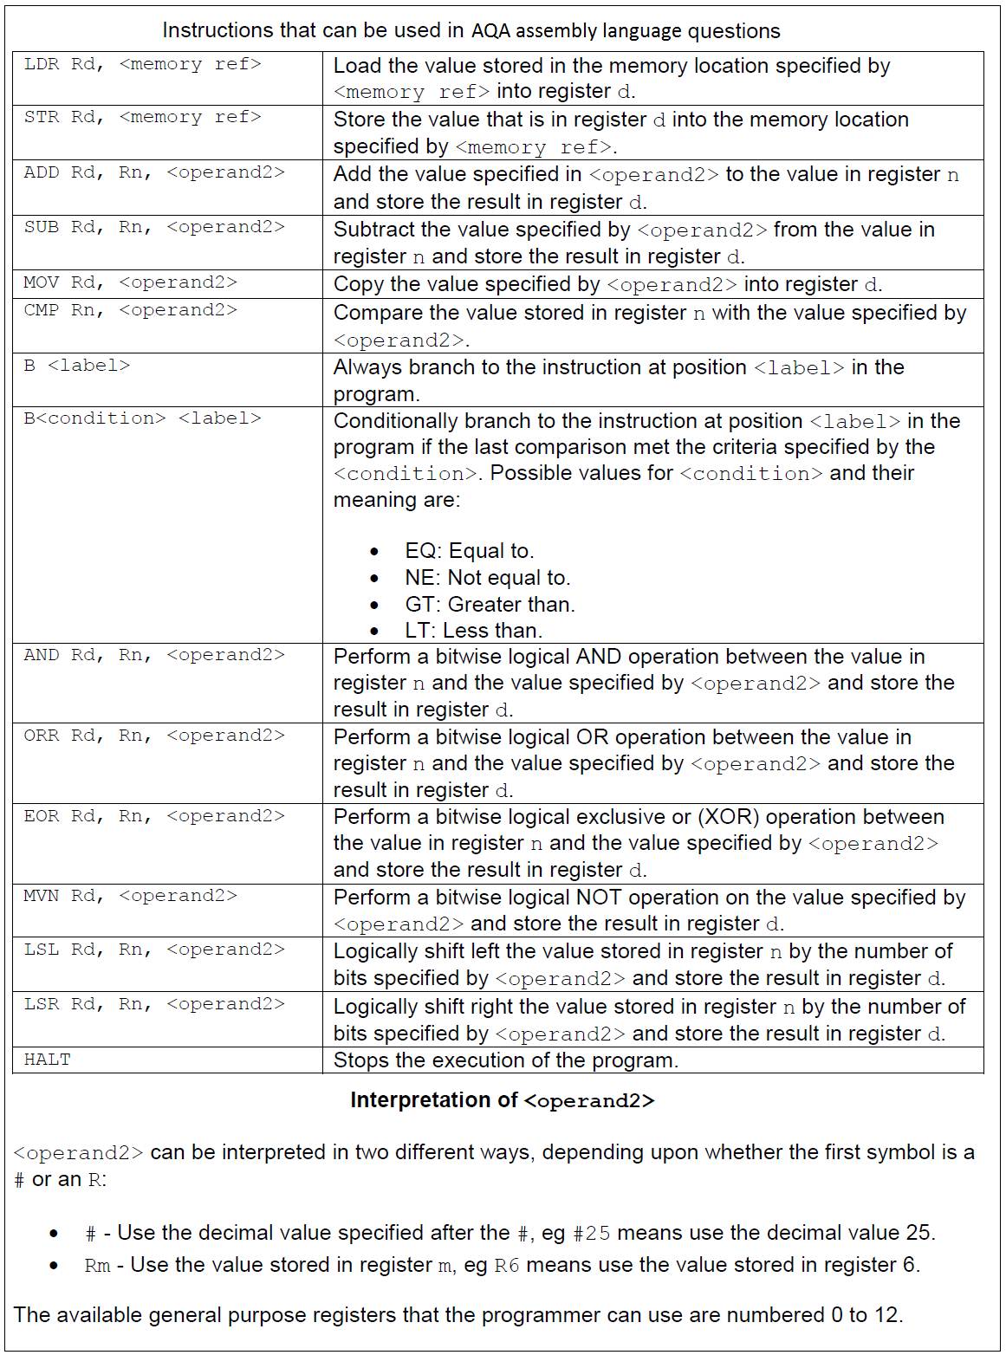

The following values have been loaded into an area of memory, and should be used in all questions.

|  |  |
| --- | --- |
| Address | Contents |
| 41 | 18 |
| 42 | 27 |
| 43 | 15 |
| 44 | 3 |
| 45 | 48 |

Write assembly language programs that perform the following tasks, using labels where appropriate:

Task 1:

* Load the value held in address 42 into R1
* Load the value 10 into R2
* Add the contents of R1 & R2, placing the result in R1
* Store the contents of R1 in memory address 46
* Halt

Task 2:

* Write a program that loads the contents of locations 41, 43 and 44 into R1, R2 & R3 respectively
* Add together the contents of R2 & R3, placing the result in R2
* Compare the values held in R1 & R2
* If the values are the same, place 10 in R3, otherwise place 20 in R3
* Halt

What value will be held in R3 after running the program?

Task 3:

* Write a program that loads the contents of locations 42, 43 and 44 into R1, R2 & R3 respectively
* Subtract the contents of R2 from R1, placing the result into R1
* Subtract the contents of R3 from R2, placing the result into R2
* Compare the contents of R1 & R2 and branch to a label ‘same’ if they are the same and ‘different’ if they are different.

Are the 2 values the same or different?

Task 4:

* Load the value held in address 44 into R1
* Copy this value into R2
* Perform a logical shift left on R2 of 2 spaces leaving the result in R2
* Add the contents of R1 & R2, placing the result in R3
* Perform a logical AND on the contents of R1 & R2 and place the result in R4

What values will be held in R3 and R4?

Task 5:

* Load the value 10 into R1 and 0 into R2
* Set a label for a loop point
* Add 2 to the contents of R2
* Subtract 1 from the contents of R1
* Compare R1 with zero and jump to a halt if equal
* Else return to the loop point.

What should R2 hold at the end of the program?