# Worksheet 6 Boolean Algebra

**Task 1**

1. X, Y and Z are Boolean variables which can be either TRUE or FALSE, represented by 1 and 0.

Complete the following “rules” of Boolean algebra:

## **General rules**

1. X ⋅ 0 =
2. X ⋅ 1 =
3. X ⋅ X =
4. X + 0 =
5. X + 1 =
6. X + X =
7. =

## **Commutative rule**

1. X ⋅ Y =
2. X + Y =

## **Associative rule**

1. X ⋅ (Y ⋅ Z) =
2. X + (Y + Z) =

## **Distributive rule**

1. X ⋅ (Y + Z) =
2. (X + Y) (W + Z) =

**Absorption rules**

1. X + (X ⋅ Y) =
2. X ⋅ (X + Y) =

*.*

2. Write down de Morgan’s first and second laws:

3. Use de Morgan’s Laws and the rules of Boolean algebra to simplify the following expressions, stating which rule you use at each step.

(a) X Y + X (Y + Z)

(b)

(c)

(d)

(e) (X + Y) (X + Z)

4. Complete the truth table to show that :

|  |  |  |  |  |  |
| --- | --- | --- | --- | --- | --- |
| **A** | **B** |  |  |  | **A + B** |
| 0 | 0 |  |  |  |  |
| 0 | 1 |  |  |  |  |
| 1 | 0 |  |  |  |  |
| 1 | 1 |  |  |  |  |

**Task 2**

1. Simplify the expression A⋅B + A⋅ (B + C)

Draw a logic circuit representing the simplified expression, using only 2 gates.

2. (a) Write the Boolean expression representing the logic circuit below.

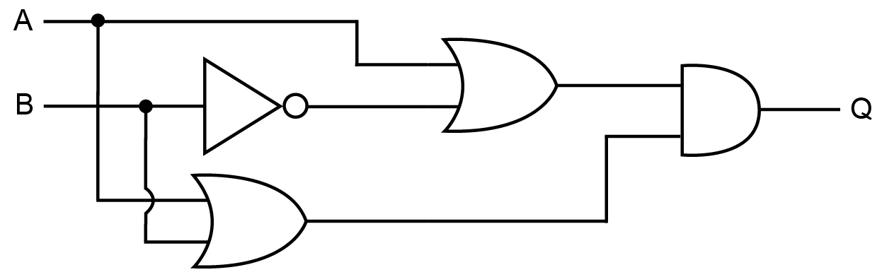

(b) Simplify the expression.

(c) With reference to the above example, explain why de Morgan’s Laws and the rules of Boolean algebra have a huge commercial significance in the manufacture of computers.