# Worksheet 5 Graphs Answers

**Task 1**

1. (a) Create an adjacency matrix to represent the following graph:

|  |  |  |  |  |  |  |  |  |
| --- | --- | --- | --- | --- | --- | --- | --- | --- |
|  | **E** | **T** | **G** | **M** | **F** | **H** | **S** | **P** |
| **E** |  |  |  | 7 |  |  |  |  |
| **T** |  |  |  | 5 | 9 |  |  |  |
| **G** |  |  |  |  | 4 |  |  | 12 |
| **M** |  |  |  |  |  | 2 | 3 | 14 |
| **F** |  |  |  |  |  |  | 2 |  |
| **H** |  |  |  |  |  |  |  |  |
| **S** |  |  |  |  |  |  |  |  |
| **P** |  |  |  |  |  |  |  |  |

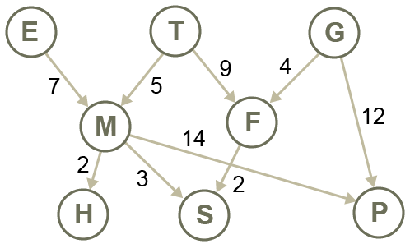

|  |  |  |  |  |  |  |  |  |
| --- | --- | --- | --- | --- | --- | --- | --- | --- |
|  | **A** | **B** | **C** | **D** | **E** | **F** | **G** | **H** |
| **A** |  | 15 | 13 | 20 |  |  |  |  |
| **B** | 15 |  |  |  | 18 |  |  |  |
| **C** | 13 |  |  |  |  |  | 14 |  |
| **D** | 20 |  |  |  | 17 |  | 8 |  |
| **E** |  | 18 |  | 17 |  | 16 |  |  |
| **F** |  |  |  |  | 16 |  |  | 7 |
| **G** |  |  | 14 | 8 |  |  |  | 10 |
| **H** |  |  |  |  |  | 7 | 10 |  |

(b) Draw the graph represented by the following matrix:

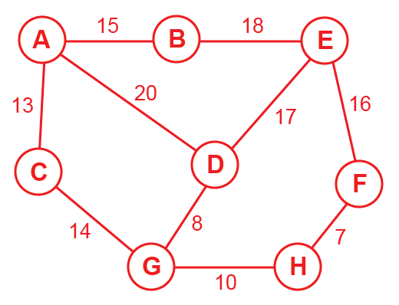

**Task 2**

2. (a) Draw the graph associated with the adjacency list below.

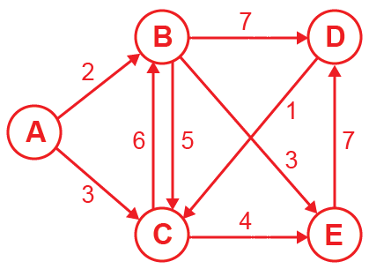

|  |  |  |  |
| --- | --- | --- | --- |
| **A** |  |  | {B:2, C:3} |
| **B** |  |  | {D:7, E:3, C:5} |
| **C** |  |  | {E:4, B:6} |
| **D** |  |  | {C:1} |
| **E** |  |  | {D:7} |

(b) Draw an adjacency list to represent the following graph:

|  |  |  |  |
| --- | --- | --- | --- |
| **A** |  |  | {F:6} |
| **B** |  |  | {A:2, C:8, D:5} |
| **C** |  |  | {E:4} |
| **D** |  |  | {G:3, H:14} |
| **E** |  |  | {B:9,H:6} |
| **F** |  |  | {} |
| **G** |  |  | {F:2} |
| **H** |  |  | {} |

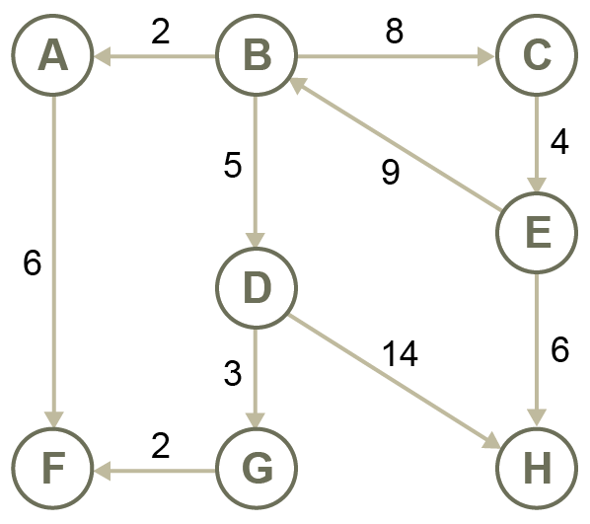

3. (a) Draw the graph represented by the following adjacency list.

|  |  |  |  |
| --- | --- | --- | --- |
| **E** |  |  | [M] |
| **F** |  |  | [S, T] |
| **G** |  |  | [F, P] |
| **H** |  |  | [ ] |
| **M** |  |  | [H,P,S] |
| **P** |  |  | [ ] |
| **S** |  |  | [ ] |
| **T** |  |  | [M, F] |

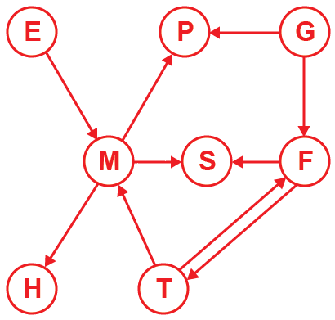

*(The shape of the graph is not important; the edges and nodes are all that is relevant)*

(b) Draw a new adjacency list for the equivalent undirected, unweighted graph.

|  |  |  |  |
| --- | --- | --- | --- |
| **E** |  |  | [M] |
| **T** |  |  | [M, F] |
| **G** |  |  | [F, P] |
| **M** |  |  | [H, S, P, E, T] |
| **F** |  |  | [S,T, G] |
| **H** |  |  | [M] |
| **S** |  |  | [M, F] |
| **P** |  |  | [M, G] |

4. (a) The following Python code represents a graph as a dictionary, with the key being a node and the value being a list of adjacent nodes. Draw the graph that it represents.

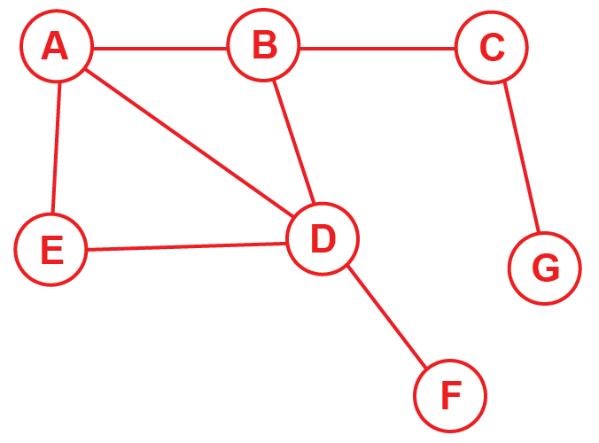GRAPH = {

'A':['B','D','E'],

'B':['A','C','D'],

'C':['B','G'],

'D':['A','B','E','F'],

'E':['A','D'],

'F':['D'],

'G':['C']

}

(b) Show how a weighted graph could be represented as a dictionary of dictionaries. (Give some weights to the edges in your graph)

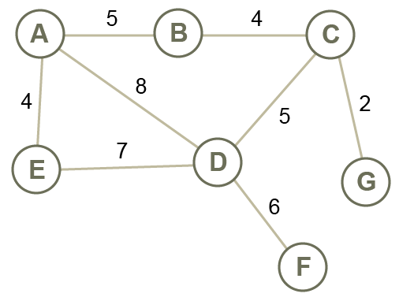 GRAPH = {

'A':{'B':5,'D':8,'E':4},

'B':{'A':5,'C’:4},

'C':{'B':4,'D':5,'G':2},

'D':{'A':8,'C':5,'E':7,'F':6},

'E':{'A':4,'D':7},

'F':{'D':6},

'G':{'C':2}

}

(see Python program GraphAsDictionary.py)