# Homework 6 Trees

# 1. Figure 1 shows a binary search tree into which the items Q, S, G, D, W have been inserted.

# Figure 1

# 

# C:\Users\Rob\AppData\Roaming\PixelMetrics\CaptureWiz\Temp\7.png

# (a) Amend the tree to show the addition of nodes ‘P’ and ‘T’ [2]

# (b) Complete the array of records below to represent the binary tree. [6]

# 

|  |  |  |  |
| --- | --- | --- | --- |
|  | **left** | **data** | **right** |
| **tree [0]** | 2 | Q | 1 |
| **tree[1]** |  |  |  |
| **tree[2]** |  |  |  |
| **tree[3]** |  |  |  |
| **tree[4]** |  |  |  |
| **tree[5]** |  |  |  |
| **tree[6]** |  |  |  |

2. The following items are to be inserted into a binary search tree so that they can be retrieved in alphabetical order.

**mushroom, satsuma, pineapple, grape, lettuce,carrot, orange, fig, watermelon, banana, radish**

(a) Draw the binary tree. [4]

# 

# 

(b) Write down the first six nodes visited in a pre-order traversal. [3]

(c) Write down the first six nodes visited in a post-order traversal. [3]

# 3. Here is a binary tree.

# (a) In what order have the items been inserted into the tree? [1]

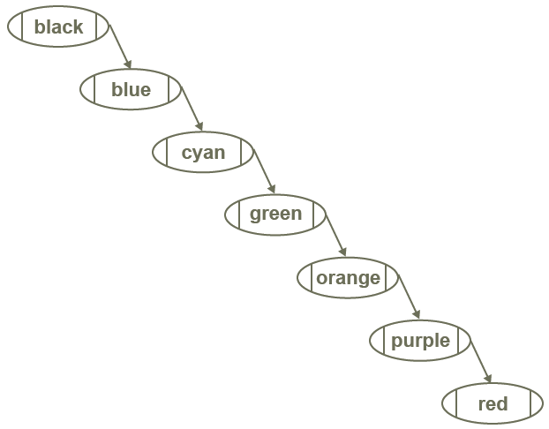

# (b) What is the effect on the time taken to find a particular item in a tree, if the tree has been constructed in this way? Explain your answer. [2]

(c) A tree can be “rebalanced” so that it will give optimal search efficiency.

Draw the tree that will result from adding the nodes in the most efficient possible way. [4]

[Total 25 Marks]