# Worksheet 6 Trees Answers

# Task 1

1. Annotate the tree below to identify the **root**, an **edge**, a **parent**, a **child**, a **subtree** and a **leaf**.

Root

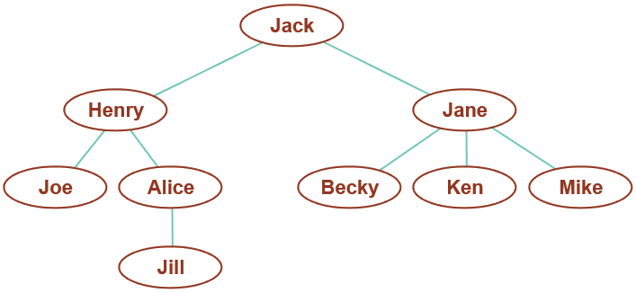

subtree

Leaf

Parent/child

Edge

2. Grundy’s game is a game for two players which starts with a pile of coins. Players take it in turn to make a move; a legal move consists of splitting a pile into two piles of unequal sizes. Thus for example a pile of 8 coins could be split into two piles of (7, 1), (6, 2) or (5, 3). The next player can split either of the two piles, so that for 2 piles of (7, 1) there will be three options of (6, 1, 1), (5,2,1), (4,3,1), etc.

(a) Complete the tree below to represent all possible moves and outcomes in the game.

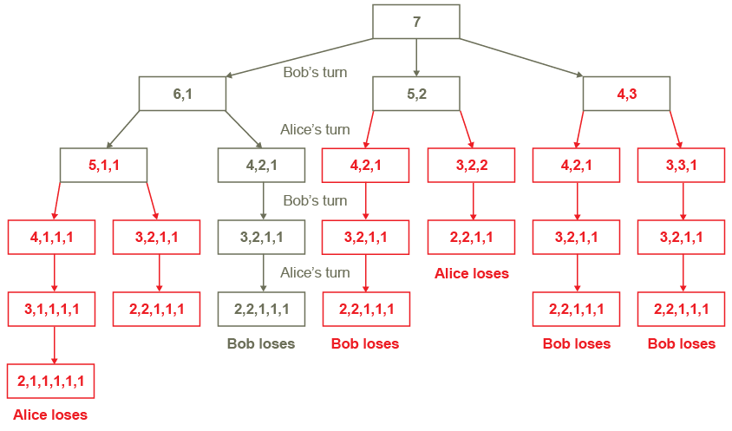

(b) If Bob has the first move, is there any strategy he can adopt to make sure he wins? Is there a winning strategy for Alice?

Unless Alice makes a mistake, there is no strategy that guarantees Bob will win. Alice just has to avoid any move which takes her into a branch where Bob can win.

**Task 2**

3. Here is a binary tree.

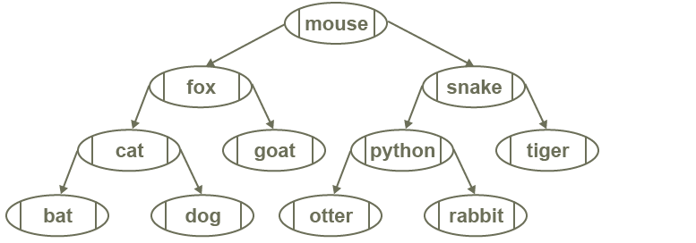

(a) Write down the order of the nodes visited in a pre-order traversal.

mouse, fox, cat, bat, dog, goat, snake, python, otter, rabbit, tiger

(b) Write down the order of the nodes visited in an in-order traversal. What pattern do you notice about this traversal?

bat, cat, dog, fox, goat, mouse, otter, python, rabbit, snake, tiger

It’s alphabetic order.

(c) Write down the order of the nodes visited in a post-order traversal.

bat, dog, cat, goat, fox, otter, rabbit, python, tiger, snake, mouse

4. Construct a binary search tree to hold the names Fred, Ken, George, Ray, Millie, Charlie, Ella, Tim, Amy, David

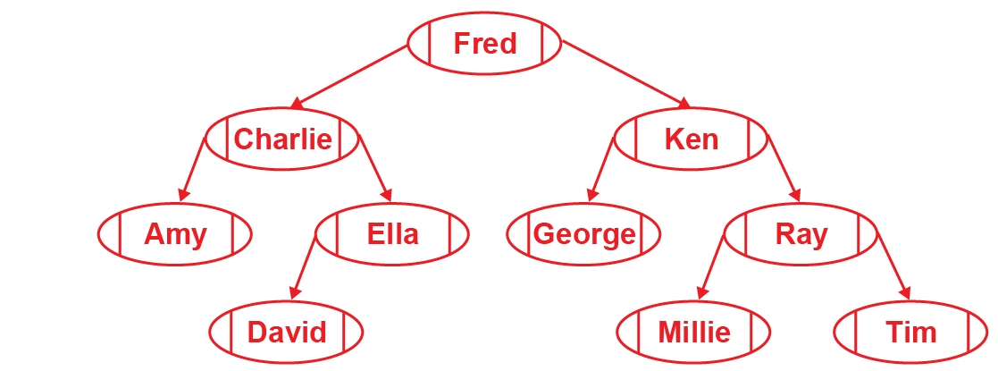

**Task 3**

5. Here is a binary tree.

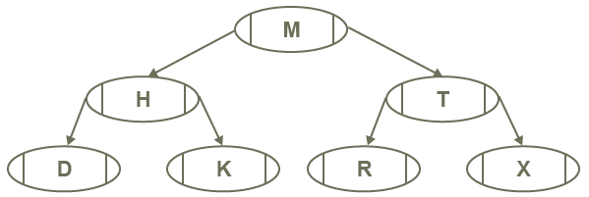

Complete the table to represent this binary tree.

|  |  |  |  |
| --- | --- | --- | --- |
|  | **left** | **data** | **right** |
| **tree [0]** | 1 | M | 2 |
| **tree[1]** | 3 | H | 4 |
| **tree[2]** | 5 | T | 6 |
| **tree[3]** | -1 | D | -1 |
| **tree[4]** | -1 | K | -1 |
| **tree[5]** | -1 | R | -1 |
| **tree[6]** | -1 | X | -1 |