# Worksheet 7 Vectors Answers

**Task 1**

1. Describe **three** different ways in which a vector can be represented. [3]

As a list of numbers

As a function

As a geometric point in space

2 ℕ is the set of all natural numbers (whole counting numbers including 0)

ℝ is the set of real numbers

(a) Give an example of a 3-vector over ℕ, defined as a function f: S ↦ ℝ,

where S is the set {0, 1, 2} and ℝ is the set of Real numbers [1]

0 ↦ 75

1 ↦ 0.5

2 ↦ 3.142 (or mappings to any other integers >= 0)

(b) Show how this function could be represented as a dictionary. [1]

{0:75, 1:0.5, 2:3.142}

(c) How is the vector notation ℝ2 spoken? [1]

“Two vector over the set of real numbers” (2-vector over ℝ )

(d) Give an example of a ℝ2 as an arrow [1]

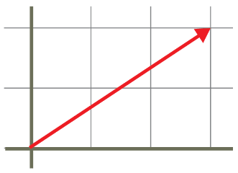

(e) Give an example of a ℕ4 vector defined as a list. [1]

[7, 49, 11, 3] or any other example showing integers >= 0

3. (a) Add the two vectors shown in the diagram and draw the resultant vector. [1]

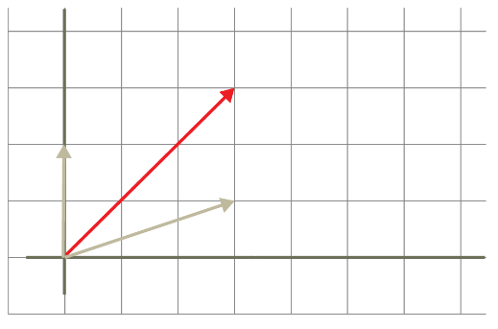

(b) Give the resultant vector as a Cartesian coordinate. [1]

(3,3)

(c) Show that the arithmetic method of adding vectors produces the same result. [1]

(3, 1) + (0, 2) = (3, 3)

4. Point A is defined as (-2, -1).

(a) Draw the vector which corresponds to this point on the diagram. [1]

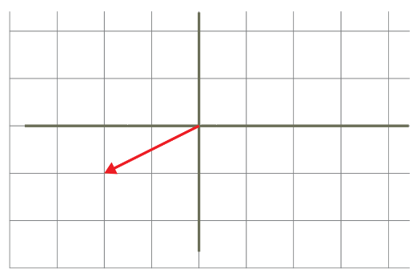

(b) Use scalar vector multiplication to multiply the vector by1/2. [1]

(-2, -1) * 1/2 = (-1, -1/2)

(c) Draw the resultant vector on the diagram. [1]

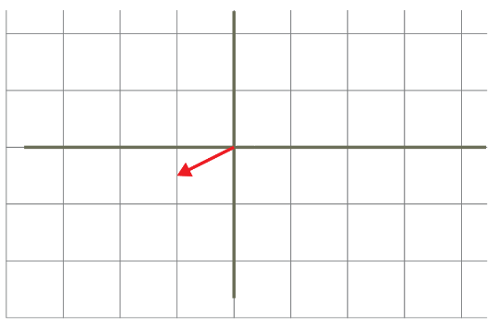

(d) Give the name for the effect of scalar vector multiplication on the vector. [1]

Scaling

Total marks for Task 1: [15]

**Task 2**

5. The convex combination method of combining two vectors is given by *w* = *αu + βv*.

(a) What constraint is applied to the values of *α* and *β*? [2]

They must both be >= 0 and they must add up to 1: *α + β = 1*

(b) Show the convex combination of the following vectors. Show your working. [2]

*u = [4, 8, 12] v = [16, 16, 16]*

*α = ¾ β = ¼*

w = (¾)(4, 8, 12) + (¼)(16, 16, 16) = (3, 6, 9) + (4, 4, 4) = (7, 10, 13)

One mark for transitive multiplication, one mark for addition

6. The dot product (*u* •  *v*) is a way to multiply 2 vectors.

(a) Given the two vectors below, find *u* •  *v.* Show your working. [2]

*u* = [7, 2] *v* = [4, 3]

One mark for multiplication (both)

One mark for addition

*u* •  *v* = (7*4) + (2*3) = 28 + 6 = 34

(b) Using the formula given below for cos Ɵ, where Ɵ is the angle between the two vectors:

cos Ɵ = (u • v )

(ǁuǁ • ǁvǁ)

find cos Ɵ for the two vectors *u* and *v* given above. [2]

*u* •  *v* = (7*4) + (2*3) = 28 + 6 = 34

ǁ*u*ǁ • ǁ*v*ǁ = √(49 + 4) * √(16 + 9) = √53 * √25 = √1325 = 36.4 (1 mark)

cos Ɵ = 34 / 36.4 = 0.93 (Ɵ = 20.9°) (1 mark)

(c) Given that cos 90° = 0, use the dot product of two vectors [7, 2] and [6, -21] to determine whether they are at right angles to each other. [1]

*u* •  *v* = 42 – 42 = 0. Therefore the vectors are at right angles to each other.

(d) (i) Draw the vectors *u* = [2, 1] and *v* = [-3, -1.5] [2]

(i) Use the diagram to find the angle Ɵ between the vectors. Answer 180° [1]



*v*

*u*

(ii) Find the value of cos Ɵ using the formula given in part (b) [3]

*u* •  *v* = -6 -1.5 = -7.5

ǁ*u*ǁ • ǁ*v*ǁ = √(4 + 1) * √(9 + 2.25)

= √(5 * 11.25)

= √(56.25) = 7.5

cos Ɵ = -7.5/7.5 = -1

Total marks for Task 2: [15]