# Assessment test

# Section 1: Topics 1-2

1. (a) In object oriented programming, explain what is meant by:

(i) a class [1]

(ii) a constructor [2]

(iii) instantiation [1]

(iv) polymorphism [2]

(b) Explain **two** advantages of object-oriented programming over   
procedural programming. [4]

2. A school employs two different types of staff, Academic and Administrative.   
Administrative staff are categorised as Office or Maintenance staff.

An incomplete diagram of the system is shown below.

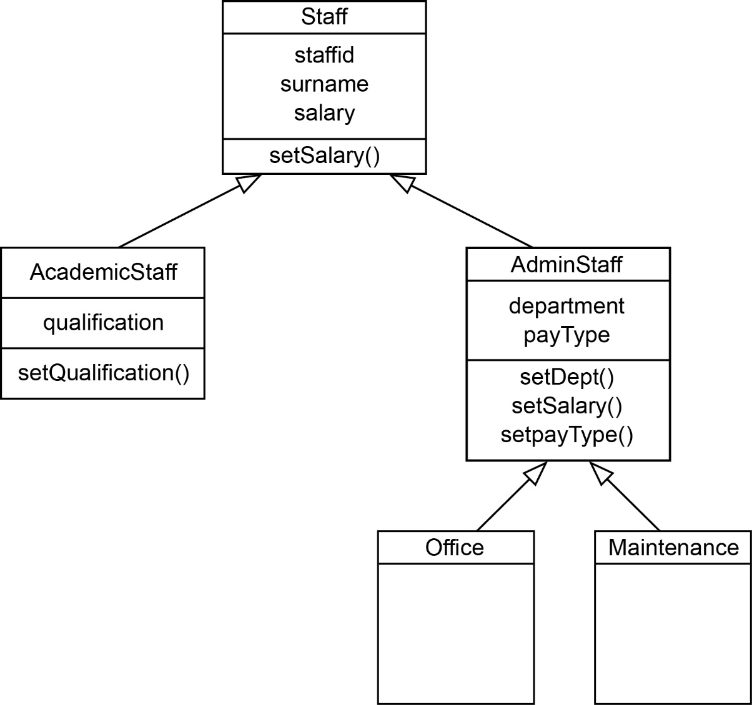

(a) What is this type of diagram called? [1]

(b) State the terms that describe

(i) setSalary() [1]

(ii) staffid [1]

(c) Explain the meaning of the arrows in the diagram, using an example. [2]

(d) Assume that AC123 has been defined as an object belonging to   
class AcademicStaff.

Explain why the statement:

AC123.setSalary(30000)

is valid even though setSalary() is not shown in this part of the diagram. [2]

(e) Academic staff are paid a monthly salary. Administrative staff are paid either   
weekly or monthly, depending on their payType.

Explain why setSalary() appears in the description of both Staff and AdminStaff. [3]

[Section 1 Total: 20 marks]

# Section 2: Topics 3-6

3. (a) If and , write an expression for   
(the composition of p and q). [1]

(b) Use functional composition to write code for a single function **comp x** which would implement p, q and .

You may assume that the built-in function **sqrt** finds the square root of a number. [3]

(c) What is the value of comp(3)? [1]

(d) The **domain** of comp is the set of natural numbers ℕ, where ℕ = {0, 1, 2, 3…}.

What is the **co-domain** of comp? [1]

4. What is returned by the following operations on

**listT = ["Oak", "Ash", "Elm", "Yew", "Pine"]** [5]

(a) head (tail listT)

(b) tail (tail (head listT))

(c) map head listT

(d) length listT

(e) null (tail (tail (head listT)))

5. **Map**, **filter**, and **fold** functions are all higher order functions.

(a) Explain what is meant by a **higher order function**. [2]

(b) Explain how a **map** function can be used to apply a discount of 6% to a list of transaction amounts. [3]

(c) Given listQ = [56, 14, 89, 23, 12, 7], how could you use one of the functions **map**, **filter**, **fold** to return all the elements in listQ which are less than 50? [2]

(d) Which function would you use to find the sum of all the elements in listQ? [1]

6. In a certain functional language, **listA** is defined using the statement

A = [1, 7, 6]

(a) What will be the output after each of the following consecutive operations?

(i) append [4, 5] to listA [1]

(ii) prepend [9] to listA [1]

(iii) length[listA] [1]

(b) Write a statement to replace the first two numbers of listA with 17 and 11 [3]

7. Big Data can be described in terms of **volume**, **velocity** and **variety**. Give an   
example of a big Data application and use it to describe what is meant by these three terms. [7]

8. Describe features of functional programming which makes it particularly suitable   
for handling Big Data applications. [3]

9. Farmer Giles owns Hill Farm jointly with his wife Daisy, a vet. Farmer Giles employs Jack the cowman, who also edits the farm website, and Jill who keeps the accounts and is engaged to Jack. Jill is an HGV driver.

Sketch a **graph schema** to represent these facts. [5]

[Section 2 Total: 40 marks]

[Total for Sections 1 and 2: 60 marks]