# Worksheet 1 Structure of the Internet Answers

### Task 1

1. Define the following Computing terms:  
   1. The Internet – A public interconnection of computer networks allowing data to be sent globally to any connected device.
   2. World Wide Web – A collection of hyperlinked documents accessible via the Internet.
   3. Backbone – A set of dedicated, high transmission rate network connections between geographical locations providing the core infrastructure for the Internet.
2. Label the diagram of the structure of the different levels of the Internet:

Answers for labels: Backbone, ISP, Home and business users.

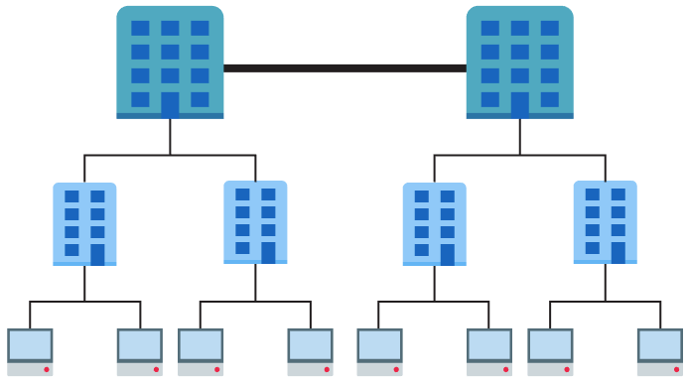

Backbone

ISP

Home and  
business users

1. IP version 4 addresses such as 13.1.67.234 and 115.90.12.101 are used to identify devices on a network. As such they need to be unique for each device.
   1. The value of each number in an IP address ranges from 0 to 255. Calculate how many addresses are possible in theory. Working: 256 x 256 x 256 x 256  
      Answer: 4,294,967,296
   2. Explain why version 4 is not enough for use on the Internet.

Each device on a network needs a unique IP address

Some addresses are private and cannot be used on the Internet

As the Internet gets bigger more and more addresses are used

Ultimately, all addresses will be used and no further devices can be added

# Task 2

IP addresses are difficult for humans to remember. DNS provides a resolution of domains names into their IP addresses.

If you type 216.58.213.174 into the address bar of your browser, you should get the www.google.co.uk web page.

We type the URL, as it is easier to remember, but it is just a label for the actual IP address that connects your computer to the Google servers.

Use the website <http://ping.eu/nslookup> to find the IP addresses of the following three websites and two more of your choice:

|  |  |
| --- | --- |
| **Website** | **IP address(es)** |
| google.co.uk |  |
| bbc.co.uk |  |
| en.wikipedia.org |  |
|  |  |
|  |  |

Check they work by typing them into a browser address bar. (Some only work in one direction.)

Compare your results with other people. They may be different. Can you explain why?

Large websites need multiple connections for their servers to balance their load evenly and not create a bottleneck of requests. DNS requests made can be directed to a group of different IP addresses.

# Task 3

1. Five Regional Internet Registries (RIRs) record the allocation of IP addresses in different geographical locations.   
     
   Research the names of these and the broad geographical area that are responsible for:

|  |  |
| --- | --- |
| **Name** | **Region** |
| African Network Information Center (AFRINIC) | Africa |
| American Registry for Internet Numbers (ARIN) | United States, Canada, several parts of the Caribbean region, and Antarctica. |
| Asia-Pacific Network Information Centre (APNIC) | Asia, Australia, New Zealand, and neighbouring countries |
| Latin America and Caribbean Network Information Centre (LACNIC) | Latin America and parts of the Caribbean region |
| Réseaux IP Européens Network Coordination Centre (RIPE NCC) | Europe, Russia, the Middle East, and Central Asia |

1. URLs are used to specify the location and means of accessing a resource across a network.   
     
   (a) Correctly label the parts of the following URL with ‘**Domain name**’, ‘**Protocol**’, ‘**Resource**’, ‘**host’**:

http://www.foodsupermarket.com/cheeses.html

**Domain name**

**Resource**

**Protocol**

**host**

(b) Identify the fully qualified domain name. www.foodsupermarket.com