Worksheet 2 Packet switching and routers Answers

Task 1

Using the tool www.monitis.com/traceroute you need to investigate how long packets of data take to travel around the Internet.

Simply type in the address of the website you are trying to reach and record the average latency from Europe. You can also see a visualisation of the hops across routers from start to finish.

Continent | URL | Average response time
Europe | www.bbc.co.uk
Europe
Africa | www.southafrica.net
Africa
Asia | www.tianya.cn
Asia
Australasia | www.smh.com.au
Australasia
North America | google.com
North America
South America | www.brasil.gov.br
South America

- Which website has the shortest latency? Likely to be those hosted in Europe if using this worksheet in the UK.

- Which has the longest latency? Likely to be an Australasian or South American website if using this worksheet in the UK.

- Why do you think this website has the longest latency? Largest distance from Europe (or rather the longest route)

Task 2

- The following network shows the latency in milliseconds (ms) between routers in a network. Routers estimate the latencies from the actual progress of packets during the previous millisecond.

Node A is sending data to node F as three packets: 1, 2 and 3.
On the diagrams below, label where these packets will be after each millisecond if each travels by one of the quickest routes calculated from the estimated latencies. Latencies and available routes vary each millisecond depending on congestion or cable failure.
1 ms | 2 ms
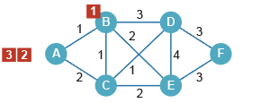 | 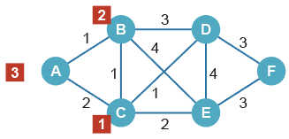
3 ms | 4 ms
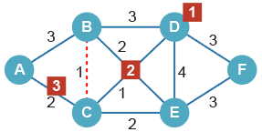 | 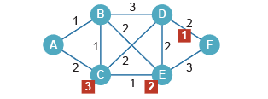
5 ms | 6 ms
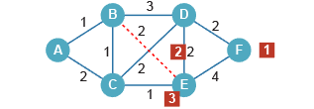 | 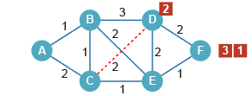
7 ms | 8 ms
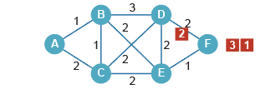 | 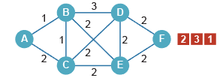

In which order will the packets arrive? 1, 3, 2

- Justify why packet payloads are usually kept to around 1500 bytes. Consider the effects of much larger payloads on transmission time, and the effects of very small payloads on the overheads within the headers and trailers.

- Very small packets on a network would increase the transfer overheads by requiring more headers and trailers. These headers and trailers would significantly increase the overall contribution to the data transferred.
- Single packets containing an entire transmission would hog the transmission routes preventing any further transmission by other routers.
- Smaller packets have less chance of corruption during transmission.

