# Worksheet 6 Client server model Answers

**Task 1**

1. For the following client server models, think of three scenarios and complete
   1. the client software making the request,
   2. the request that is being made, and
   3. the data response provided by the server.

The first has been completed for you. Answers will vary.

|  |  |  |
| --- | --- | --- |
| C:\Users\Rob\AppData\Roaming\PixelMetrics\CaptureWiz\Temp\48.png | **Software:** | Operating system |
| **Request:** | Access to file |
| **Response:** | Requested file |

|  |  |  |
| --- | --- | --- |
| C:\Users\Rob\AppData\Roaming\PixelMetrics\CaptureWiz\Temp\48.png | **Software:** | Web browser |
| **Request:** | Web page from server |
| **Response:** | Web page content |
| C:\Users\Rob\AppData\Roaming\PixelMetrics\CaptureWiz\Temp\48.png | **Software:** | Client operating system |
| **Request:** | Network details from network OS |
| **Response:** | Network configuration |
| C:\Users\Rob\AppData\Roaming\PixelMetrics\CaptureWiz\Temp\48.png | **Software:** | Database application |
| **Request:** | View data from server |
| **Response:** | Data in search results |

1. A web developer is creating several web applications using free services available on the Internet. For the following Web API functions suggest how each app may make use of the service:

|  |  |  |  |
| --- | --- | --- | --- |
| **Web app** | **Web service** | **API function** | **Use in app** |
| Tourist trail | Map service | Return geographical coordinates of item of interest | The app could search for a building by name and be sent the location on the map where it is. This could then be used to navigate a route there |
| Social media summariser | Social media site | Return timeline for specified user | The app could receive updates for a given user to display popular posts. |
| Video editor | Online video service | Post video to user’s account | The app could upload an edited video to an online video service |
| Weather app | Forecast website | Return weather data for given location | The app could retrieve the weather forecast and determine when rain is due |

**Task 2**

A RESTful web application has been developed to interface with an online clothes shopping website. Label the web page below identify and describe where HTTP methods PUT, GET, POST and DELETE could be used to interact with the database.

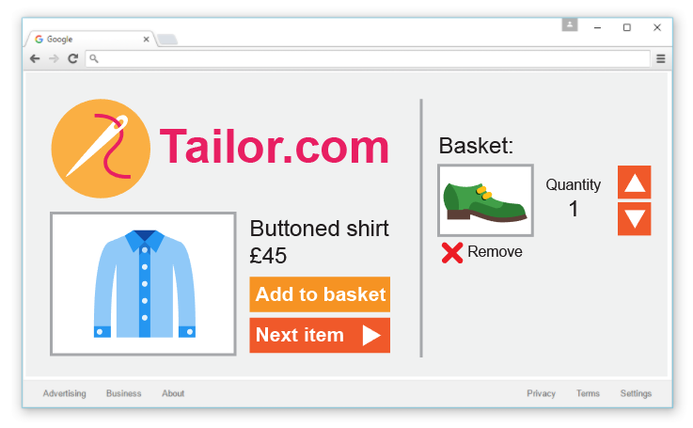

**HTTP method: PUT.**

Adjusts the quality value within an order record.

**HTTP method: DELETE.**

Used to delete an item from the order which will remove the record from the table.

**HTTP method: POST.**

Used to add an item into the order (will create a related record in a table).

**HTTP method: GET.**

Retrieves details about an item (the whole record from the database).

**Task 3**

A lead developer wants to use XML to handle data in a web application a company is developing. A junior developer thinks JSON would be a more appropriate alternative.   
  
Write an email to the lead developer explaining why JSON might be a better choice.

Points should include:

* Will be easier to read for human // Code will be clearer so will make sense to other developers maintaining the code at a later date
* Languages such as Javascript have functions built-in to directly process JSON
* As a result, will reduce the time taken to develop
* Increased performance as the code is parsed more quickly and will reduce processing time
* This will also make the data quicker to transmit