**Writing SQL for the Northwind database**

The Northwind database is a sample database that originally shipped with MS Access. It deals with the sales and shipping of speciality foods around the world. The w3schools website has an SQL editor which can be used to write standard SQL syntax to query this database. Open the editor with the link below:

<http://www.w3schools.com/sql/trysql.asp?filename=trysql_select_all>

On the right hand side of the screen, you can find a list of all of the tables in the database. Selecting each of these will pull out all fields in the table. The (somewhat complex) E – R diagram for the original database is shown below. Note that the w3schools version does not have as many fields and some of the field names may be different!

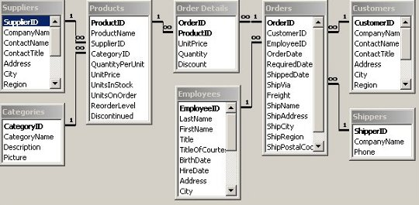

Now try to query the database to find the following. You can cut and paste from the query output and it should create a table in the word document.

1. Write a query to extract all fields from the customer table for customers in Spain. Order the output alphabetically by city.
2. Now modify the customer query to select those customers (any country) where the company Name begins with A. Note you will need the keyword LIKE and the wildcard symbol is a % sign, not a *.
3. Now perform a pattern match to find out which employee attended Sussex University.
4. Now query the products table to produce a list of all products where the price is 10 (presumably dollars!) or less in descending price order.
5. Now for the first 2 table query! Write a query to produce a list of all products that belong to the category ‘Dairy Products’. Your output should list the product name, quantity per unit and unit price in alphabetical order by product. This will work with either and explicit INNER JOIN, or with an implicit inner join (i.e. selecting from both tables and then using the WHERE criteria to specify the link between the tables).
6. Now add a third table to the above query, Suppliers. Modify the query so that it produces a list of all dairy products from suppliers in Italy. Note that for some reason the w3schools database engine will not support an SQL statement with 2 INNER JOINS (it should!). Therefore the only way to get this query to work is with implicit joins – you need to select all 3 tables and write a compound WHERE statement (with several logical ANDs) to specify the criteria.
7. Now we will look at the orders relationship. Write a query to pull out a list of all Companies who have placed orders through Nancy Davolio (who is Nancy Davolio?), sorted first in order of country and then in alphabetical order of company name.

You will notice that some customers are listed more than once – presumably because they have placed more than one order. As a refinement, modify the query so it returns a list of customers without duplicates. The keyword DISTINCT is used for this – you can work out where to put it.

1. Now for the really big one! This query works across 4 tables. Write a query to produce a list of all companies who have ordered Queso Cabrales (Strong Asturian blue cheese), the country they are based in and the date on which the order was placed, ordered by date with the most recent first.
2. Finally, let’s go for one table more! You might be able to leave some of the previous code and just modify it slightly. Produce a list of all products that are shipped to Island Trading (on the Isle of Wight, so at least one ‘ship’!) together with the name and country of the supplier for that product, ordered by country then product. Note that Country is a field name in both the Customers and Suppliers table, so you will need to specify which table you are referring to. There should be 5 products of which 4 are alcohol – not sure what that says about people from the Isle of Wight.