# Homework 6 Big data

1. Big Data can be represented using graph schema. Here is part of such a schema relating to a sensor network.

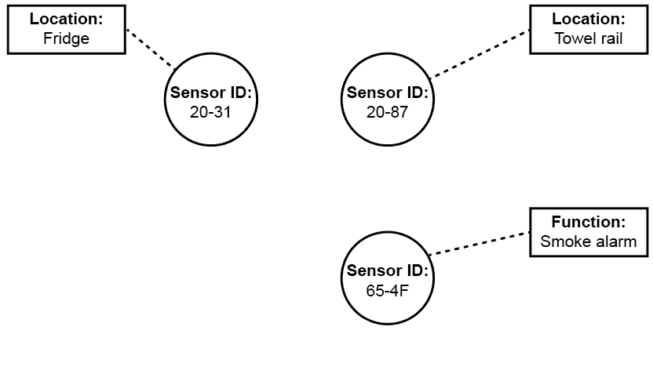

Complete the graph schema to represent the following facts:

(a) Any sensor with an ID starting “20-“ has the function “Temperature” [1]

(b) The smoke alarm is located in the kitchen [1]

(c) The towel rail is currently heated to 32 degrees Celsius [1]

(d) Sensor 20-31 is connected to a door sensor in the same location. [2]

(e) XYZ alarms are contracted to service all smoke alarms [1]

2. Big Data often involves a large volume of data. Explain two other distinguishing   
features of Big Data and give examples. [6]

3. Describe an appropriate computer architecture for processing Big Data and   
explain why it is appropriate. [4]

4. Functional programming languages contain map and fold/reduce functions, and map-reduce algorithms are often used to process Big Data.

(a) Explain the general principle of a map-reduce algorithm. [2]

(b) Explain why these algorithms are commonly used with Big Data [2]

[Total 20 Marks]