# Homework 1 Mealy machines Answers

1. Why are finite state machines considered to be abstract? [1]

They are a way to represent the behaviour of systems, but are not the real system.   
They don’t show how the FSM will be implemented, for example in hardware,   
so abstract this away.

2. A speaker system responds to the press of a button. On each press of the button, the volume is increased. The volume output moves through a cycle of Off, Low, Medium, and High, Off, Low, …. Here is an image of an FSM that describes this system.

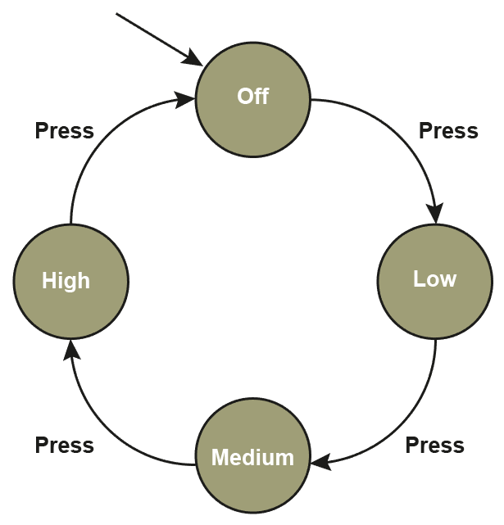

Complete this Mealy machine diagram representing the speaker system. [4]

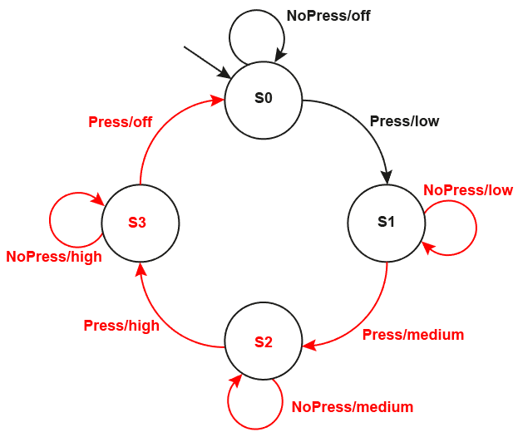

3. Here is a diagram of a Mealy machine.

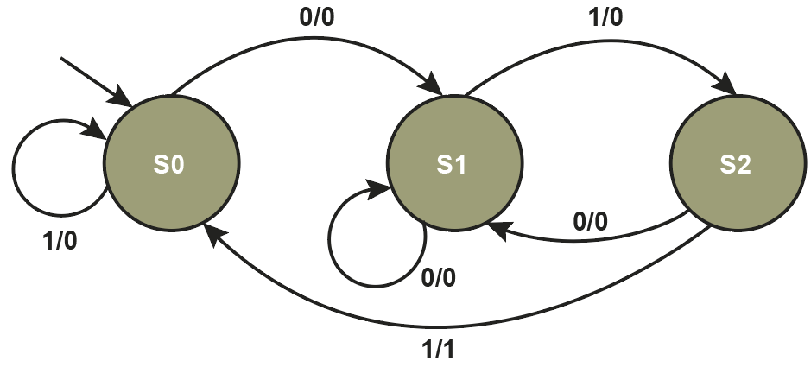

(a) Complete the state transition table based on this Mealy machine diagram. [6]

|  |  |  |  |
| --- | --- | --- | --- |
| **Input** | **Current state** | **Output** | **Next state** |
| 0 | S0 | 0 | S1 |
| 1 | S0 | 0 | S0 |
| 0 | S1 | 0 | S1 |
| 1 | S1 | 0 | S2 |
| 0 | S2 | 0 | S1 |
| 1 | S2 | 1 | S0 |

(b) Show the state sequence for the input string 101110. [5]

|  |  |  |  |  |  |  |  |
| --- | --- | --- | --- | --- | --- | --- | --- |
| Input | 1 | 0 | 1 | 1 | 1 | 0 |  |
| State | S0 | S0 | S1 | S2 | S0 | S0 | S1 |
| Output | 0 | 0 | 0 | 1 | 0 | 0 |  |

(c) What sequence of inputs did it identify by outputting a 1? [1]

Sequence 011

4. Design a Mealy machine that translates an input string to its complement. For example,   
the input string 0101 should generate an output of 1010. [3]

Marks: 1 = single state; 1 = 1/0 arc; 1 = 0/1 arc

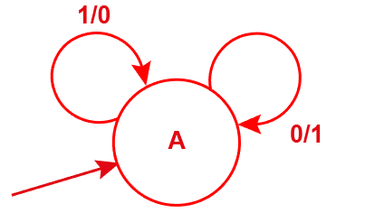

[Total 20 Marks]