# Worksheet 2 Sets Answers

**Task 1**

The notation for common sets is:

* + **N** = set of natural numbers: {0, 1, 2,…}
  + **Z+** = set of positive integers: {1, 2, 3,…}
  + **Z** = set of all integers: {…, -2,-1, 0,1, 2,…}
  + **Q** = set of rational numbers (can be expressed as a fraction)
  + **R** = set of real numbers

1. The set of even numbers >= 0 can be expressed as

S = { x | x ∈ N ᴧ x is even } using **set comprehension**.   
  
 Using set **enumeration**, S can be expressed as {0, 2, 4, 6, …}

Use set enumeration to express the set: S = {t | t is a letter in “pepper”} S = {e, p, r}

1. Indicate whether each of the following is True or False:

|  |  |  |
| --- | --- | --- |
|  |  | **T or F** |
| **1** | A set is unordered | T |
| **2** | A set can contain duplicate values | F |
| **3** | A set is usually denoted by a lowercase letter | F |
| **4** | A member is usually denoted by a lowercase letter | T |
| **5** | 5 ∈ {1, 2, 3, 4, 5, 6, 7, 8} | T |
| **6** | 3 ∉ {2, 4, 6, 8, 10} | T |
| **7** | a ∈ {c | c is a letter in “computing”} | F |
| **8** | a ∈ {d | d is a letter in “abacus”} | T |
| **9** | a ∉ ø | T |
| **10** | Ø and {} both denote an empty set | T |
| **11** | {a,b,c} ∈ {a, b, c, d, e} | F |

The set in 7 is {c, o, m, p,u, t, i, n, g}

The set in 8 is {a, b, c, u, s}

Qu 11 is tricky: the letters a, b, and c are members of the set {a, b, c, d, e} but the set {a, b, c} is not a member.

1. Complete the tables to show the definitions of sets.

|  |  |
| --- | --- |
| **Definition** | **Set Comprehension** |
| T = {1, 2, 3, 4} | T = {c | c ∈ **Z+** ᴧ c < 5} or {c | c ∈ **N** ᴧ c > 0 ᴧ c < 5} |
| C = {} or Φ | C = {x | x ∈ **Z** ᴧ x2 – 2 = 0} |
| X = {√2, -√2} | X = {y | y ∈ **R** ᴧ y2 – 2 = 0} |
| T = {5, 10, 15, …} | T = {c | c ∈ **Z+** ᴧ c MOD 5 = 0} |
| C = {3} | C = {x | x ∈ **N** ᴧ x + 7 = 10} |

|  |  |
| --- | --- |
| **Definition (Strings)** | **Compact Representation** |
| T = {10, 100, 1000…} | T = {10n | n ≥ 1} |
| Y = {1100, 111000} | Y = {1n0n | n > 1 ᴧ n < 4} |
| T = {1000, 110000, 11100000,1111000000, …} | T = {1n0n+2 | n ∈ **Z+**}  or {1n0n+2 | n ∈ **N** ᴧ n > 0} |
| C = {01, 0101, 010101, …} | C = {(01)n | n > 0} |

**Task 2**

Remember the symbols

∈ ∉ ∪ ∩ \ { } ø

1. Given sets: A = {1, 2, 3, 4, 5} B = {3, 4, 5, 6, 7} C = {2, 3, 8, 9} D = {3, 4}
2. A ∪ B = {1, 2, 3, 4, 5, 6, 7}
3. A ∩ B = {3, 4, 5}
4. C \ B = {2, 8, 9}
5. Is it true that 3 ∈ C? Yes
6. Is it true that 4 ∉ C? Yes
7. Is it true that {3} ∈ B? No, because {3} is a set. The true statement would be 3 ∈ B.
8. (D \ A) ∪ B = {} ∪ B = {3, 4, 5, 6, 7} = B
9. Is it true that (A ∩ B) \ D = (B \ D) ∩ A? Show your working.

Yes

(A ∩ B) \ D = {3, 4, 5} \ {3, 4} = {5}

(B \ D) ∩ A = {5, 6, 7} ∩ {1, 2, 3, 4, 5} = {5}

1. Is it true that (D \ A) ∪ B = D \ (A ∪ B)? Show your working.

No

(D \ A) ∪ B = {} ∪ B = {3, 4, 5, 6, 7} = B

D \ (A ∪ B) = {3, 4} \ {1, 2, 3, 4, 5, 6, 7} = {}

1. Write an expression to construct a set T = {1, 2, 3, …9} from the sets A to D

T = A ∪ B ∪ C

1. Write an expression to construct a set T = {1, 4, 5, 6, 7} from the sets A to D

T = (A ∪ B) \ C

1. Write an expression to construct a set T = {6, 7, 8, 9} from the sets A to D

T = (C ∪ B) \ A

**Task 3**

1. Sets: A = {1, 2, 3, 4, 5} B = {4, 5, 6, 7} C = {2, 3, 8, 9} D = {3, 4} E = {5, 7, 6, 4}
2. Is it true that D ⊆ A? Yes
3. Is it true that E = B? Yes, they both contain the same members
4. Is it true that D ⊆ C? No, 4 ∉ C
5. Is it true that E ⊂ B? No, because it is an equivalent set
6. Is it true that D ⊂ A? Yes
7. Is it true that E ⊆ B? Yes
8. State the name of the set X where X ⊆ A and X ⊆ B and X ⊆ C and X ⊆ D and X ⊆ E.

The empty set (Accept {} or Φ )

1. Recall the common sets (**N, Z+, Z, Q, R**). Use the subset operator (⊆) to produce a true statement about their relationship.

**Z+** ⊆ **N** ⊆ **Z** ⊆ **Q** ⊆ **R**

1. Is it true that A ∩ B ⊆ D? Show your working. No, A ∩ B = {4, 5} ⊈ D
2. Is it true that D ∩ E ⊆ B? Show your working. Yes, D ∩ E = {4} ⊆ B
3. Is it true that D ⊆ D? Yes, every set is subset of itself.

**Task 4**

1. Given sets: A = {1, 2, 3} B = {w, x} C = {2, 3, 4} D = {a, b, c}
2. C x D =

{(2,a), (2,b), (2,c), (3,a), (3,b), (3,c), (4,a), (4,b), (4,c)}

1. A x B =

{(1,w), (1,x), (2,w), (2,x), (3,w), (3,x)}

1. Is it true that C x D = D x C? Show your working.

No.

C x D = {(2,a), (2,b), (2,c), (3,a), (3,b), (3,c), (4,a), (4,b), (4,c)}

D x C = {(a,2), (b,2), (c,2), (a,3), (b,3), (c,3), (a,4), (b,4), (c,4)}

1. Construct a set T = {(w,w), (w,x), (x,w), (x,x)} from the set B using the Cartesian product operation.

T = B x B

1. (A x B) ∩ (C x B) =

{(1,w), (1,x), (2,w), (2,x), (3,w), (3,x)} ∩ {(2,w), (2,x), (3,w), (3,x), (4,w), (4,x)}

= {(2,w), (2,x), (3,w), (3,x)}

1. (A x B) \ (C x B) =

{(1,w), (1,x), (2,w), (2,x), (3,w), (3,x)} \ {(2,w), (2,x), (3,w), (3,x), (4,w), (4,x)}

= {(1,w), (1,x)}

1. Construct an expression to generate the set: {(1,2), (1,3), (1,4), (2,4), (3,4)}. Show your working.

Hint: Which sets only use numbers? Which operator do you need to generate an ordered pair? Which operators reduce the size of sets?

(A x C) \ (C x A)

A x C = {(1,2), (1,3), (1,4), (2,2), (2,3), (2,4), (3,2), (3,3), (3,4)}

C x A = {(2,1), (2,2), (2,3), (3,1), (3,2), (3,3), (4,1), (4,2), (4,3)}

(A x C) \ (C x A) = {(1,2), (1,3), (1,4), (2,4), (3,4)}

h) What is the cardinality of A X C?

9 – ie the number of elements in the set.

**Extension task**

1. Extension: Many programming languages support list and set operations, and have special tools to iterate over sets. However, a Cartesian product can be implemented using simple constructs common to all programming languages.

Given setA = {1, 2, 3, 4} and setB = {5, 6}, write a procedure to generate the Cartesian product. Here are some sample outputs.

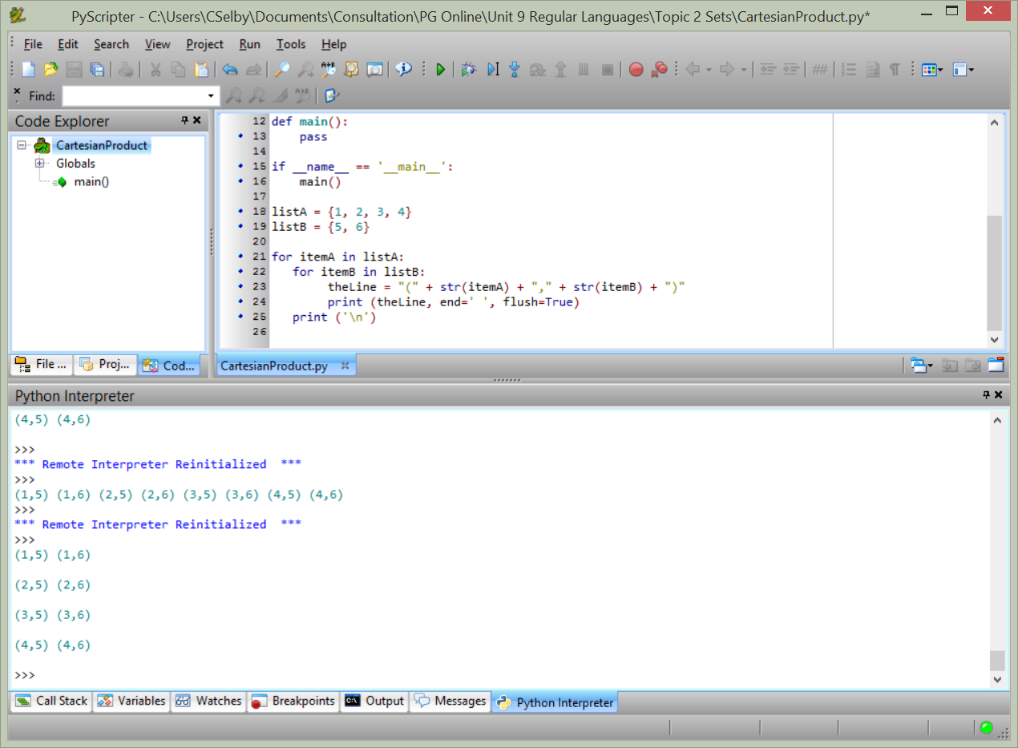 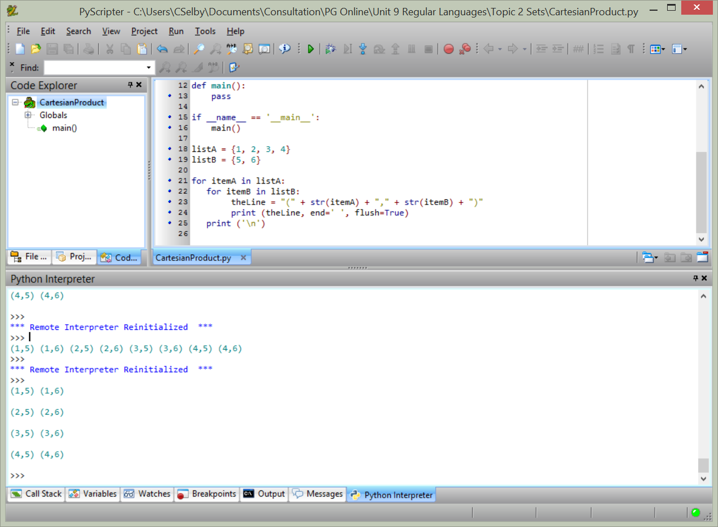

Pseudocode:

setA = {1, 2, 3, 4}

setB = {5, 6}

FOR EACH x IN SetA DO

FOR EACH y IN SetB DO

PRINT (“(“ + x + ”, “ + y + ”)”)

END FOR EACH

END FOR EACH

Python:

setA = {1, 2, 3, 4}

setB = {5, 6}

for itemA in setA:

for itemB in setB:

theLine = "(" + str(itemA) + "," + str(itemB) + ")"

print (theLine, end=' ', flush=True)

print ('\n')