# Worksheet 3 Regular Expressions

# 

|  |  |
| --- | --- |
| Symbol | Meaning |
| | | Separates alternatives (or, ⋁) |
| * | Indicates that there are *zero or more* of the preceding element |
| + | Indicates that there is *one or more* of the preceding element |
| ? | Indicates that there are *zero or one* of the preceding element |

# Task 1

1. Complete the table. All expressions are binary expressions using only the digits 0 and 1.

|  |  |
| --- | --- |
| **Regular Expression** | **Requirements** |
|  | 0 or 1 |
|  | All 1s |
|  | All binary strings |
|  | Binary string ending with a 1 |
|  | Binary string beginning with 1 |
|  | Binary string ending with 00 |
| (0|1)*1(0|1)*1(0|1)*1 |  |
|  | Has at least 3 1s in a row somewhere |
| (0|1)*110(0|1)* |  |
|  | Cannot include the substring 110 |
| (0|1)((0|1)(0|1))* |  |

1. Given the regular expression, indicate which strings are accepted and which are rejected. Note: C = {A…Z} L = {a…z} D = {0 …9}

(C|L)(C|L)*D

45AB, Aa3, M4, JK94

(C|L)D*(C|L)D

A35Q7, Dd7, 73K, E45a3

D+(C|L)+D?

7k, 99Pp77, 57ABC3, AD73

DCL(D*|L+)

3Ww754, 7b24, 8Qaa9, B78

**Task 2**

1. Write the regular expressions described by these FSMs.

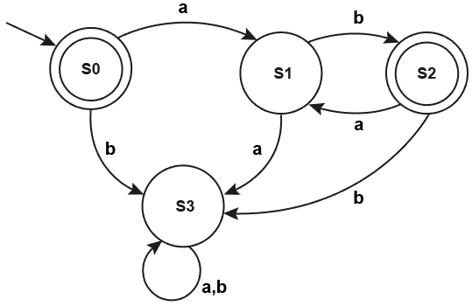

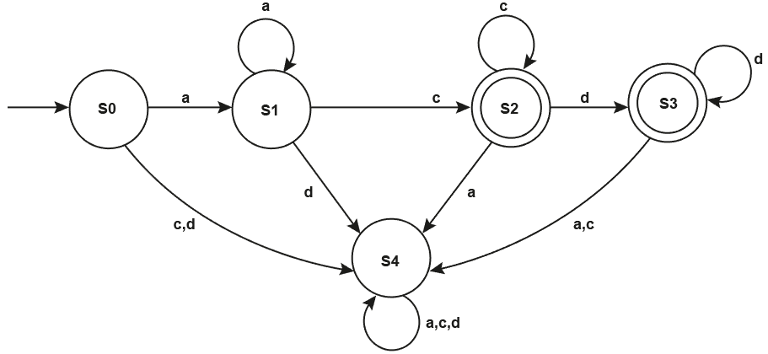

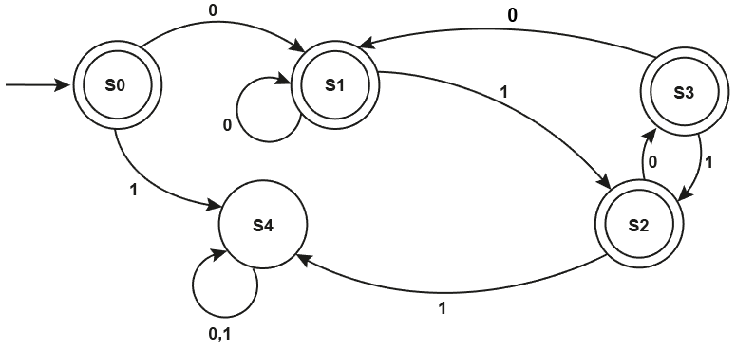

**Task 3**

1. Construct FSMs for the following regular expressions.
2. ab*a
3. 10+1
4. a+b+
5. 1(01)+1