# Homework 6 Reverse Polish Notation Answers

1. Convert the following to Reverse Polish Notation.

(a) 3 / (9 + 5) 3 9 5 + /

(b) (g / h^i) + (h * g) g h i ^ / h g * +

(c) 7 * x + 8 * y + 4 7 x * 8 y * + 4 +

(d) (a + b) / (c – d) a b + c d - /

(e) (a + b) * c / (b + c) a b + c * b c + /

[5]

1. (a) Create a binary tree for y = (3 * x) + 9 / (x + y), with the first + sign at the root. [3]

(b) State the output of a pre-order traversal (Polish Notation, prefix) [1]

(c) State the output of a post-order traversal (Reverse Polish Notation, post-fix) [1]

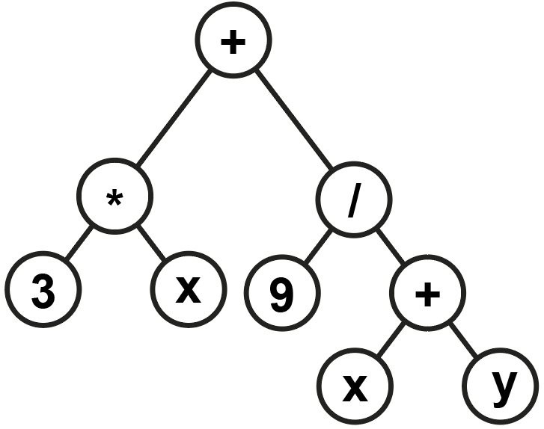

(3 * x) + (9 / (x + y))

Preorder: + * 3 x / 9 + x y

Postorder: 3 x * 9 x y + / +

1. Evaluate this RPN expression, showing the state of the stack for each step.  
   1. 5 2 * 3 4 * +

[5]

|  |  |  |
| --- | --- | --- |
| **Stack** | **Pop, execute, push** | **5 2 * 3 4 * +** |
| 2  5 | 10 = 5 * 2 | 5 2 * |
| 10 |  | 3 4 * |
| 4  3  10 | 12 = 3 * 4 |  |
| 12  10 |  | + |
|  | 22 = 10 + 12 |  |
| 22 |  |  |

[Total 15 Marks]